

Project PAM

A Reference Design for

Photoresin Additive Manufacturing for

The Open Source Community

Saluki Engineering Company

Reference Number: S14-75-3DPR

2014-12-02

|  |  |
| --- | --- |
| Nicholas Lowman | Computer Engineering |
| Daniel Olsen | Computer Engineering |
| Chance Baker | Electrical Engineering |
| Casey Spencer | Electrical Engineering |
| Jeffrey Burdick (PM) | Mechanical Engineering |
| Nathaniel Tyler | Mechanical Engineering |

# Transmittal Letter: CWB

2014-11-18

Saluki Engineering Company

Southern Illinois University Carbondale

College of Engineering – Mail Code 6603

1230 Lincoln Drive

Carbondale, IL 62901

Steven Blair, President

Saluki Makerspace

Southern Illinois University Carbondale

College of Engineering – Mail Code 6603

Room E0021

1230 Lincoln Drive

Carbondale, IL 62901

Mr. Blair,

On behalf of the Saluki Engineering Company, I would like to thank you for including us in the bid for a project to design a digital light processing printer. Attached is a design report for a DLP photoresin printer, Project PAM. Along with this report, we have included the computer host software code and build instructions of the prototype.

Project PAM proposes a reference Photoresin Additive Manufacturing (PAM) system which maximizes accessibility to the hobbyist. It is intended to be easily obtainable to consumers. This is achieved through extensive use of currently available or easily fabricated hardware and open-source software. The design allows this hardware to be very flexible, to scale to the size requirements of the maker. The reference design will be open-source hardware and software to the lowest practical level. Thorough documentation will provide the necessary means for the maker to go from an empty table to a functioning printer.

Our prototype is constructed to allow a build volume up to 192 mm x 216 mm x 216 mm with an X and Y pixel size of 100 μm and layer thicknesses down to 10 µm. In its current single-projector configuration it can provide a build volume of up to 216 mm x 121.5 mm with an X and Y pixel size of 112.5 µm. It can also close focus to provide a much smaller pixel size for smoother builds of smaller objects. This can be accompanied with a smaller build table and build vat to involve a smaller volume of resin.

The prototype comes with a 1920 x 1080 pixel ViewSonic projector which has been proven to provide very close focusing and will be perfect for later expansion to a large volume two projector system.

Please feel free to contact me at (815) 214 9661 or by email, burdickjp@siu.edu, if you have questions about this project.

Sincerely,

Jeffrey P Burdick

Project Manager

Project PAM: Team75-3DPR

Saluki Engineering Company

(815) 214-9661

burdickjp@siu.edu

# Acknowledgements: CWB

We would like to express our thanks to Dr. Spyros Tragoudas and Dr. Rasit Koc along with the Electrical and Computer Department and the Mechanical Department for the support and financial contributions. The project would not have been possible without their financial backings.

We would also like to take the time to thank the backers of the crowed funding campaign. Very person’s contribution was very much accommodating to the needs of our group. We would like to thank them for not only their financial report but their words of encouragement and belief in our project.

From the beginning of the project Dr. Lizette Chevalier has given priceless words of encouragement and advice that has been very critical to the success of the project.

At this time we would like to thank Lakendria Kenner of WSIU, Scott J. Grunewald of 3D Printing Industry, Eddie Krassenstein of 3D Print, and Austin Miller of Dailey Egyptian for the kind words in their articles. Their articles have help spread the work of Project PAM out to the global community.

We would like to take this opportunity to thank Dr. James Mathias for him allowing us to have use to his laboratory space giving Project PAM a place to call home.

We also would like to express a deep sense of gratitude to the team’s Faculty Technical Advisors; Dr. James Mabry and Joe Lennox, for their constant support, valuable guidance, and professional advice throughout the various stages of the design project.

We are grateful for the assistance of Tim Attig of the SIUC Machine Shop. His vast machining skills and knowledge have been a great part of the project’s success. Tim’s time and technical advice was invaluable to the team.

Lastly, we would like to thank the professors and teachers of the class; Dr. Tod Policandriotes, Dr. Vidya Singh-Gupta, Dr. Frances Harackiewicz, and Dr. Alan J. Weston for their support, ideas, and suggestions.

# Table of Contents: CWB

Transmittal Letter: CWB 2

Acknowledgements: CWB 3

Table of Contents: CWB 4

Table of Figures: CWB 5

Table of Tables: CWB 5

Table of Drawings: CWB 5

1 Executive Summary: CWB 6

2 Project Description: 6

2.1 Introduction: CWS 6

2.2 Overall Printer Diagram: 8

3 Costs: DMO 8

3.1 Crowdsourcing Campaign: DMO 8

3.1.1 Indiegogo 8

3.1.2 Social Media 11

3.1.3 Media Coverage 11

3.2 Prototype Costs: DMO 11

4 Schedules: 12

4.1 Proposed and Reworked Schedule: DMO 12

4.2 As Worked Schedule: DMO 12

5 Subsystem Descriptions: 12

5.1 Chassis: JPB 12

5.1.1 Process of Design 12

5.1.2 Process of Assembling 13

5.1.3 Equipment Needed 13

5.1.4 Health and Safety Issues 13

5.1.5 Recommendations 14

5.2 Mechanical Motion: JPB 14

5.2.1 Process of design 14

5.2.2 Process of Assembling 14

5.2.3 Equipment Needed 15

5.2.4 Recommendations 15

5.3 Technical Drawings: NBT 15

5.4 Printer Control Software: DMO 15

5.4.1 Process of Design 15

5.4.2 Process of Developing 15

5.4.3 Development Schedule 15

5.4.4 Health and Safety Issues 15

5.4.5 Recommendations 15

5.5 Hardware-Software Interface: NAL 15

5.6 Motors: CWS 15

5.7 Motor Control: CWS 15

5.8 Resin Management: CWB 16

5.8.1 Process of Design 16

5.8.2 Health and Safety Issues 16

5.8.3 Recommendations 16

5.9 Optics: CWB 17

5.9.1 Design 17

5.9.2 Recommendations 17

6 Test Print Results 17

7 References: CWB 18

8 Appendix 20

8.1 Schedules 20

8.1.1 Proposed and Reworked 20

8.1.2 As Worked 22

8.2 Bill of Materials 24

8.3 CAD Models 24

8.4 MakerJuice G+ Safety Data Sheet 24

8.5 MakerJuice G+ Techincal Data Sheet 32

8.6 Website (GitHub Pages) 34

8.6.1 Home Page 34

8.6.2 Hardware Page 37

8.6.3 Software Page 38

8.6.4 Google Analytics Reports 39

8.7 Project PAM Prezi 42

8.8 Indiegogo 57

8.8.1 Story 57

8.8.2 Funders 62

8.8.3 Gallery 64

8.9 Social Media Pages 66

8.9.1 Twitter Page 67

8.9.2 Facebook Page 72

8.10 Articles Project PAM Was Featured In 77

8.10.1 3DPrint.com 78

8.10.2 3D Printing Industry 82

8.10.3 WSIU 86

8.10.4 Make Magazine 88

# Table of Figures: CWB

Figure 1. Market gap 8

Figure 2. Flow diagram for Project PAM printer control software 8

Figure 3. Crowdsourcing campaign activity 11

Figure 4. An isometric view of the current chassis design 13

Figure 5. Robot Test Print 18

Figure 6. 20 mm Cube Test Print 18

# Table of Tables: CWB

Table 1. Indiegogo perks 9

Table 2. Articles Project PAM was featured in 11

Table 3. Cost of subsystems 11

Table 4. Total system cost 12

# Table of Drawings: CWB

# Executive Summary: CWB

Project PAM proposes a reference Photoresin Additive Manufacturing (PAM) system which maximizes accessibility to the hobbyist. It is intended to be flexible by allowing for configurations of hardware available or easily obtainable to the maker. This is achieved through extensive use of currently available or easily fabricated hardware and open-source software. The reference design uses open-source hardware and software to the lowest practical level. Thorough documentation provides the necessary means for the maker to go from an empty table to a functioning printer.

The major subsystems of Project PAM include: Mechanical Motion, Chassis, Printer Control Software, Hardware-Software Interface, Resin Management, Optics, Vat, and Coupler. Our teams is still striving to achieve the optimist solution to achieve the highest level of quality.

Several of the design activities and decisions show how Project PAM is more desirable than the competition. One example of this is Project PAM’s build volume size. The maximum build volume is almost double that of any other DLP printer. This is achieved by supporting the use of two 1920 x 1080 pixel projectors. As consumer resins increase with quality this feature will allow the PAM system to grow. Though the maximum build volume would use up to 9 L of resin, Project PAM’s flexible design can accommodate smaller vats and build tables. The maker can use a vat and build table sized appropriately for their build. This will minimize resin waste, saving the maker money.

This printer is expected to have the capability of producing high quality prints. The initial goals of Project PAM included: keep the cost of the project under $700 excluding the price of the projectors, support the use of two projectors, have a maximum build size of approximately 8 L, layer thickness as thin as 100 µm, and have a printing resolution error within 100 µm.

The prototype is sized to support a build volume of 192 mm x 216 mm x 216 mm which is a volume of 8.9 L. This would be achieved through the use of two 1920 x 1080 pixel projectors used in tandem, providing a pixel size of 100 μm. The prototype is currently configured with a single 1920 x 1080 pixel projector. With 2mm pitch lead screws and stepper motors providing 200 steps per revolution layer heights can be as thin as 10 µm without microstepping.

This report consists of: a project description that will introduce the report and project, a cost analysis allowing the open-source community to see the end cost, expected build time schedule, detailed subsystems descriptions along with recommendations, and an appendix.

# Project Description:

## Introduction: CWS

Today when one uses the term "3D printing" they referring to the manufacturing process that allows a digital model to be manufactured through an additive process. 3D printing is unique from other machining processes because it implements what's known as additive manufacturing rather than the more common techniques of drilling or cutting to remove material. 3D Printers are able to accomplish this by slicing the virtual models into several two dimensional layers and then printing those layer one by one to build up the object. This is advantageous because it is much less wasteful than traditional techniques. A 3D printer is also capable of building nearly any object which allows manufacturers to change products without having to buy any new equipment.

The first 3D printer was built in 1984 by Chuck Hall [1] but the process has not been widely available until the early 2010's. Printers are most commonly used for cheap and rapid prototyping but the process has shown potential in a number of fields, including architecture, automotive design, and even the biomedical field to print human tissue and organs. Because of this potential the industry is estimated to be worth more than $2.2 billion today [2].

There are several techniques used to accomplish this layer-by-layer building operation, the most common of the additive manufacturing processes today is extrusion deposition. With this extrusion deposition each 2D layer is built by extruding a bead of material which will harden almost instantly upon leaving the extruder nozzle. The nozzle head moves across a surface depositing the material in the shape of the given layer and then moves on to build the next layer of the object. As each layer is added the print object gains volume. This method is simple and inexpensive but is less accurate than other techniques and also error prone since any defect can lead to a jam or clog in the extruder.

However, another method that is slowly gaining popularity is using light and photocurable resins to build these layers. The resin is exposed to some form of UV light which hardens the resin. This hardened section of resin is one layer of the object. The print area then moves down and the process is repeated to build the next layer. This is known as photopolymerization and the most common form of photopolymerization is using a DLP projector to project images onto the resin. DLP printing has several advantages over the previously mentioned extrusion deposition method, the first of which is speed. Instead of moving an extrusion nozzle slowly across a surface to build the individual layers, DLP printers project an image of the entire layer and cure it all at once. Another advantage is that since there is no physical contact between the projector and the building material there is not possibility for jamming. However, DLP printing’s greatest strength lies in its ability to produce extremely precise and detailed print objects since its resolution is only limited by the resolution of the projector used.

Need Market Gap

Figure . Market gap

## Overall Printer Diagram:



Figure . Flow diagram for Project PAM printer control software

# Costs: DMO

## Crowdsourcing Campaign: DMO

The idea of crowdsourcing Project PAM was brought up during the spring; however, it was decided to be too much of a commitment for the team members at that time. As the semester continued and the estimated cost of building the prototype became apparent crowdsourcing was again looked at. The decision was made at the beginning of the fall to move forward with a crowdsourcing campaign.

The first step of this process was to pick a crowdsourcing platform. Originally Kickstarter was chosen; however, after during the process of trying to create the campaign it was determined Kickstarter did not meet the needs of the project. Because of this Indiegogo was chosen as the crowdsourcing platform for Project PAM.

One of GitHub’s features called GitHub Pages, which hosts simple static HTML websites for free and provides Creative Commons licensed templates to use, was used to develop a website for Project PAM [3]. GitHub supports both project pages (website for repo) and organization pages. For Project PAM an organization page along with two project pages (Hardware and Software Repos) were created using the Architect theme as a starting point. The print outs of the website are included in the appendix at 8.6.

### Indiegogo

The first part of the Indiegogo campaign was to take the information from the website and modify to follow the Indiegogo Playbook, a guide to running a successful crowdsourcing campaign [4]. Indiegogo recommends creating a short video to introduce the project and be a commercial for the product [4]. The decision was made to use an online tool called Prezi, a kind of PowerPoint tool for presenting ideas on a virtual canvas [5]. With the help of a student in the Mass Communications program voice over was recorded for the Prezi.

The second step for the Indiegogo campaign was to set the funding goal for the campaign. Unlike other crowdsourcing platforms Indiegogo has an option to allow the campaign to keep all funds raised instead of requiring the campaign to reach the goal to receive the funds. Indiegogo calls this option flexible funding and charges a higher rate if the goal is not reached. Because of this and the ability to receive funds that were donated through PayPal immediately it was decided to use Indiegogo flexible funding option [6]. The main portion of the project that was hoped to be funded through the crowdsourcing campaign was the two 1080p projectors, which at the time coasted a total of $1,400. Because of Indiegogo’s and credit card companies’ percentage they take of the raised funds and it was decided to set the goal at $2,500. This goal would have made possible for the purchase of the two projectors along with the purchase of additional resin and additional prototyping costs.

The final step was to decide on the perks for funders to claim. It was decided for Project PAM to have 4 perks at differing price points. The perks that were used for Project PAM are described in Table 1 along with the number of funders who claimed them.

Table . Indiegogo perks

|  |  |  |  |
| --- | --- | --- | --- |
| Perk | Price | Description | Number Claimed |
| Thank You | $5 | For contributing $5.00 or more you will receive a personalized thank you email from the team and you will be immortalized as a funder on our website. | 0 |
| Key Chains | $25 | For a contribution of $25.00 or more you will receive one Open Source Hardware Association logo key chain AND one Open Source Initiative logo key chain. Our intent is to 3D print these key chains with the Project PAM prototype. (Additional cost of $10 for international shipping.) | 7 |
| Bound Documentation of Design | $250 | For a contribution of $250.00 or more you will receive all documentation associated with the design professionally bound and well presented. Also includes $25 perk. (Additional cost of $50 for international shipping.) | 1 |
| Full Kit and Documentation | $1500 | For a contribution of $1,500.00 or more you will receive a full unassembled build kit for the printer. (The kit does not include projectors.) Also includes $25 perk and $250 perk. (Additional cost of $300 for international shipping.) | 0 |

The campaign was launched on September 30, 2014 and was originally planned to be 14 days and end on October 14, 2014. However, after a week and a half the decision was made to use Indiegogo’s one time campaign extension to extend it to a full 30 days and to end on October 28, 2014. The performance of the campaign is shown in Figure 3. The majority of the funds raised was raised in the final day of the campaign, it went from $300 to over $700 during that day.

Overall $741 was raised, in 11 contributions, of the $2,500 goal or the project was 29.64 % funded. This does not include funds raised outside of Indiegogo. If the funds raised outside of the Indiegogo are included the total was around $960, which was enough to purchase a single refurbished 1080p projector and additional items needed for prototyping. Additionally the Indiegogo page had 1,253 visits and 146 referrals.

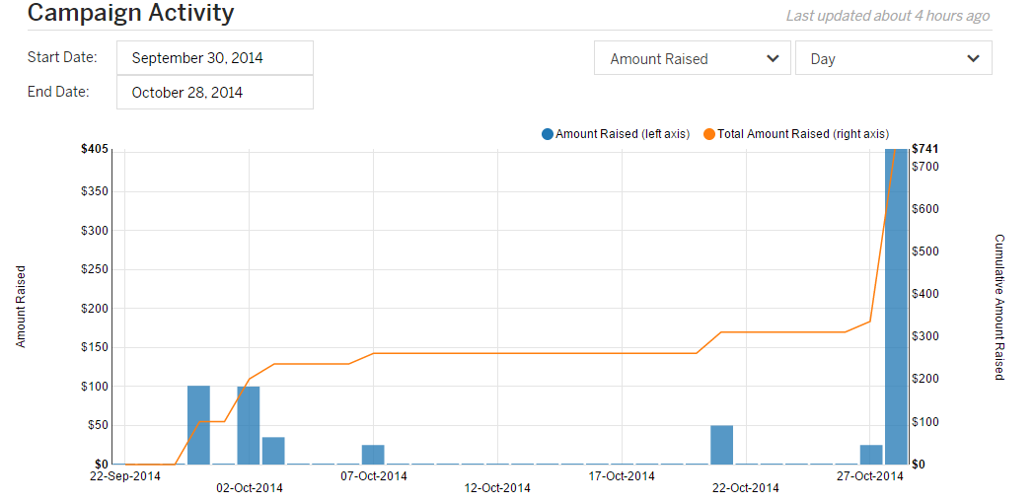

Figure . Crowdsourcing campaign activity

### Social Media

In addition to the GitHub organization for Project PAM, a Gmail account for email, and the GitHub Pages, social media accounts/pages were created to supplement the crowdsourcing campaign. These accounts/pages included Twitter (@ProjectPAM), Facebook, Google+, and YouTube. Twitter had 59 tweets and 17 followers, Facebook had 40 likes, and the YouTube videos had 1062 views. Additionally, Google Analytics were set up for the GitHub Page and the reports of traffic for September to December are included at 8.6.4.

### Media Coverage

The Project PAM crowdsourcing campaign was featured in 4 major news outlets. Those include 3DPrint.com, 3DPrintingIndustry.com, WSIU, and Make Magazine. Full page print outs are included at 8.10.

Table . Articles Project PAM was featured in

|  |  |
| --- | --- |
| Media Outlet | Article Titles |
| 3DPrint.com | Project PAM – College Students Look to Create an Entirely Open Source DLP 3D Printer [7] |
| 3DPrintingIndustry.com | Help The Open Sourced DLP 3D Printer called Project Pam on Indiegogo? [8] |
| WSIU | SIU Engineering Students Use Crowdfunding for 3D Printer [9] |
| Make Magazine | Cool Crowdfunding: October 26, 2014 [10] |

## Prototype Costs: DMO

The costs of Project PAM are split into two tables: one for the cost of the subsystems and the total cost of the printer including the projector. A complete bill of materials is included at 8.2.

Table . Cost of subsystems

|  |  |
| --- | --- |
| Subsystem | Price |
| Motion control | $113.61 |
| Chassis | $315.99 |
| Hardware software interface | $25.97 |
| Motors/motor control | $82.83 |
| MakerJuice G+ resin | $45.00 |
| Total | $602.17 |

Table . Total system cost

|  |  |
| --- | --- |
| Subsystem | Price |
| Printer | $602.17 |
| Projector | $690.00 |
| Total | $1292.17 |

# Schedules:

## Proposed and Reworked Schedule: DMO

With the addition of an additional team member at the start of the second semester, the schedule was able to be reworked to free up team members. The proposed and reworked (additions in orange) are included in the appendix at 8.1.1.

## As Worked Schedule: DMO

Project PAM experienced procurement problems that set the schedule back 3 weeks. The setback was not a total waste because it allowed for the construction of a linear motion test rig to be used for testing as soon as the parts arrived.

The other big change to the schedule was the addition of the crowdsourcing campaign. This set software back a whole month because the team member doing software was put in charge of developing the campaign.

The as worked schedule can be found at 8.1.2.

# Subsystem Descriptions:

## Chassis: JPB

### Process of Design

An early goal of the hardware design was to have a product which was very rigid and allowed adjustability for all pieces which need to be aligned. Several options were considered for the construction of the chassis, from an incorporated enclosure and chassis design to open source linear motion systems.

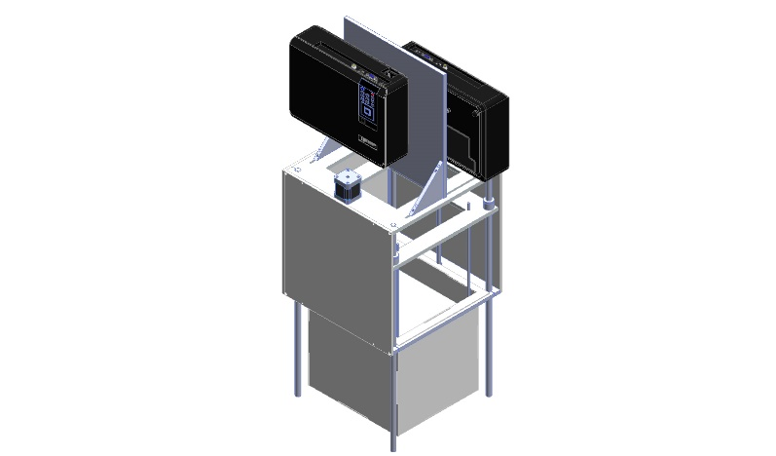

Figure . An isometric view of the current chassis design

It was decided that conventional round linear bearing shafts could be used as the vertical component of the chassis, as shown in Figure 4. This removes the necessity for a separate vertical chassis structure. This simplified the chassis design to just two horizontal structural plates to hold the motion-driving components, projector, and vat, and the linear bearing shafts. The chassis plates attach to the linear bearing shafts by clamping. The height of the system could then be easily changed, and the system could be easily squared by adjusting the plates and shafts.

A design was considered which used three linear bearing shafts as legs instead of four, as this would make the alignment process easier and was thought to reduce material. It was found that material costs would not be reduced, as a configuration using three or four legs would involve ordering the same length of shaft because of minimal material requirements with most industrial suppliers. The tripod design would also necessitate larger chassis plates and more material waste.

The initial design proposal involved chassis dimensions of 300 x 320 mm to accommodate stepper motors mounted on the bottom chassis plate. This would require the order of a 12 x 18 inch plate and involve wasting a lot of material. In order to fit the design within a 12 x 12 inch plate the stepper motors were moved to the top plate. This also allowed the weight of the carriage to be carried by thrust bearings in the bottom plate rather than the stepper motors and couplers.

The throw and focusing distance of the project allowed it to be clamped directly to the top chassis plate. Testing could then be accomplished without needing to permanently mount the projector.

### Process of Assembling

The four bearing shafts are placed in the bottom chassis plate. The protrusion of the shafts from the plate is established using calipers. One of the shafts is tightened fully, while the others are left snug. The assembly is then placed on a surface plate and the chassis plate is leveled using a height gage. The carriage is placed on the bearing shafts and the top plate is placed. After the correct distance between the two plates is determined, the top chassis plate is leveled using the height gage and the carriage can be leveled according to the assembly directions in section 5.2.2.

### Equipment Needed

Manufacturing of the prototype was completed using machine tools, but manufacturing for the maker can be achieved by water jetting, EDM, or CNC machining. This is easy and inexpensive to contract with machine shops, or made in bulk. Finish machining can be done using hand tools.

### Health and Safety Issues

### Recommendations

An enclosure can be assembled from nearly any sheet material. Gaffers tape is good for sealing. When doing quick testing a leaf bag can be used as an expedient enclosure.

## Mechanical Motion: JPB

### Process of design

The single axis of motion is achieved by the use of a carriage plate riding on four linear bearings riding on the chassis shafts. The build table hangs from this carriage into the vat.

The initial motion control design involved a single lead screw. It was determined that the rigidity required to implement the design with a single lead screw would require a prohibitive amount of complication. Using two lead screws would allow for smoother operation without an excessive cost increase. Both lead screws ride on ball-bearing thrust bearings held in the bottom chassis plate.

Backlash has been a rather prolific problem with 3d printers of all varieties. Many interesting and complicated methods of handling backlash have been suggested in the community [11]. It was decided to make the lead screw nut out of acetal and attempt a novel method of implementing threads which involved heating the lead screw and allowing the acetal to flow form around it [12]. The cooled lead screw nut would then fit more snugly than cut threads. This proved excessively difficult with the acetal used. It was decided to abandon this method in favor of a more traditionally manufactured lead screw nut, but retain delrin as the material of choice. A section of lead screw was used to construct a tap and a section of acetal was drilled to the smallest inside diameter specified for the thread profile in the hopes that a tight fit could be achieved. After tapping this proved to provide a sufficiently tight enough fit to prevent backlash. When implemented on the chassis it has shown to not produce so much friction as to cause mistepping of the stepper motors.

The stepper motors are connected to the lead screws by flexible couplers, which allow axial misalignment while maintaining torque transmission. While off-the-shelf components are readily available and inexpensive, a design for these couplers is included in the project.

### Process of Assembling

The linear bearings are assembled on the carriage plate which is then installed between the chassis plates during chassis assembly. The lower chassis plate is then leveled. The thrust bearings are then installed in the lower chassis plate. The lead screw nuts are fitted to the lead screws, which are fitted up into the carriage plate and dropped into the thrust bearings. The positioning of the upper chassis plate is determined to ensure the lead screw couplers engage the stepper motors and lead screws thoroughly. The lead screws are then removed, the upper chassis plate is then leveled, and then the lead screws are reinstalled. The lead screw nuts are fastened to the carriage plate by M20 jam nuts threaded to the outside of the lead screw nuts. The couplers are attached to the lead screws and the stepper motors are installed, but left unattached to the couplers. The carriage is leveled by adjusting the lead screws and then the couplers are tightened to the stepper motors. The lead screws should not be turned by hand, as this would put the carriage out of level.

The build table should be suspended from the carriage and leveled. The level of the build table should be checked by filling the vat with salt water and adjusting the build table to ensure that the liquid is level over the build table.

### Equipment Needed

Proper leveling should be done on a surface plate with a height gage, but can be achieved on any sufficiently flat surface with a good ruler, calipers, or trammel points.

### Recommendations

Suspending smaller build tables by three rods instead of four should allow faster leveling. If there is a bend or warp to the table the fourth rod can be introduced to minimize this. Level and flatness of the build table is much more obvious when suspended over a level of liquid than when just using a height gage.

## Technical Drawings: NBT

## Printer Control Software: DMO

### Process of Design

Proposal from last semester

Wait for B9 Creator update and associated licensing

Problems with B9Creator

Problems with OSS CAM

### Process of Developing

KDevelop

Libraries

### Development Schedule

### Health and Safety Issues

### Recommendations

## Hardware-Software Interface: NAL

## Motors: CWS

## Motor Control: CWS

## Resin Management: CWB

### Process of Design

As Project PAM was unfolding, the decision to become a photoresin printer emerged. The first design of the resign was to use a custom product from Momentive. Momentive Specialty Chemicals Inc. serves the global wood and industrial markets through a broad range of thermoset technologies, specialty products and technical support for customers in a diverse range of applications and industries [13]. This would have allowed Project PAM complete control over the wavelength needed to cure the resin, over the color, over the density, and over the curing agents.

Because of the goal of the project to be completely open source, this idea was abandon for buying resins that will be more accessible to the open source community. While looking through photoresin system forums, there was one company that had shown up on multiple posts as being reliable and cost effective, MakerJuice Labs [14]. MakerJuice Labs is an American company first started in 2013 with a focus of quality and low cost resins aimed for the hobbyists’ community [15]. They have sold over eight-thousand items and have over two-thousand customers since their start [15]. This gave Project PAM the facts it needed to use MakerJuice for the prototype.

### Health and Safety Issues

Resins by MakerJuice Labs are in compliance of USA and Canada standards [15]. Material safety data sheets (MSDS) for all of their products can be found on their website. The MSDS for the resin G+, ordered by Project PAM can be found in this report at 8.1.

G+ is a category 2 skin corrosion, category 1 serious eye damage, and a category 1 for skin sensitization set by the 2012 OSHA Hazard Communication Standard [15]. The precautionary prevention steps are as follows: Wash face, hands and any exposed skin thoroughly after handling, wear protective gloves/protective clothing/eye protection/face protection, avoid breathing dust/fume/gas/mist/vapors/spray, and contaminated work clothing should not be allowed out of the workplace [15].

The precautionary response steps are as follows: If in the eyes; Rinse cautiously with water for several minutes. Remove contact lenses, if present and easy to do. Continue rinsing. Immediately call a POISON CENTER or doctor/physician. If on the skin; Wash with plenty of soap and water. Take off contaminated clothing and wash before reuse. If skin irritation or rash occurs: Get medical advice/attention [15].

### Recommendations

There are several different types of resins that are open to the hobbyist community. Some resins cure harder than other resin, but this can result in a longer cure time. Different types of resins can allow for the end print to be flexible, like MakerJuice Lab’s Flex [15].

There are a few things to keep in mind while shopping for resin. The first thought is the cost. There are several companies that are based out of the US who have cheaper resins but the shipping cost is sometimes up to triple the cost of their product. Another thought is the shrink percent. MakerJuice Lab’s G+ substance has an experimental shrinkage of 3.3%, while their G substance has an 8% experimental shrinkage [15]. Shrinkage is the most common problem with prints with a build volume over 100cm3 [14]. The G+ was $45.00 a liter, and the G was $40 a liter in May of 2014 [15]. The user will have to decide if it is worth the extra $5 to ensure precise prints.

To help offset the use of resin several hobbyist have had success of using saltwater [14]. The resin floats on top of the saltwater. This means that a hobbyist only needs to put as much resin in the vat as what is needed for the build or the layer thickness. With the price of most resins being around $50, this idea is a great way to save resin and money.

## Optics: CWB

### Design

The project is the biggest investment of the project. ­­­­There are several things to keep in mind when making a choice on what projector to go with. There are several different types of projectors. The two main projectors are light-emitting diode (LED) and digital light processing (DLP). For the truest and highest quality of prints the best choice to use is DLP. DLP uses a mirror for each pixel in the projected image. This allows each pixel to be controlled individually unlike the LED were groups of pixels work together to make an image.

Another big decision is the native pixel resolution. The resolution will directly decide the quality of the prints and the size of the build area. The higher the number, the higher the max build area and better the quality. A full HD 1080p is actually at the ratio of 1920 by 1080 pixels. This allows a max build area with a 100µm precision to be 20 cm by 10 cm.

Another major component of the projector that will impacted the quality of the prints is the throw ratio. This effects the screen size or in printing terms the build area. Personal off-the-shelf projectors are not made for projecting images less than a foot away from the lens. The farther back the projector is from the build area will mean a larger build area, but at the sacrifice of pixel resolution. Depending on the projector this may be fixed by opening up the projector and modifying or replacing the lens to account for the shorter distance [1].

Aside from the pixel resolution is the lumen output. Depending on the type of resin that is used for the print will decide how many lumens it takes to cure. MakerJuice’s resin takes 2000 lumens to cure [15].

### Recommendations

Though Project PAM’s design is flexible to allow use of almost all consumer projectors, the prototype used View Sonic’s PJD7820HD 1080p 3D Home Theater Projector. This projector outputs 3000 lumens allowing faster build times. It has a 15000:1 contrast between a fully on pixel and off pixel. It supports HDMI in, dual VGA in, and VGA out giving great flexibility to the user. The projector has a filter-less design. It also has a 3-year limited warranty on parts and labor; and a 1-year warranty on the lamp. All of this comes in a 4 lb plastic case, making it ideal for mounting it over head. [16]

Most importantly the 1.2x Optical Zoom lens and throw ratio of 1.25-1.5:1 is able to give Project PAM the build area and resolution without modifying the lens [16]. This was found by doing a test. The project was set 21 cm away from the screen to simulate the space between the build layer and the lens. The zoom was then set to give a build area of 10.2 cm by 18.4 cm, which is close to the desired 10 cm by 20 cm. The focus was then adjusted until font size 8 was easily readable.

# Test Print Results

Project PAM has had several different successful prints. The first print attempted by Project PAM was a robot that can be seen on the right side in Figure 5. Robot Test Print. The projector was not calibrated correctly and this led to the aspect ratio to be wrong. The left robot in Figure 5 is the second print and as can be seen, is of much better quality. The was accomplished by fixing the aspect ratio, increasing the down and up travel from 1mm to 2mm, and doubling the move speed to 50 mm/min down and 100 mm/min up.

Though the robots were a good starting point to prove full system success, Project PAM aimed to quantify test. This led to the printing of 20 mm cubs that can be easily measured and compared. In Figure 6 the first printed cube is on the left and the second cube printed is on the right. Cube #1 had 2 second cure time layers, 50 μm layer thickness, and move speed of 200 mm/min down and 200 mm/min up. The actual print came out to be 19.4x19.6x unmeasurable (um) mm. The first couple of layers where ruined when removing the build from the build table. There is also imprecise edges do to over curing the resin giving a bleed effect. The error of the cube is 3x2xum %. Cube #2, right side of Figure 6, has the same parameters but with a 1 second cure time and a 100μm layer thickness. Not only did this cut the build time in half, but it gave a much higher quality print with less bleed. The actual dimensions are the same as Cube #1 but the edges are almost a true 900. Both of these cubes are smaller than the set dimensions do to the shrinkage percentage from the resin. More testing is being done to find what the shrink percentage is so that prints can be compensated in the software.

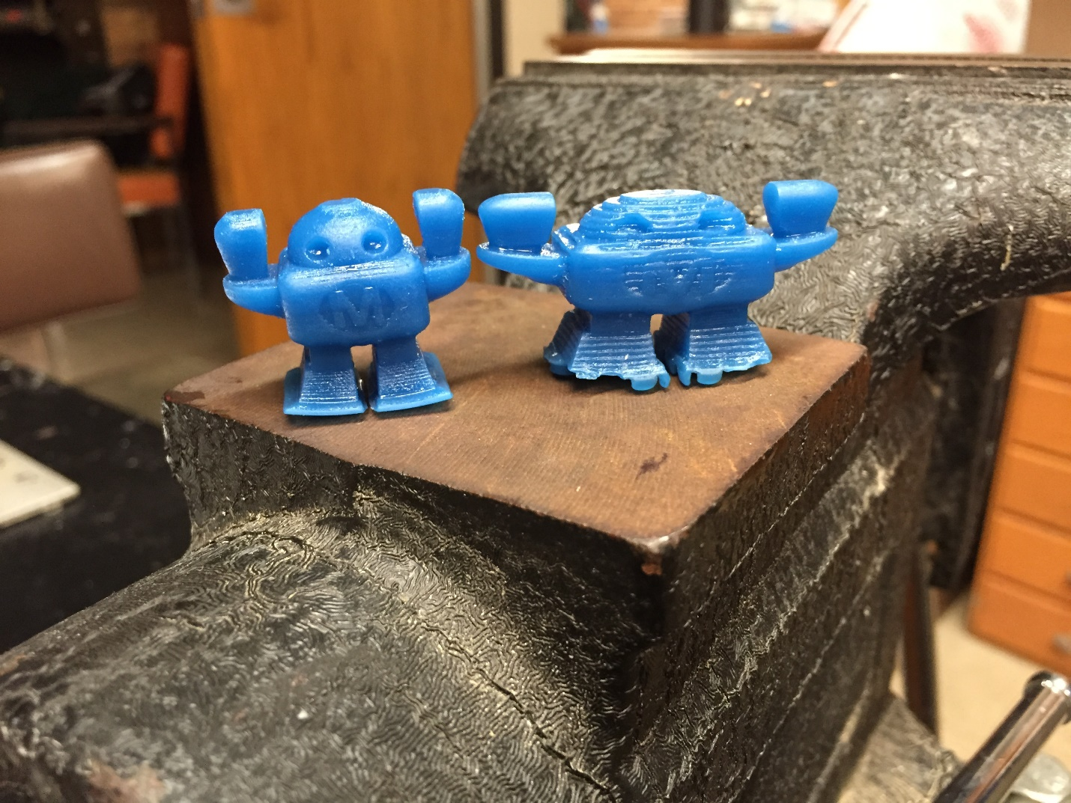

Figure . Robot Test Print

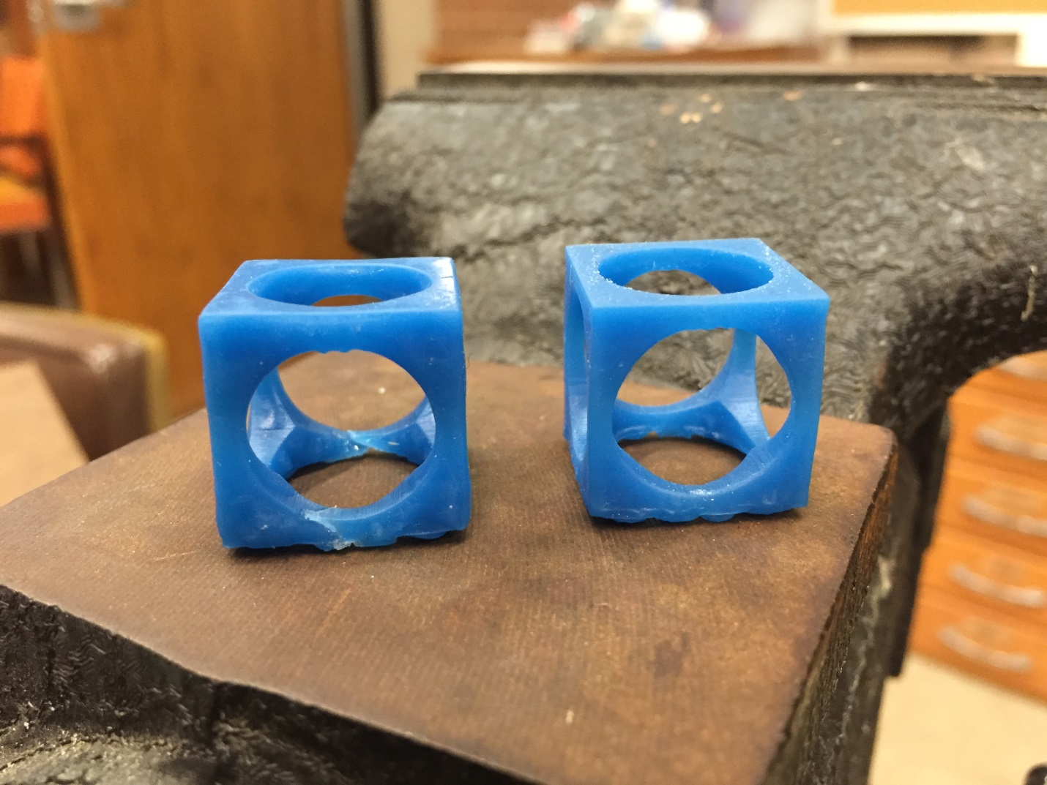

Figure . 20 mm Cube Test Print

# References: CWB

|  |  |
| --- | --- |
| [1] | "3D Printing: What You Need to Know," [Online]. Available: http://www.pcmag.com/slideshow_viewer/0,3253,l=293816&a=289174&po=1,00.asp. [Accessed 17 April 2014]. |
| [2] | "3D Printing Scales Up," *The Economist,* 7 September 2013. |
| [3] | GitHub, Inc., "GitHub Pages," 2014. [Online]. Available: https://pages.github.com/. [Accessed 3 December 2014]. |
| [4] | Indiegogo, Inc., "Indiegogo Playbook," 2014. [Online]. Available: https://go.indiegogo.com/playbook. [Accessed 3 December 2014]. |
| [5] | Prezi Inc., "Prezi," 2014. [Online]. Available: http://prezi.com/. [Accessed 3 December 2014]. |
| [6] | Indiegogo, Inc., "Pricing & Fees," 2014. [Online]. Available: https://go.indiegogo.com/pricing-fees. [Accessed 3 December 2014]. |
| [7] | E. Krassenstein, "Project PAM – College Students Look to Create an Entirely Open Source DLP 3D Printer," 2 October 2014. [Online]. Available: http://3dprint.com/17504/project-pam/. [Accessed 3 December 2014]. |
| [8] | S. Grunewald, "Help The Open Sourced DLP 3D Printer called Project Pam on Indiegogo?," 2 October 2014. [Online]. Available: http://3dprintingindustry.com/2014/10/02/help-open-sourced-dlp-3d-printer-called-project-pam-indiegogo/. [Accessed 3 December 2014]. |
| [9] | L. Kenner, "SIU Engineering Students Use Crowdfunding for 3D Printer," 15 October 2014. [Online]. Available: http://news.wsiu.org/post/siu-engineering-students-use-crowdfunding-3d-printer. [Accessed 3 December 2014]. |
| [10] | C. Kraft, "Cool Crowdfunding: October 26, 2014," 2014 October 2014. [Online]. Available: http://makezine.com/2014/10/26/cool-crowdfunding-october-26-2014/. [Accessed 3 December 2014]. |
| [11] | S. Wygant, "M5 Nut Anti Backlash Assembly," [Online]. Available: http://repables.com/r/349/. [Accessed 30 November 2014]. |
| [12] | Evan, "Making Acetal leadscrew nuts the easy way," 15 September 2010. [Online]. Available: http://bbs.homeshopmachinist.net/threads/43645-Making-Acetal-leadscrew-nuts-the-easy-way. [Accessed 30 November 2014]. |
| [13] | Momentive, "Momentive," 2014. [Online]. Available: http://www.momentive.com/. [Accessed 2014]. |
| [14] | Build Your Own SLA, "Resins," January 2014. [Online]. Available: www.buildyourownsla.com. [Accessed 26 February 2014]. |
| [15] | Maker Juice Labs LLC, "Maker Juice," 2014. [Online]. Available: www.makerjuice.com. [Accessed May 2014]. |
| [16] | VeiwSonic Corporation, "PJD7820HD," 2014. [Online]. Available: http://www.viewsonic.com/us/projectors/high-performance/pjd7820hd.html. [Accessed 3 December 2014]. |

# Appendix

## Schedules

### Proposed and Reworked

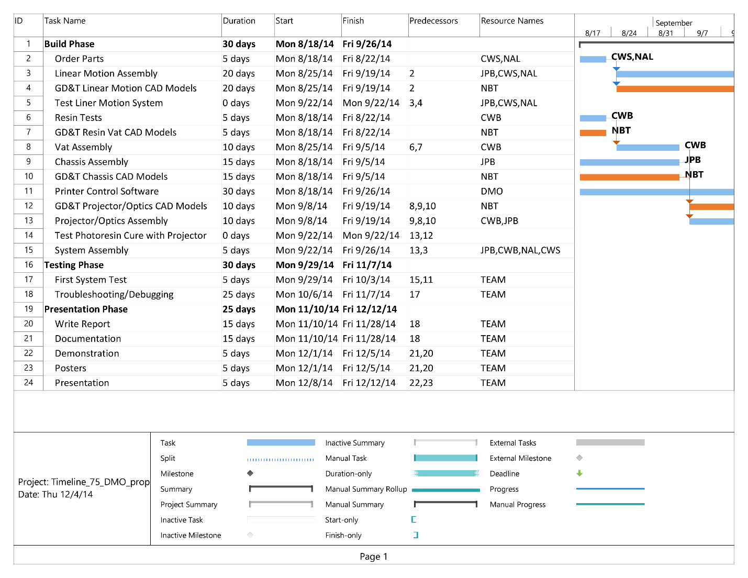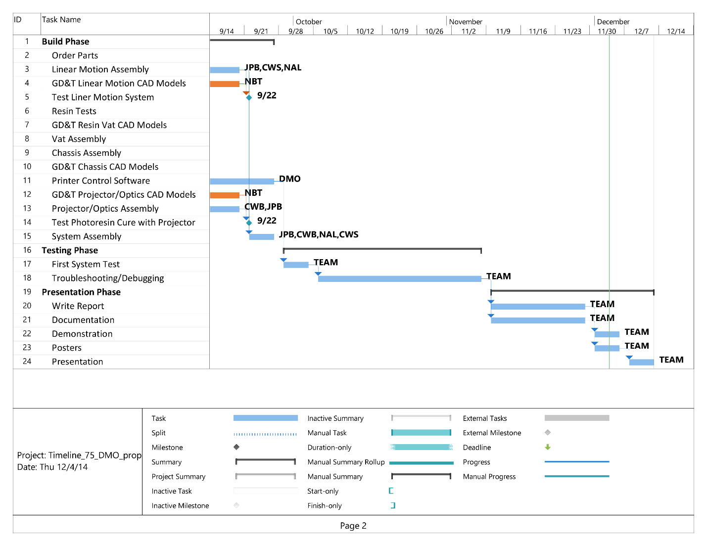

### As Worked

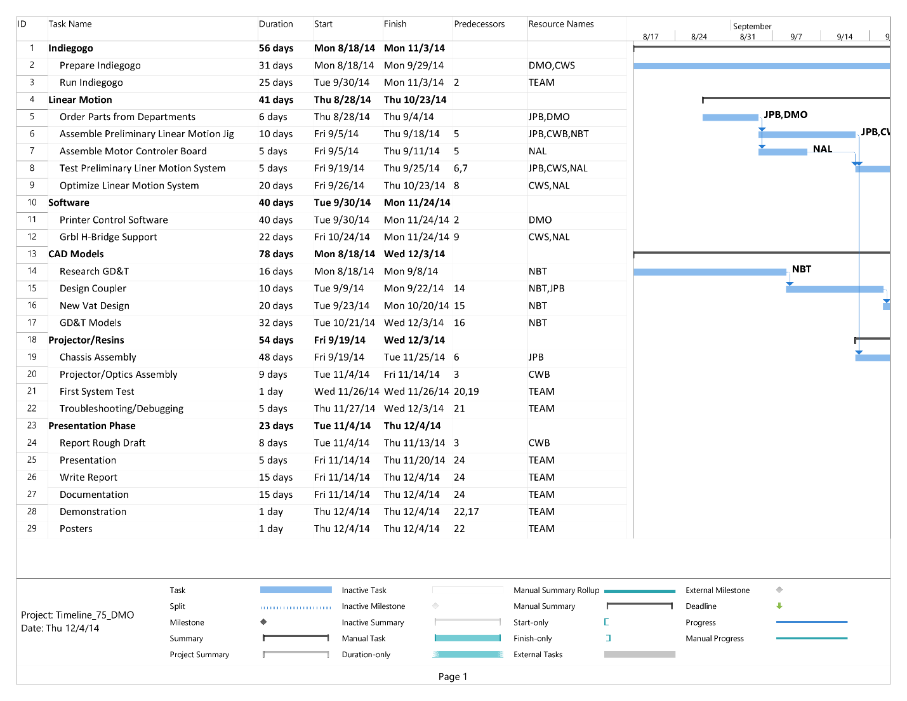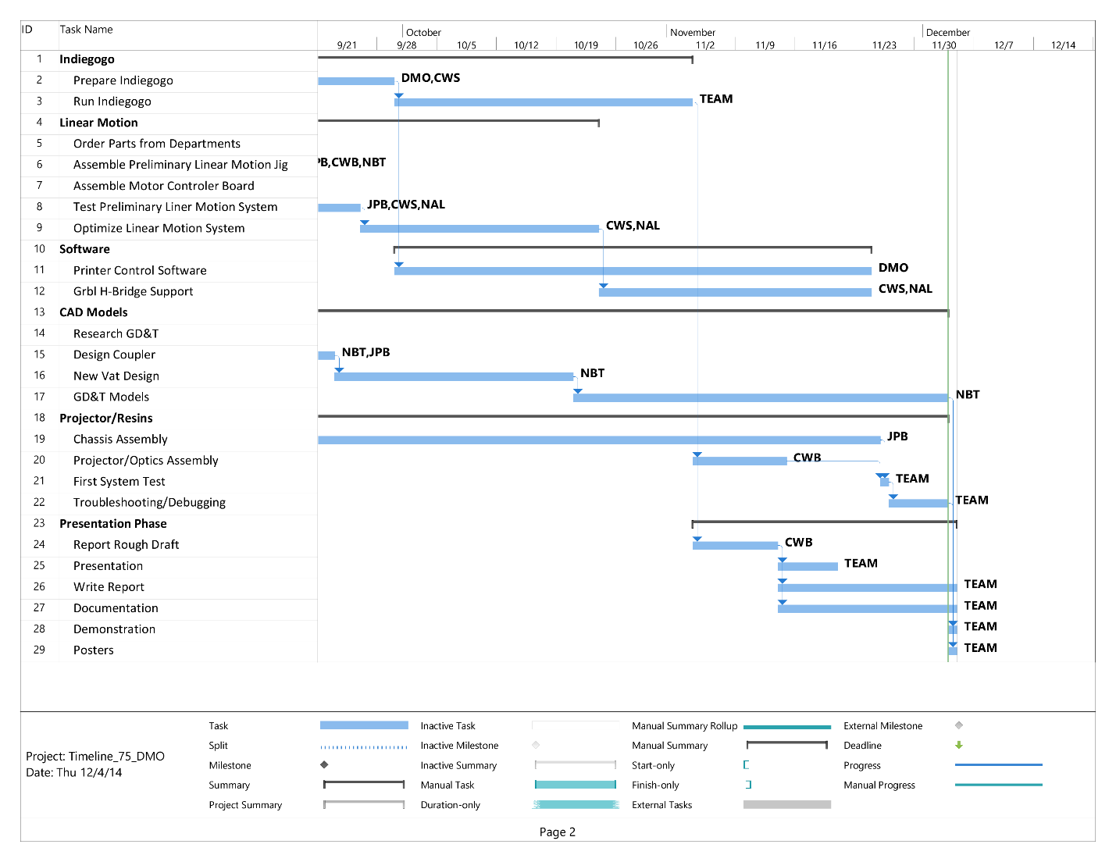

## Bill of Materials

## CAD Models

## MakerJuice G+ Safety Data Sheet

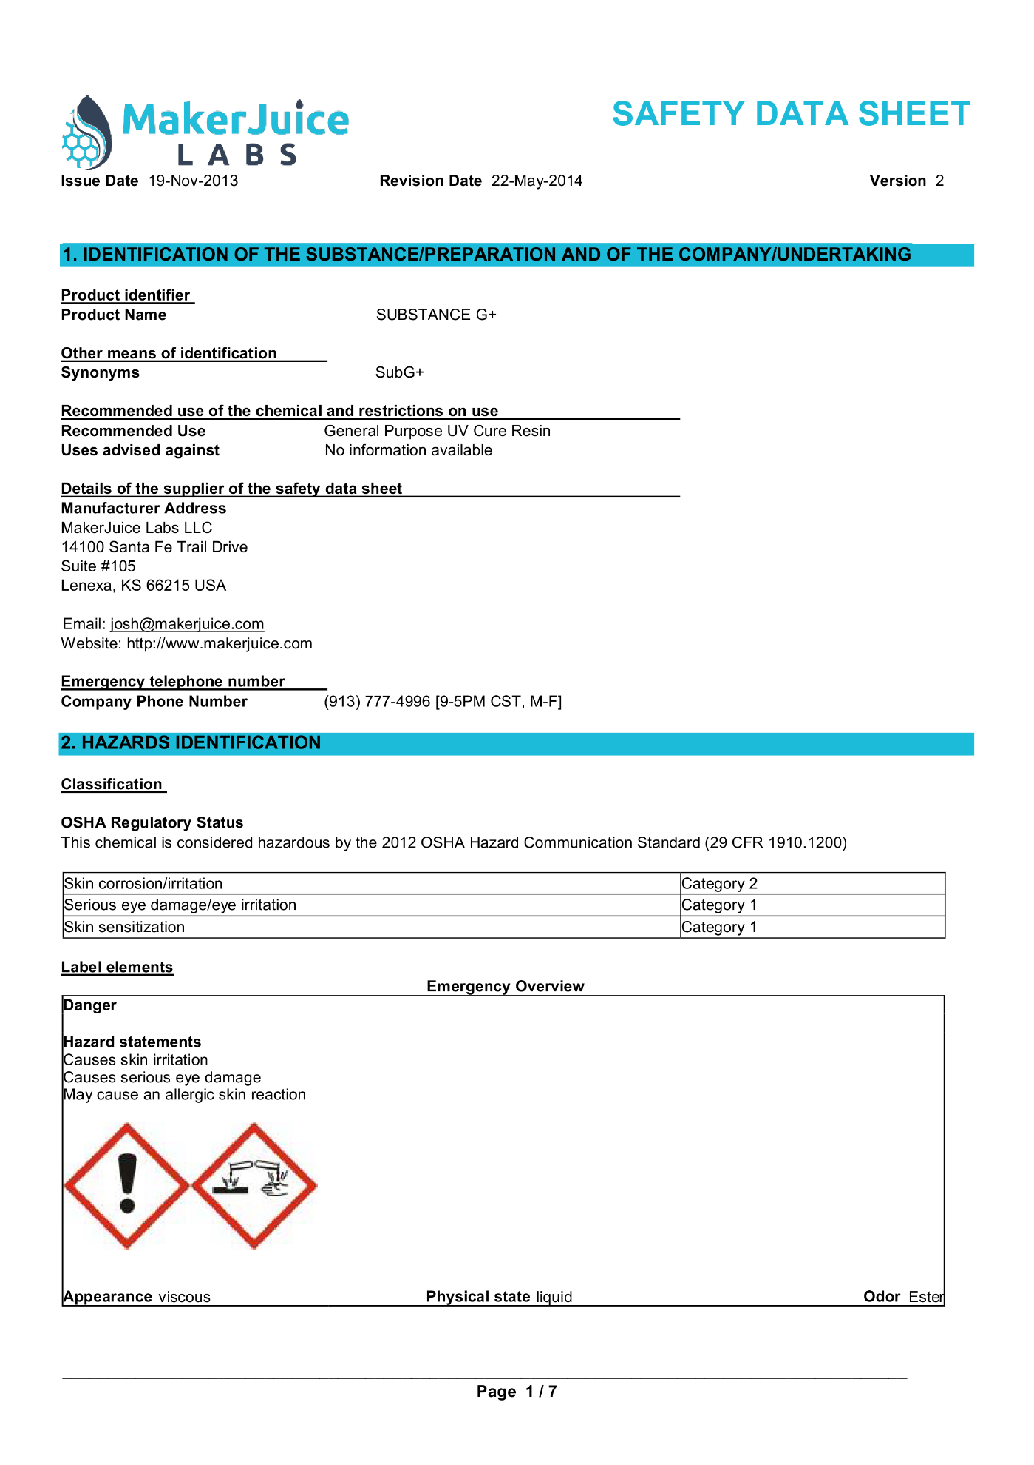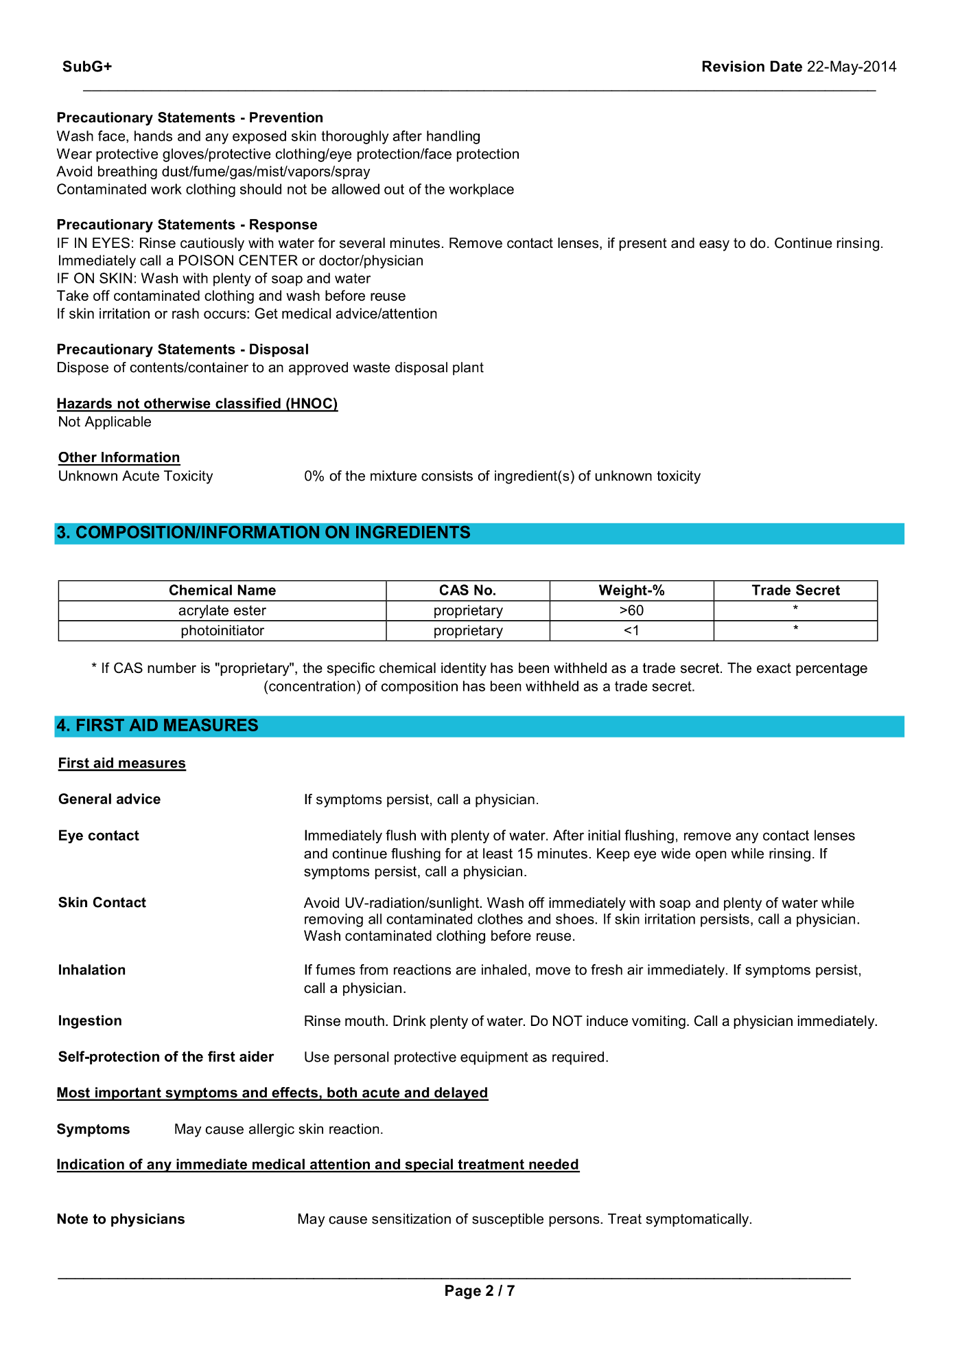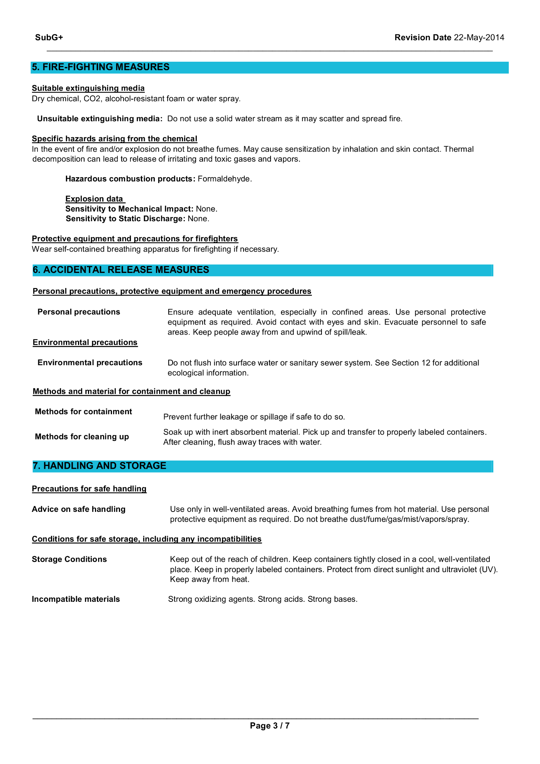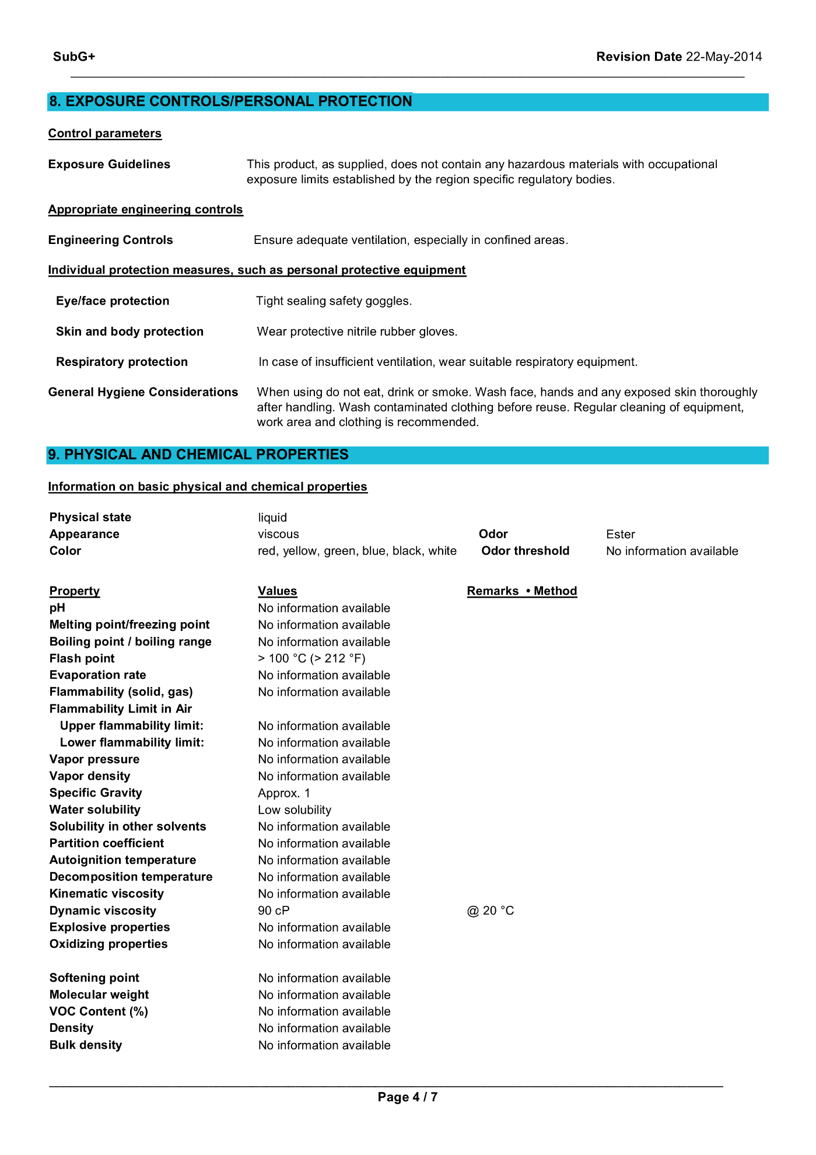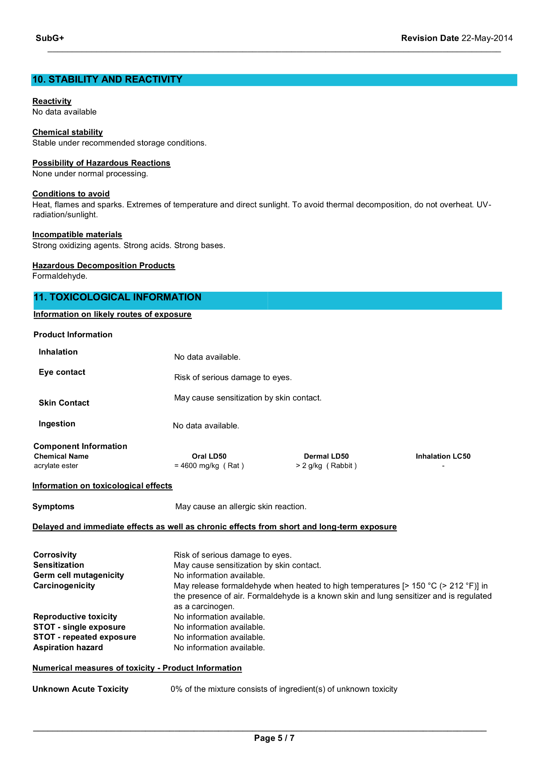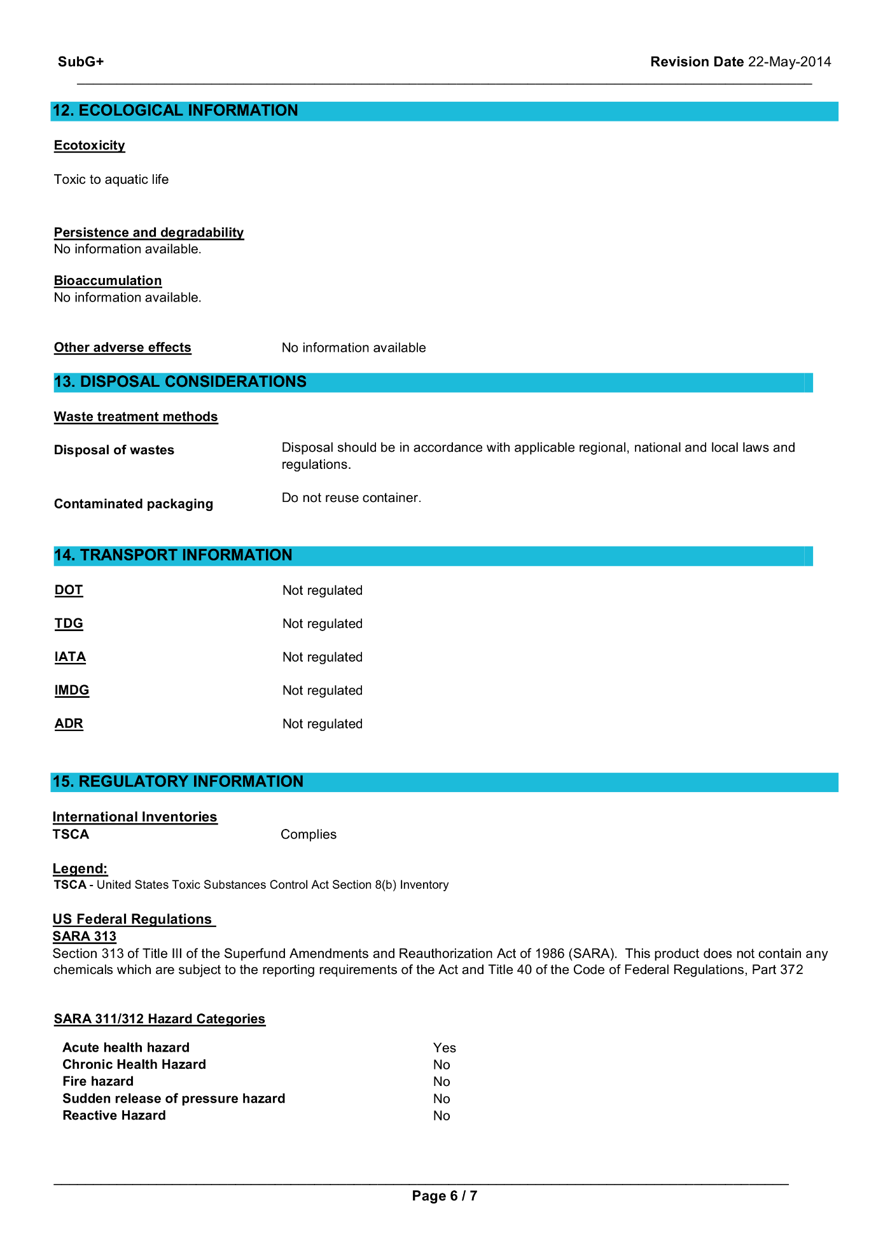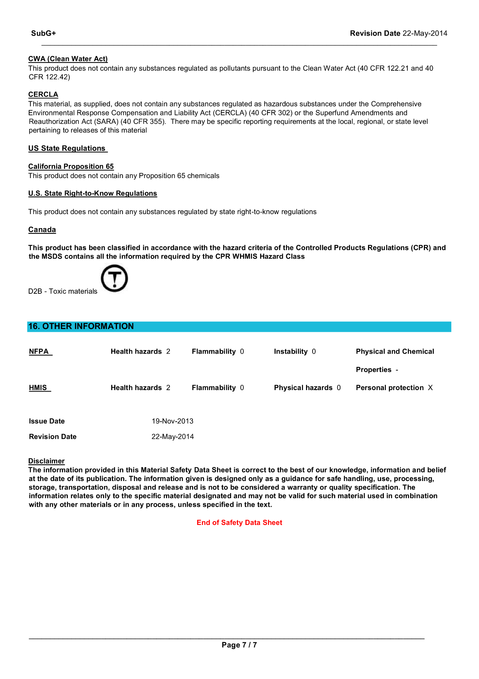

## MakerJuice G+ Techincal Data Sheet

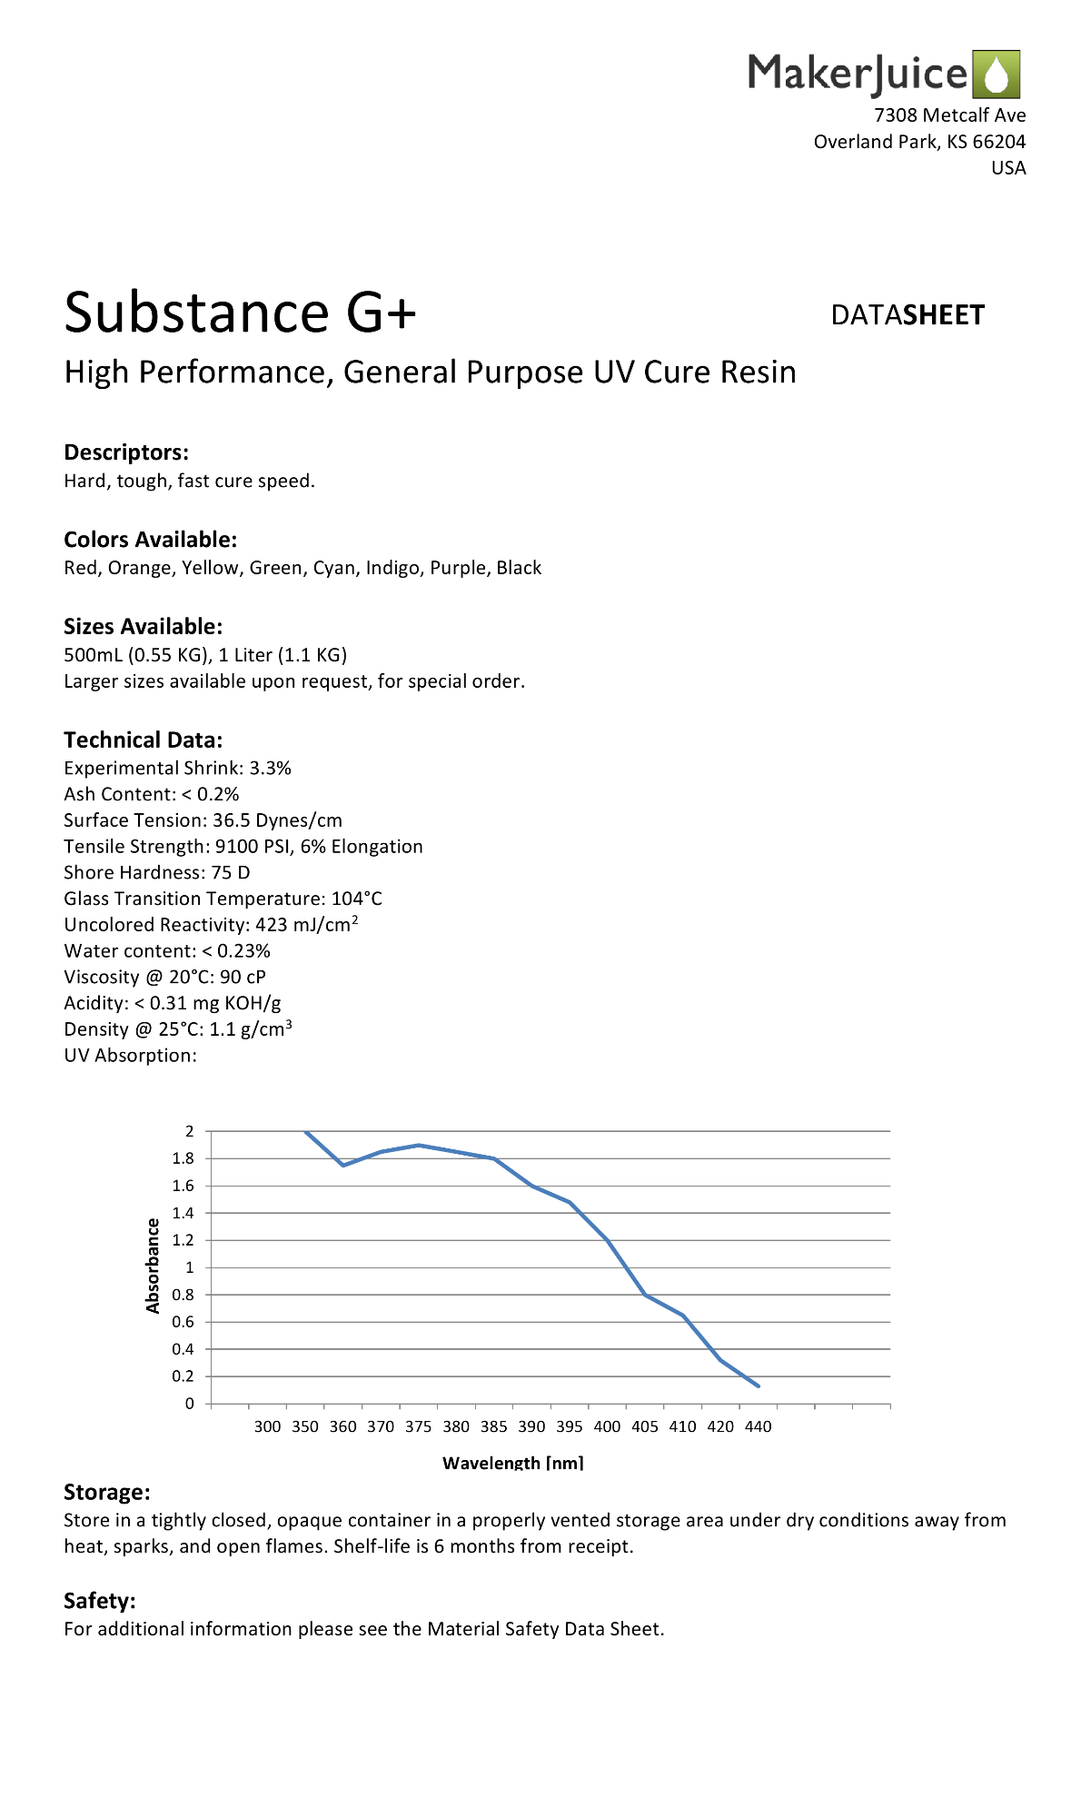

## Website (GitHub Pages)

### Home Page

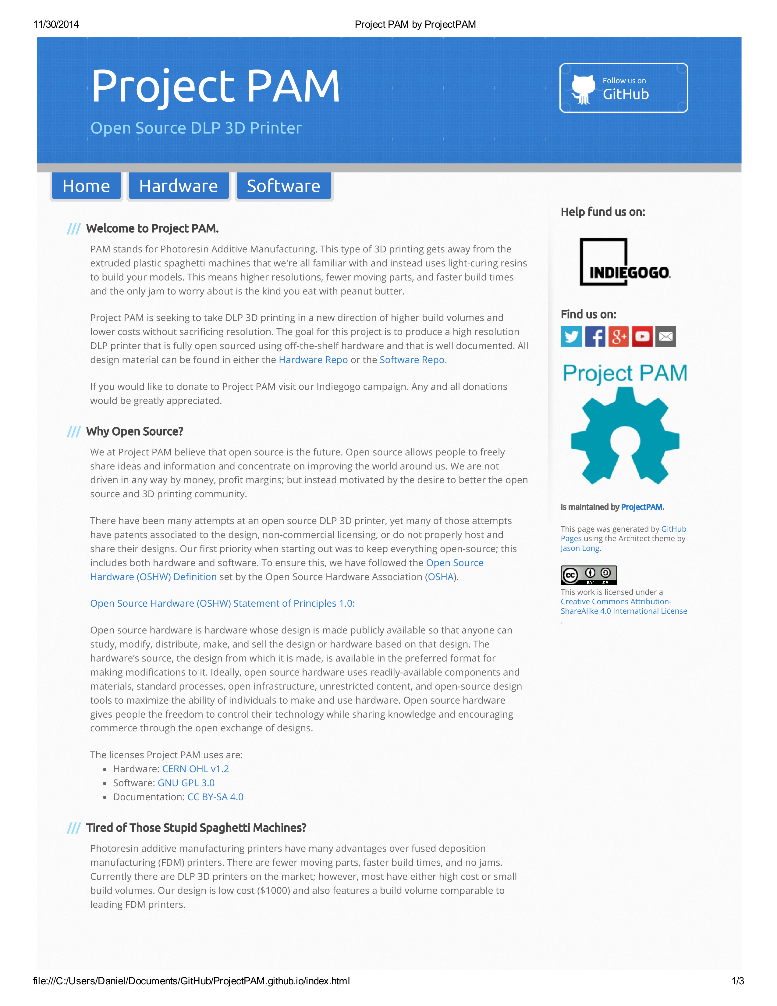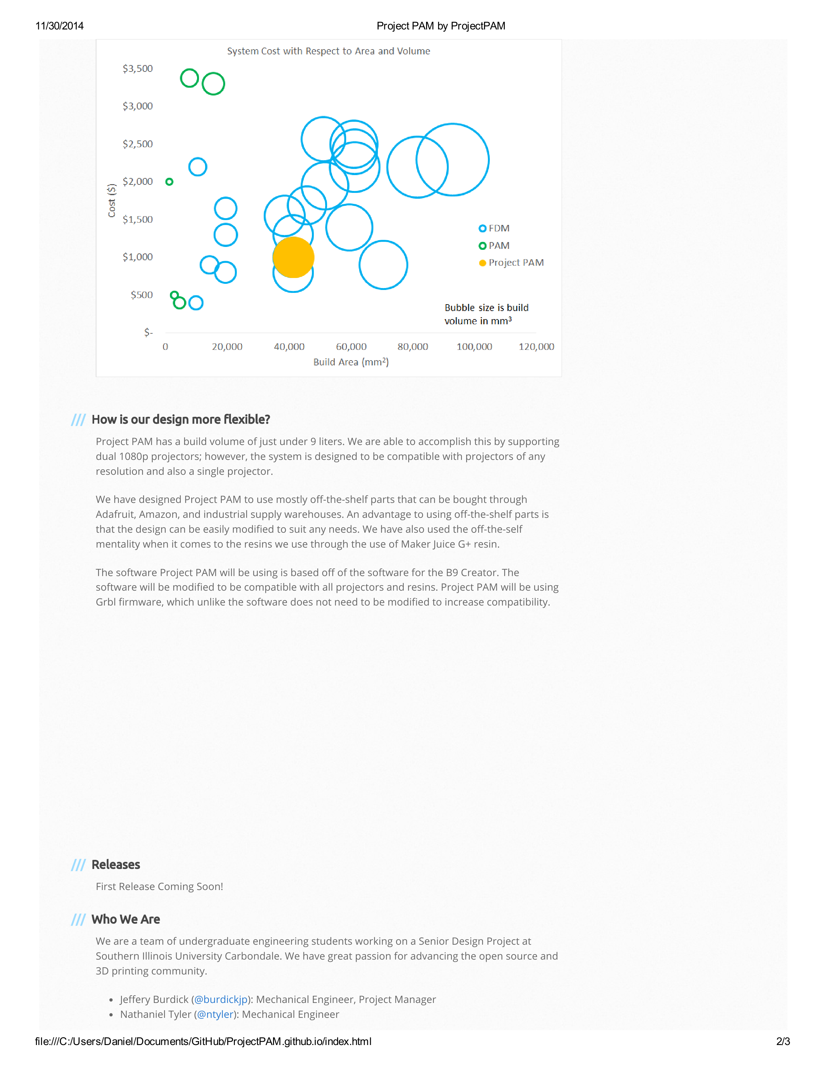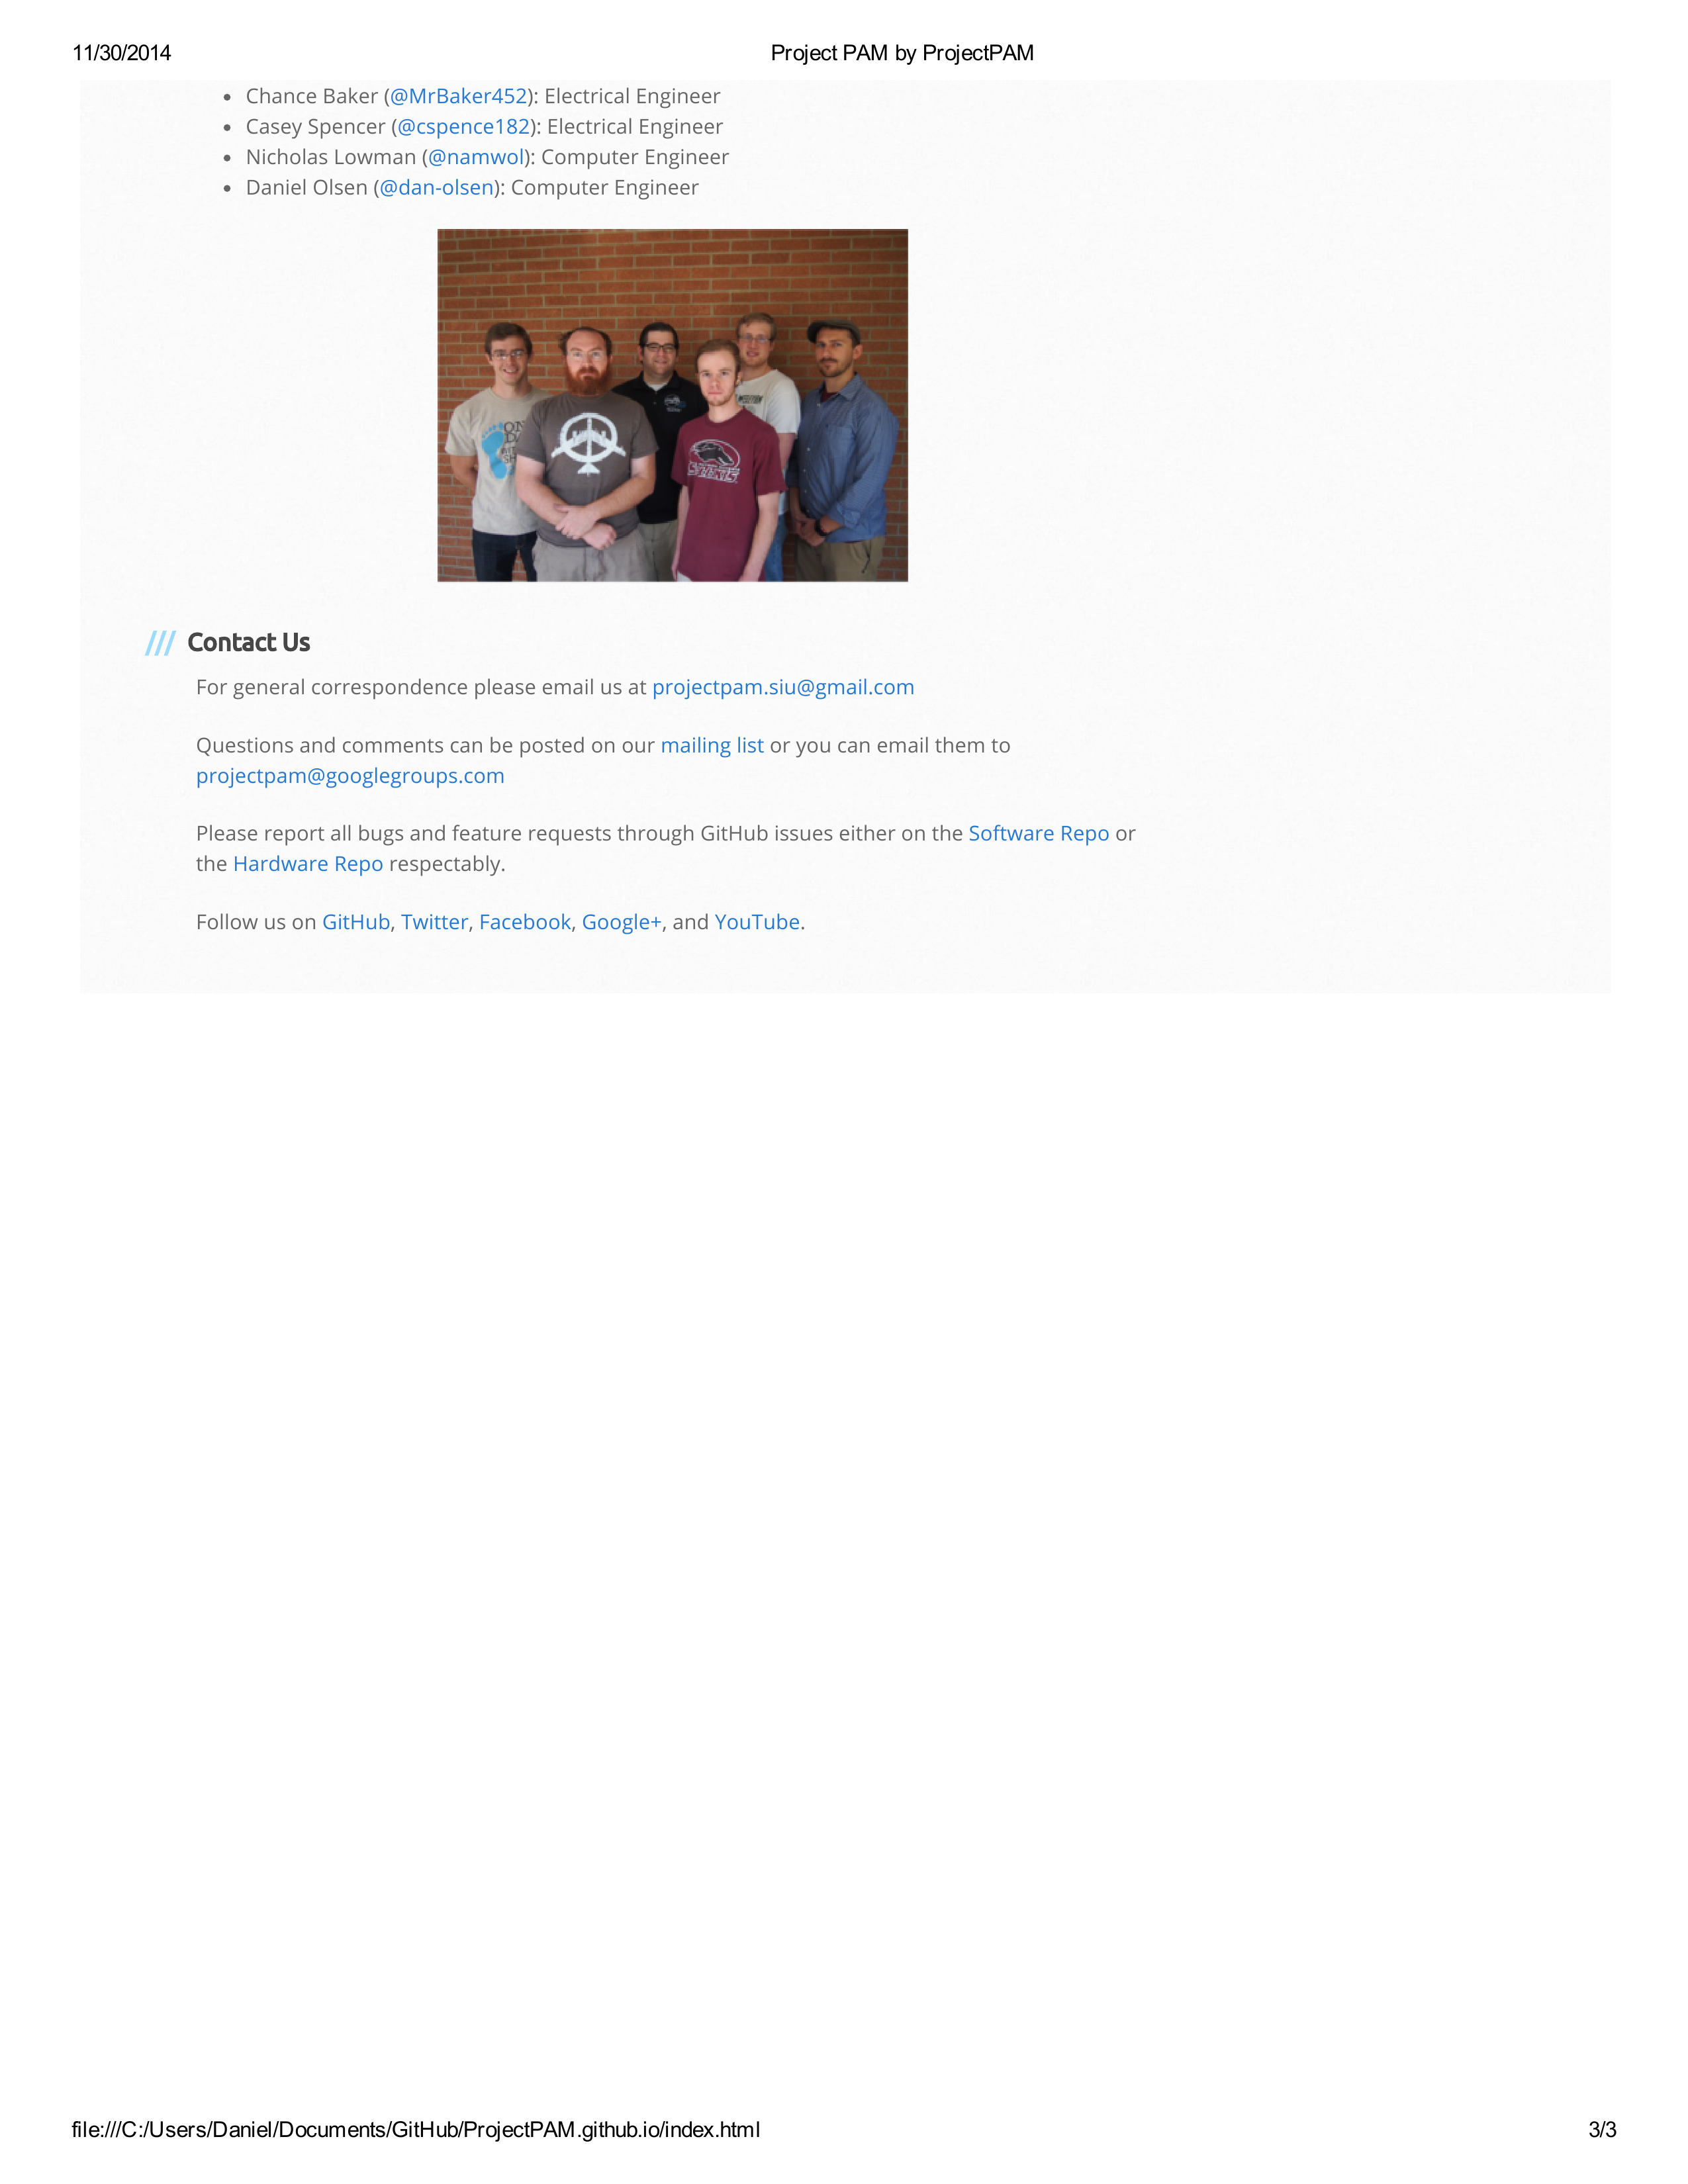

### Hardware Page

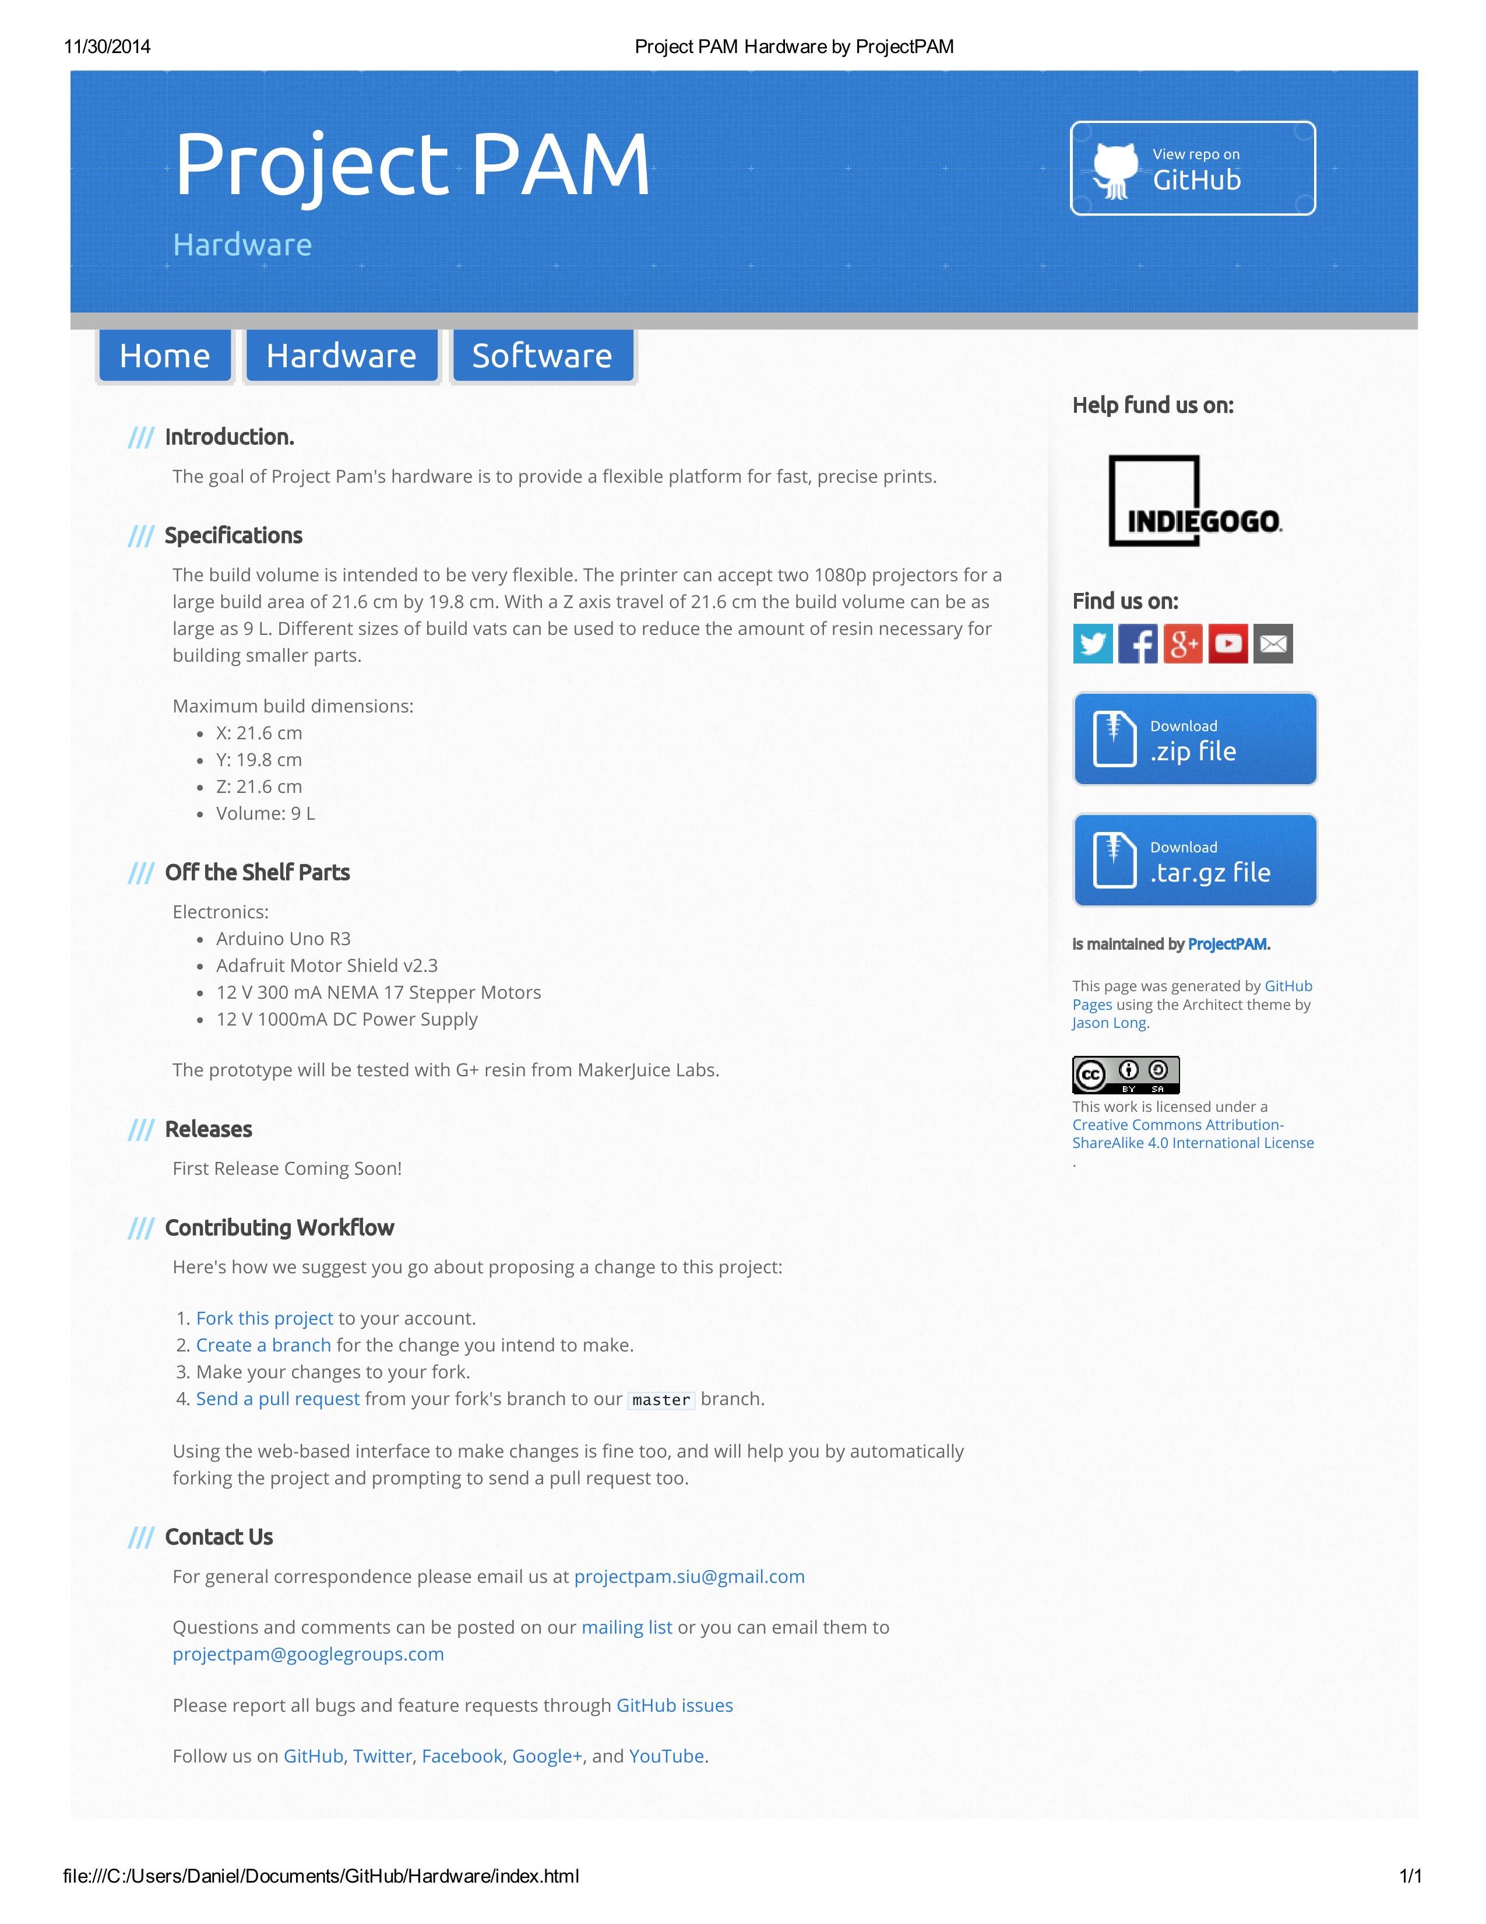

### Software Page

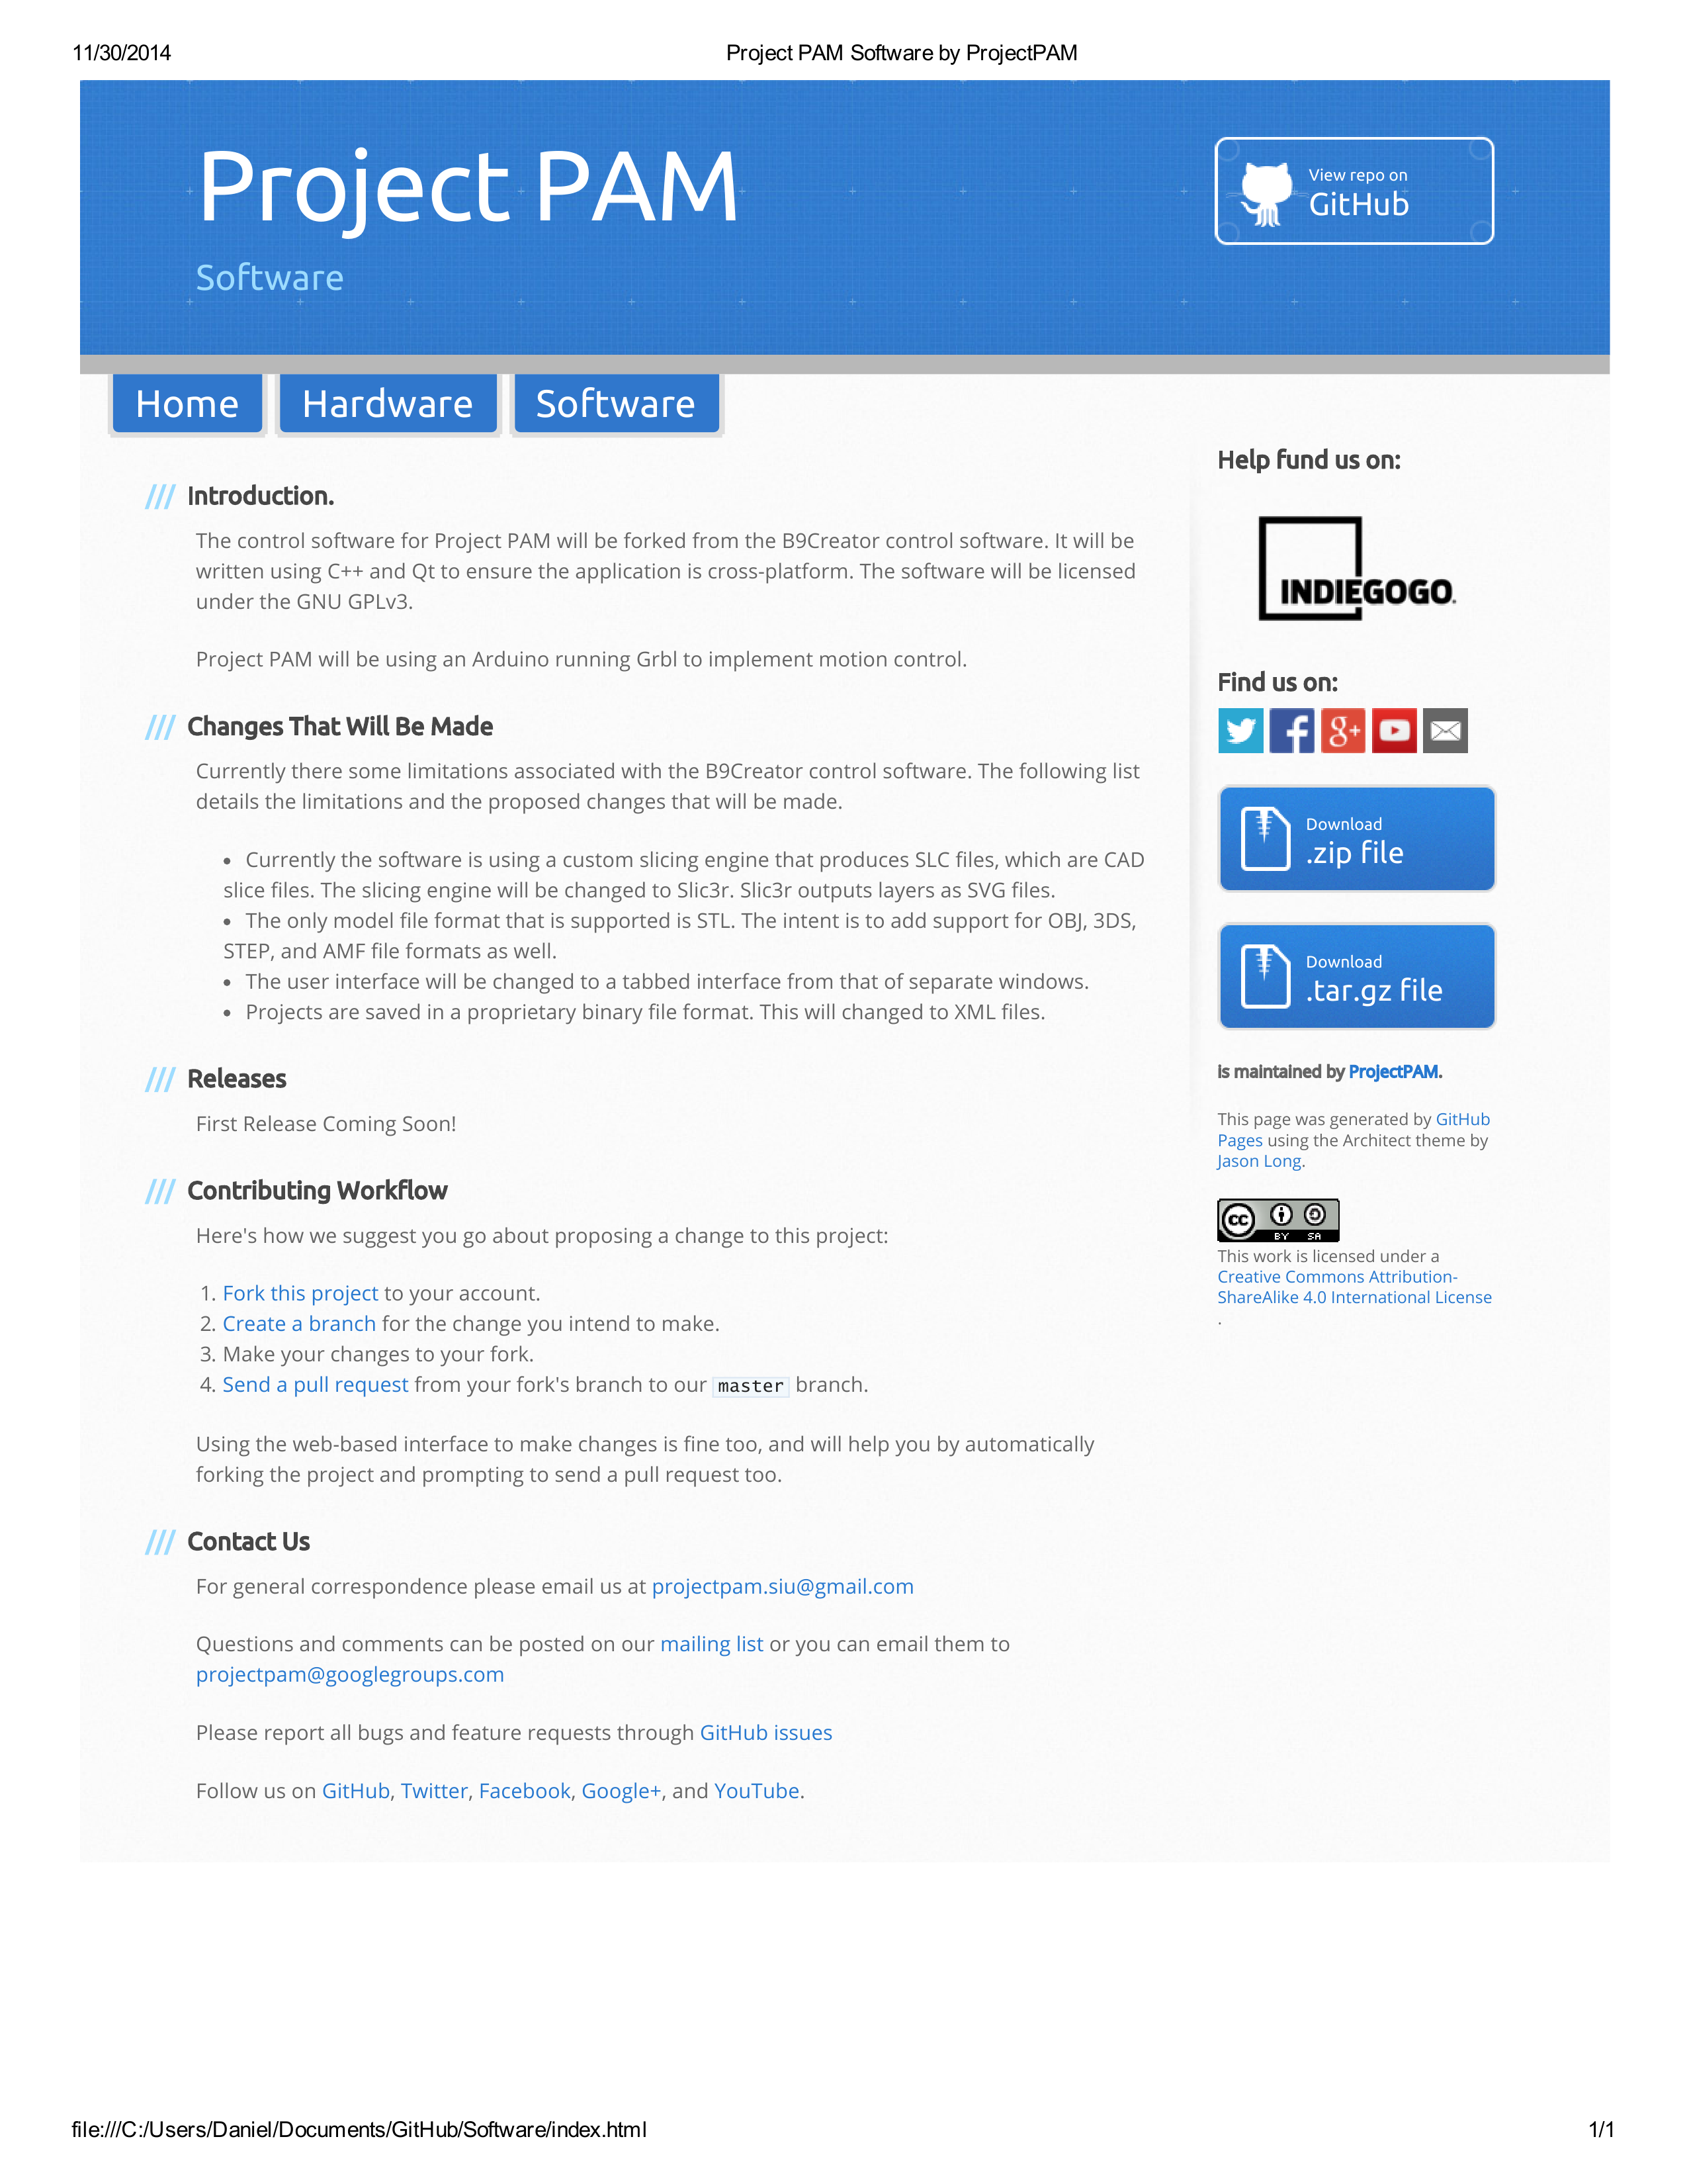

### Google Analytics Reports

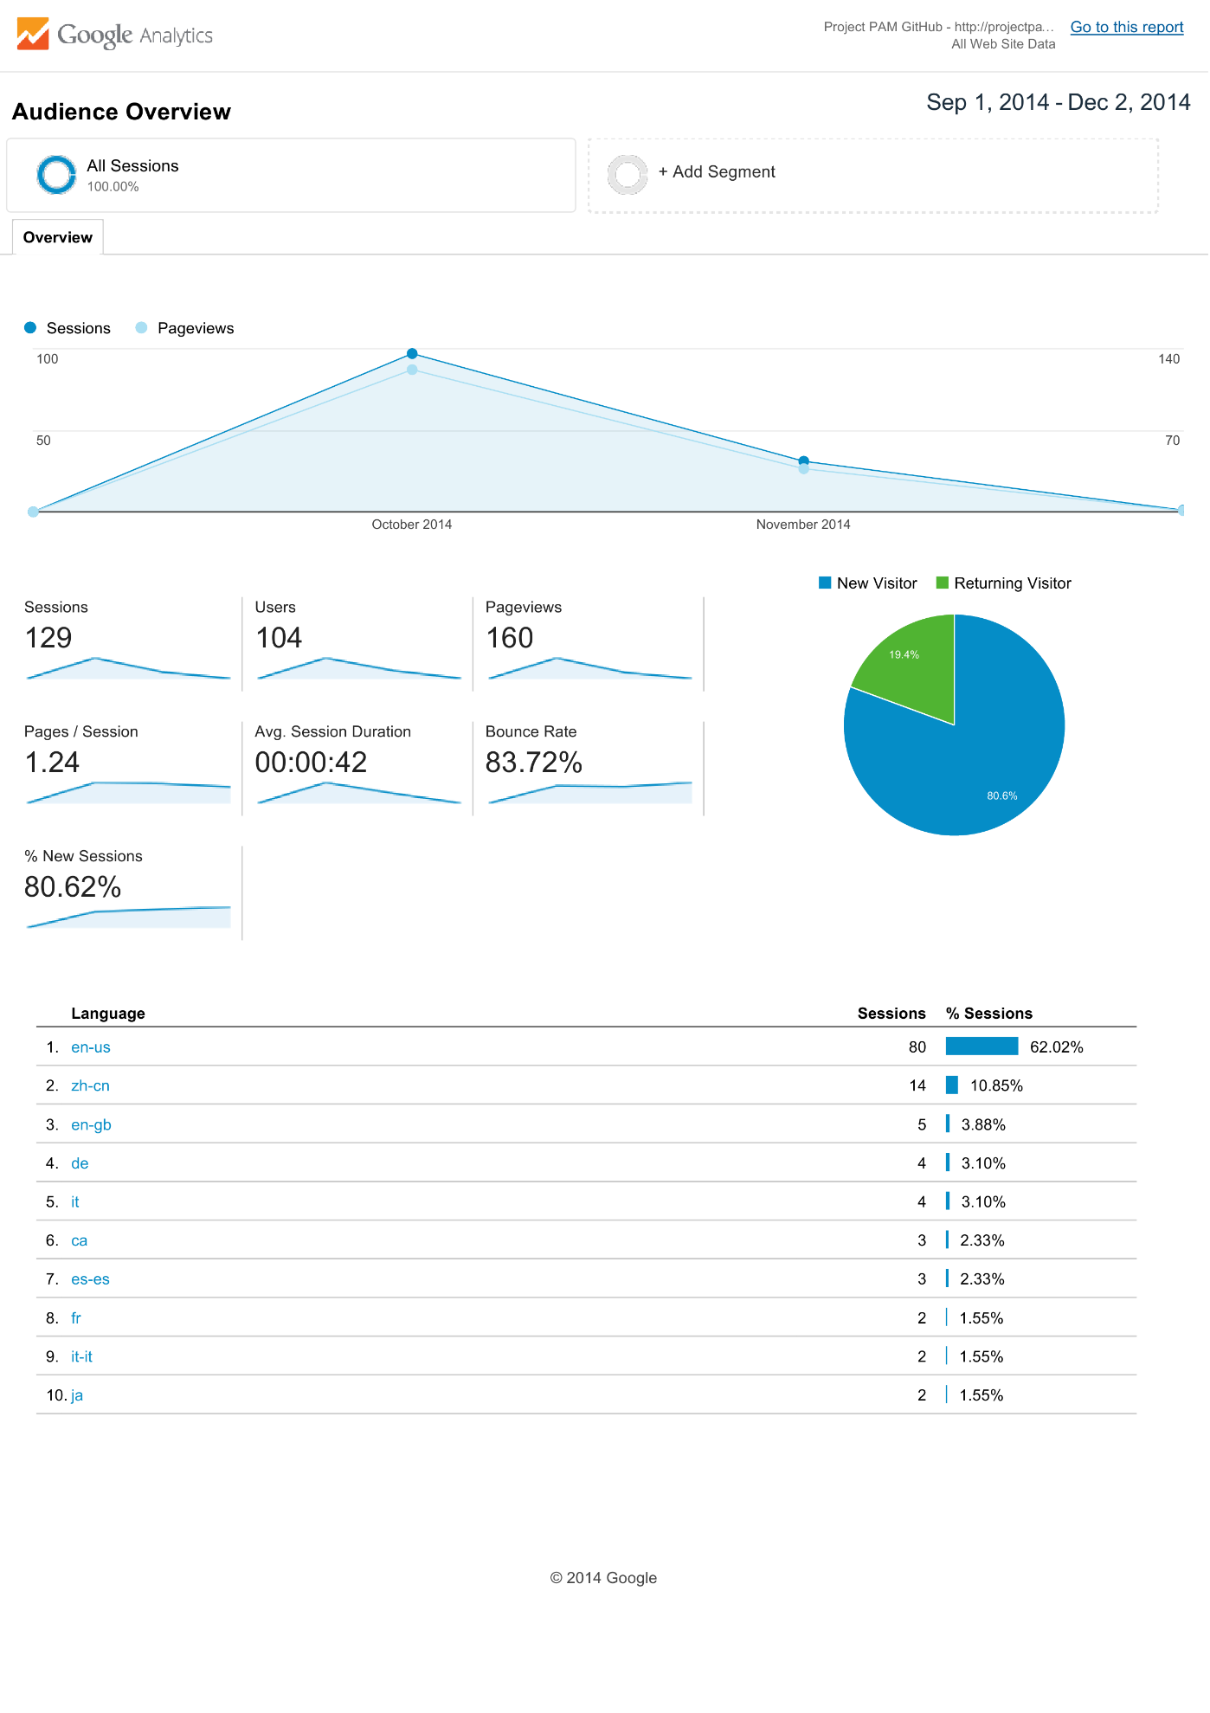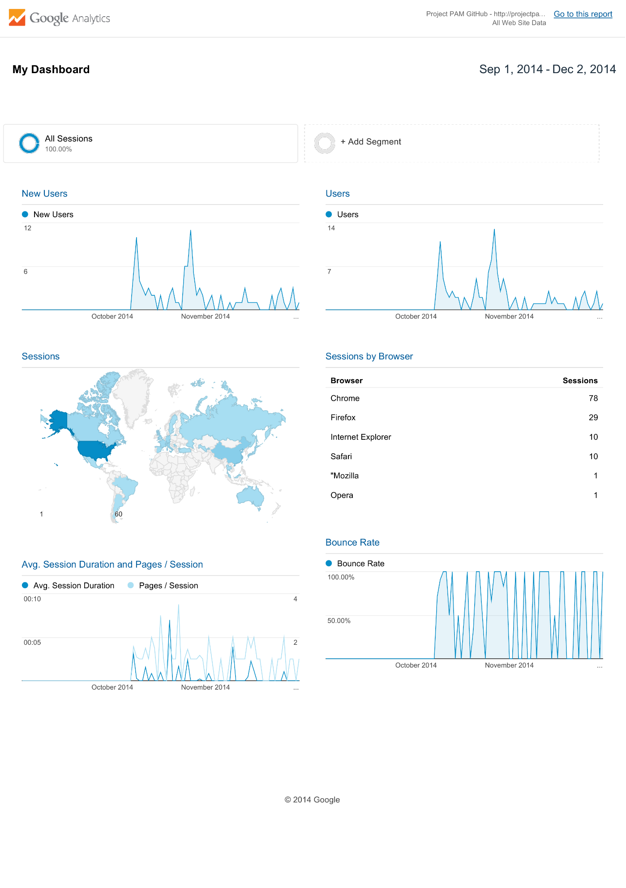

## Project PAM Prezi

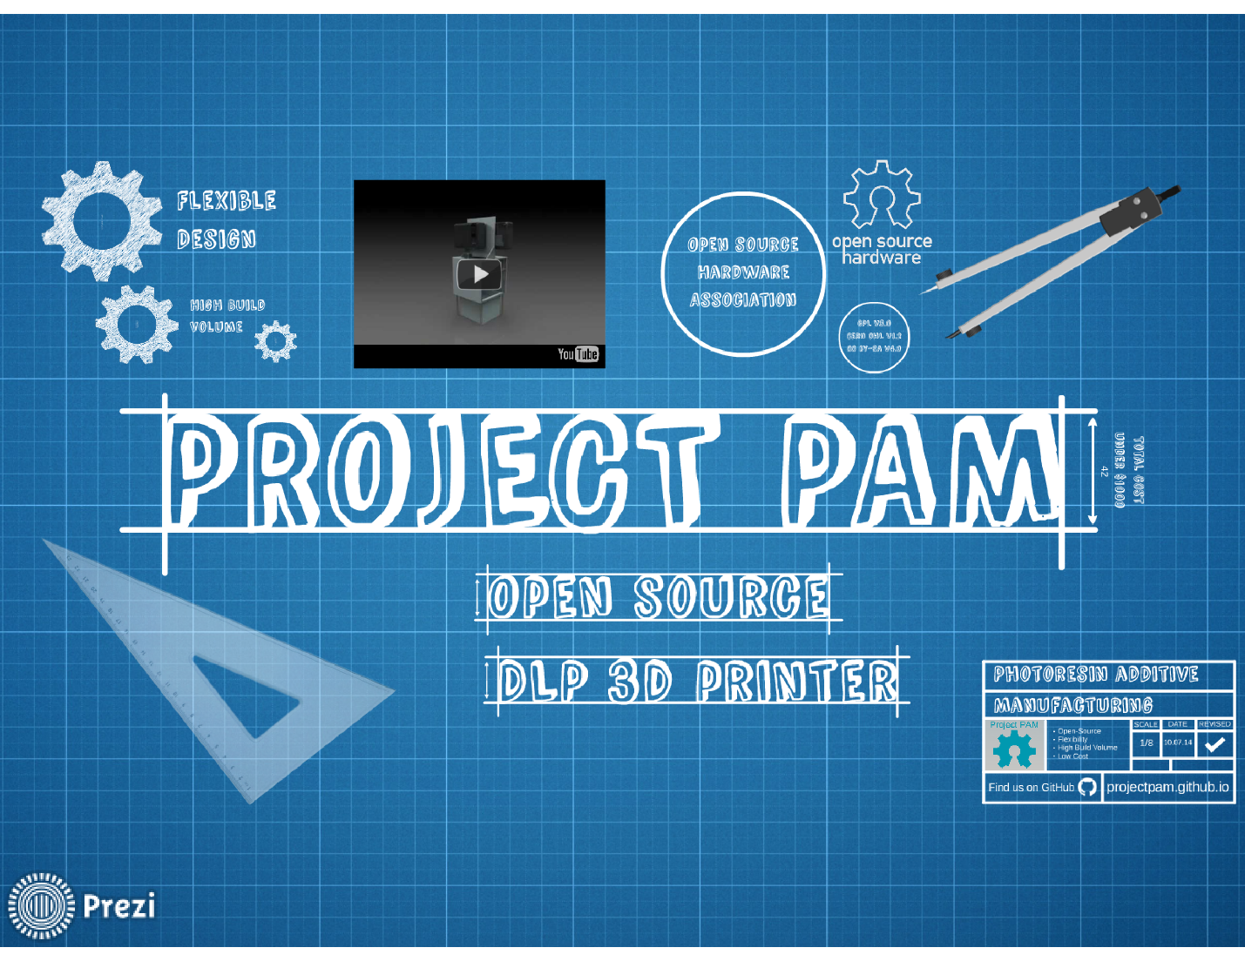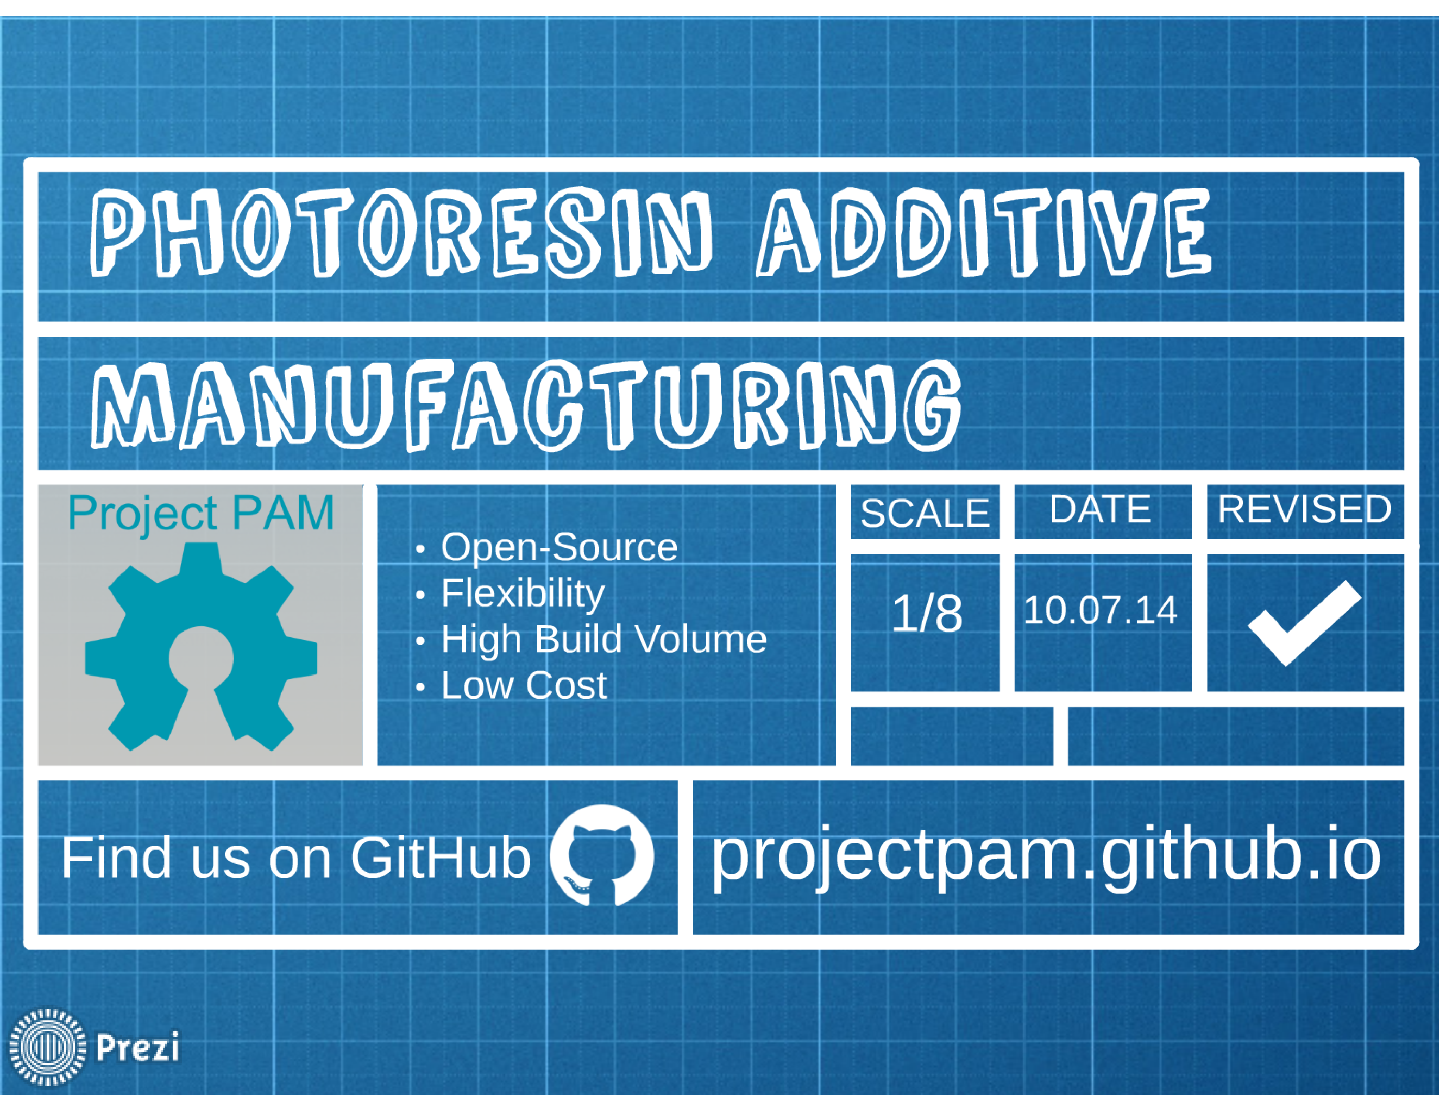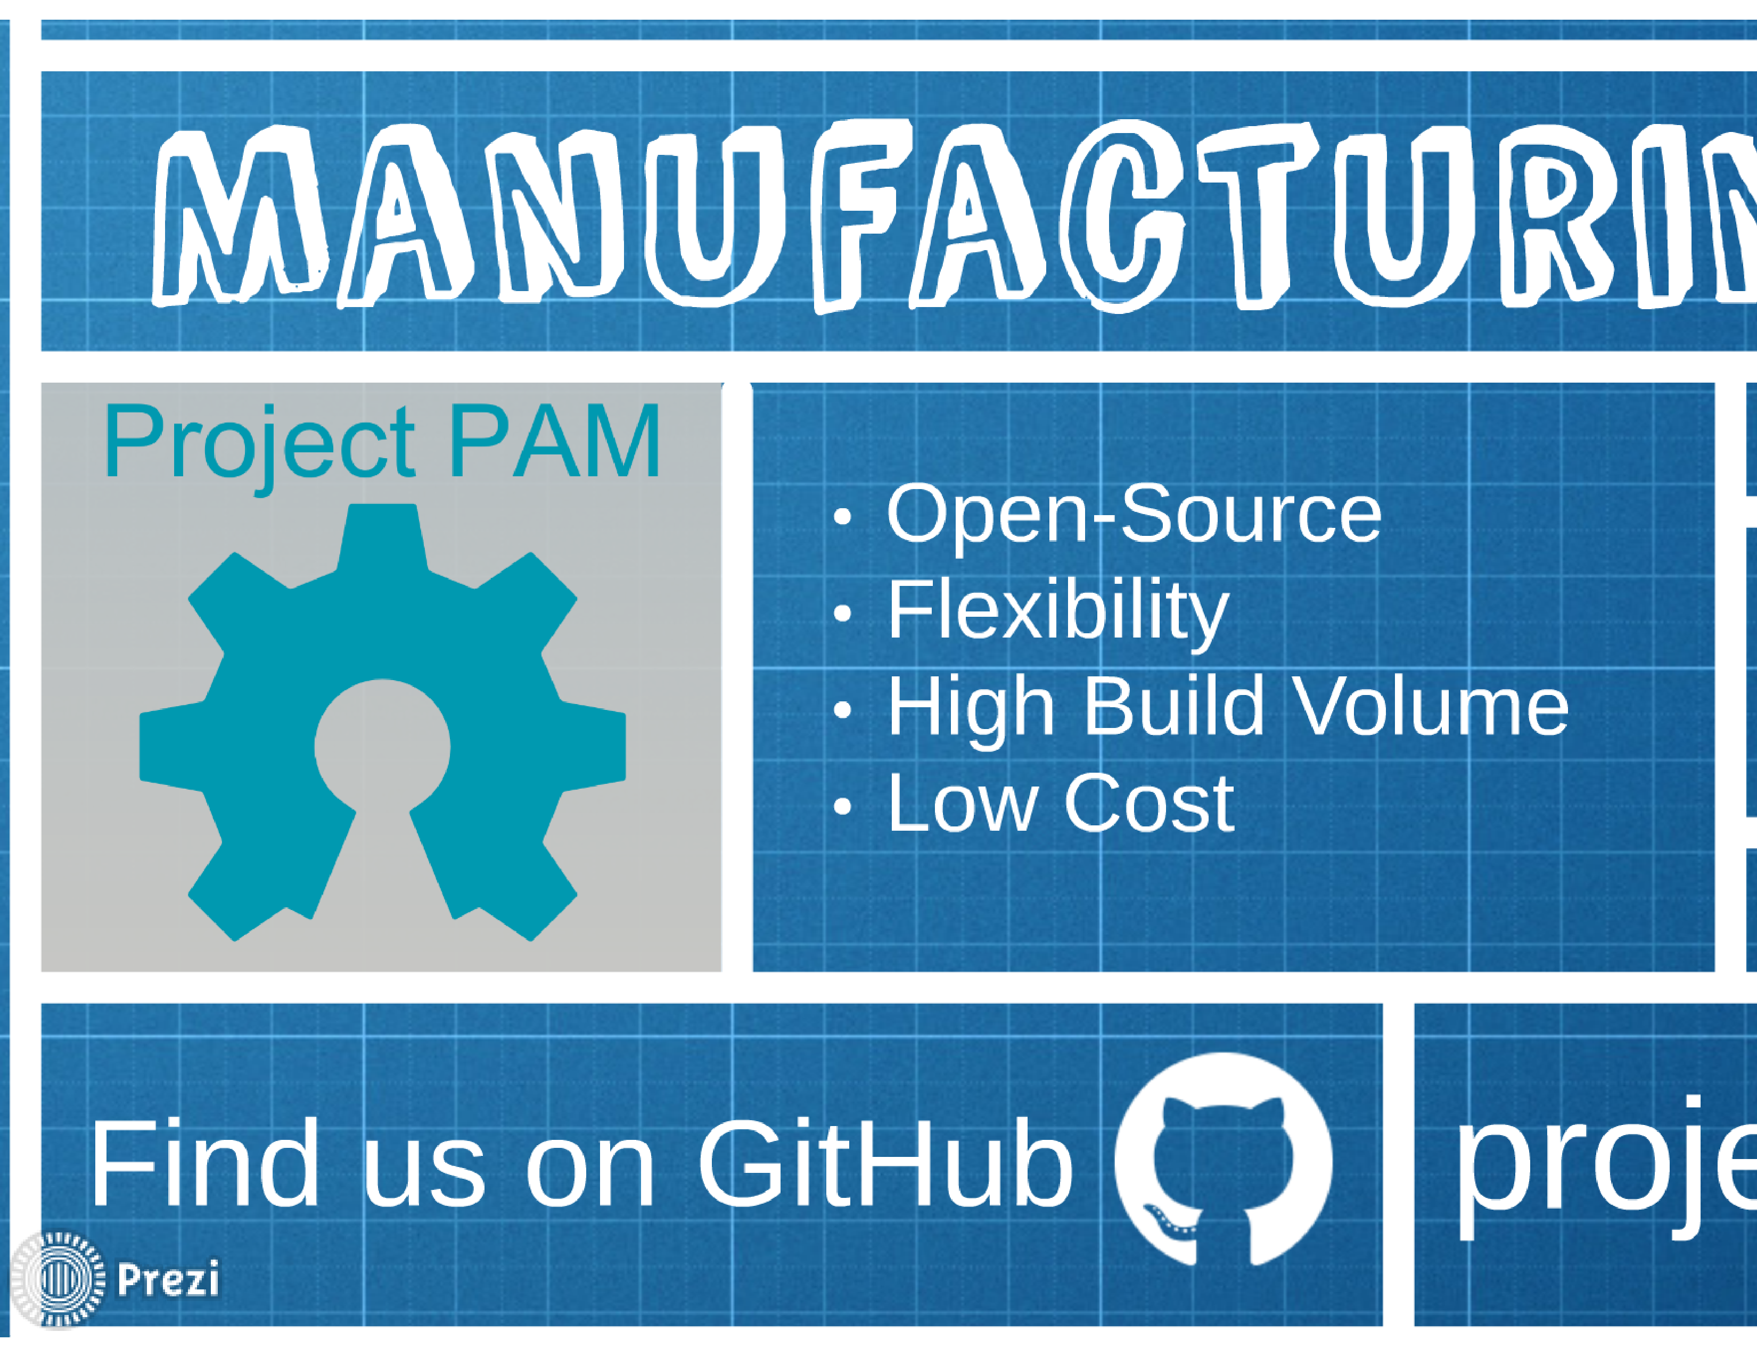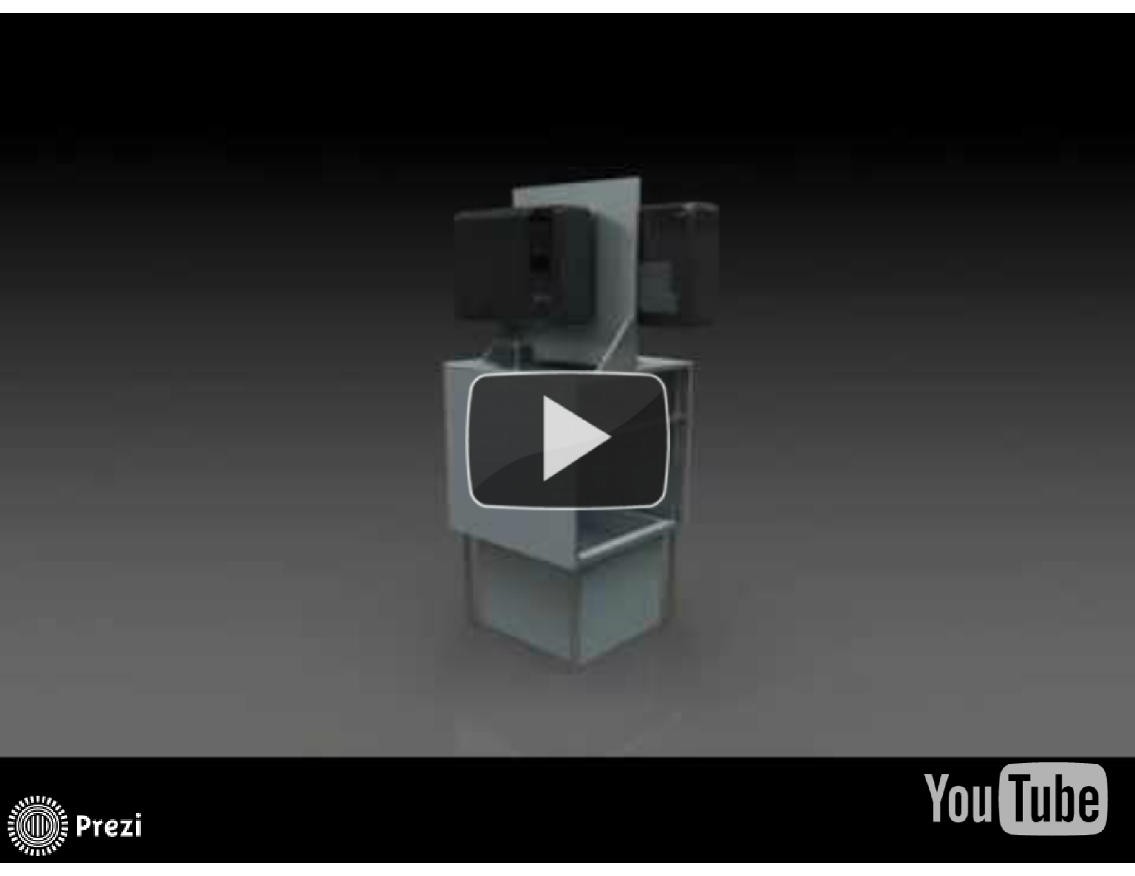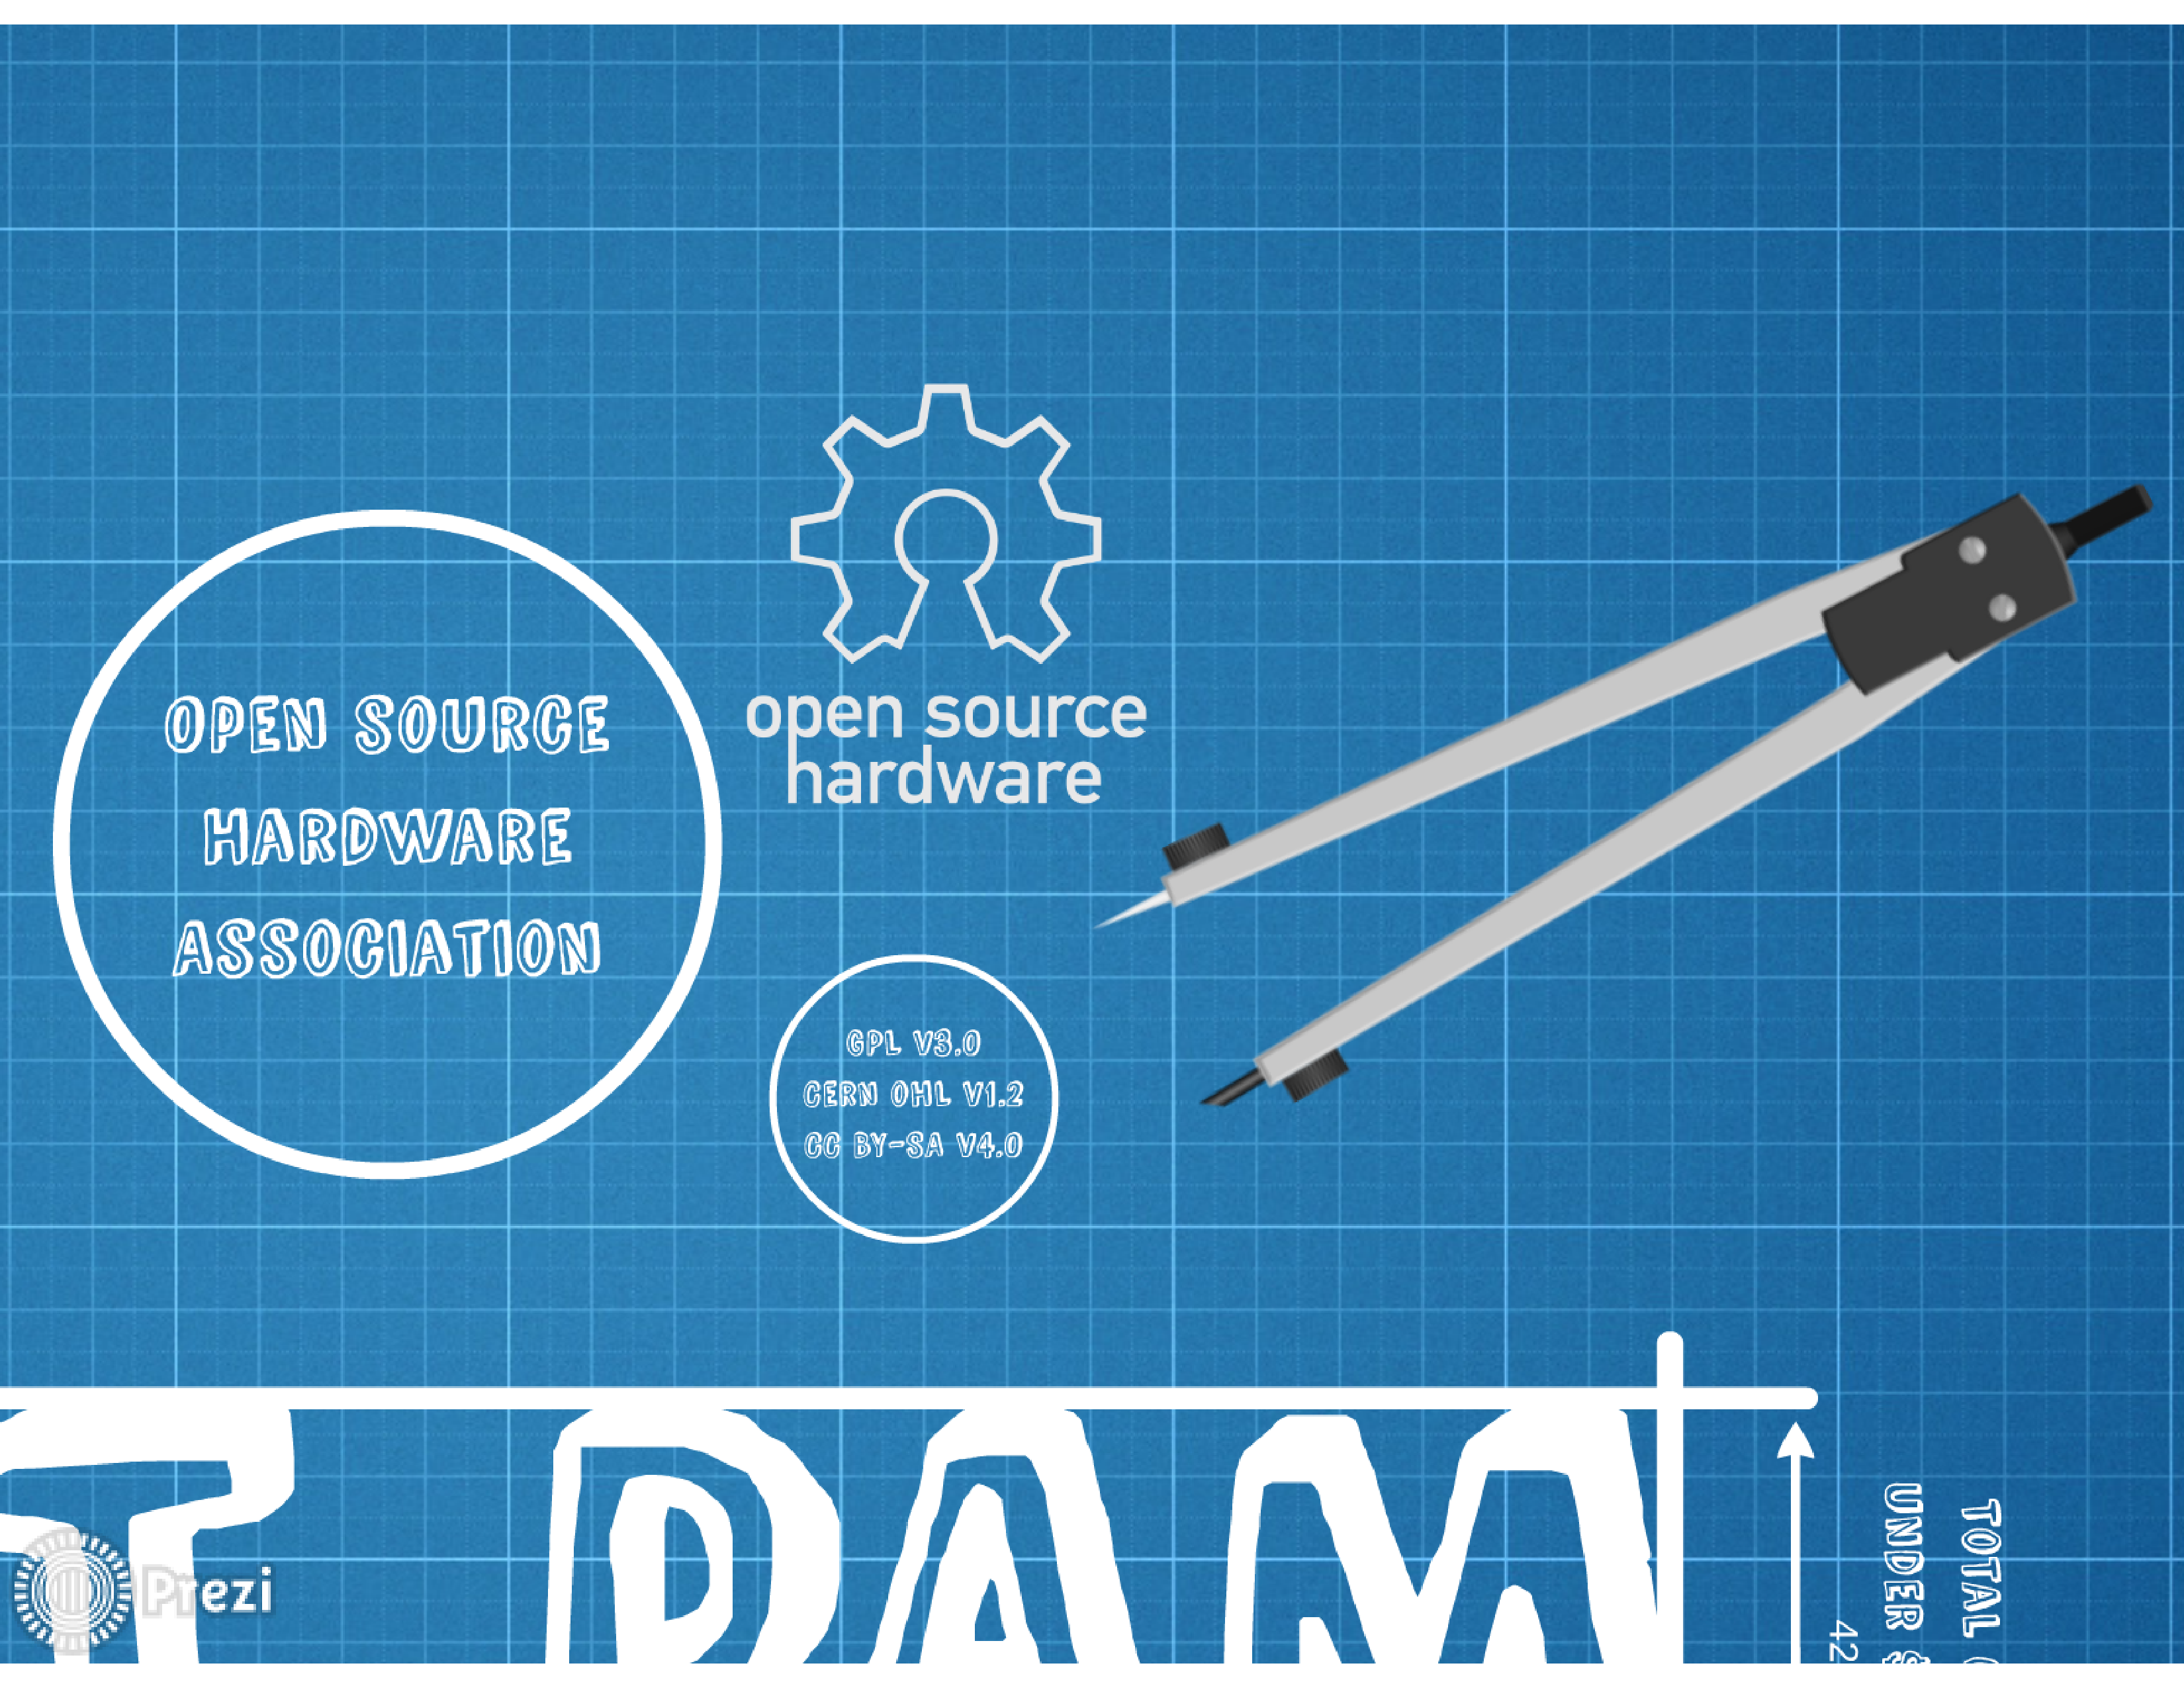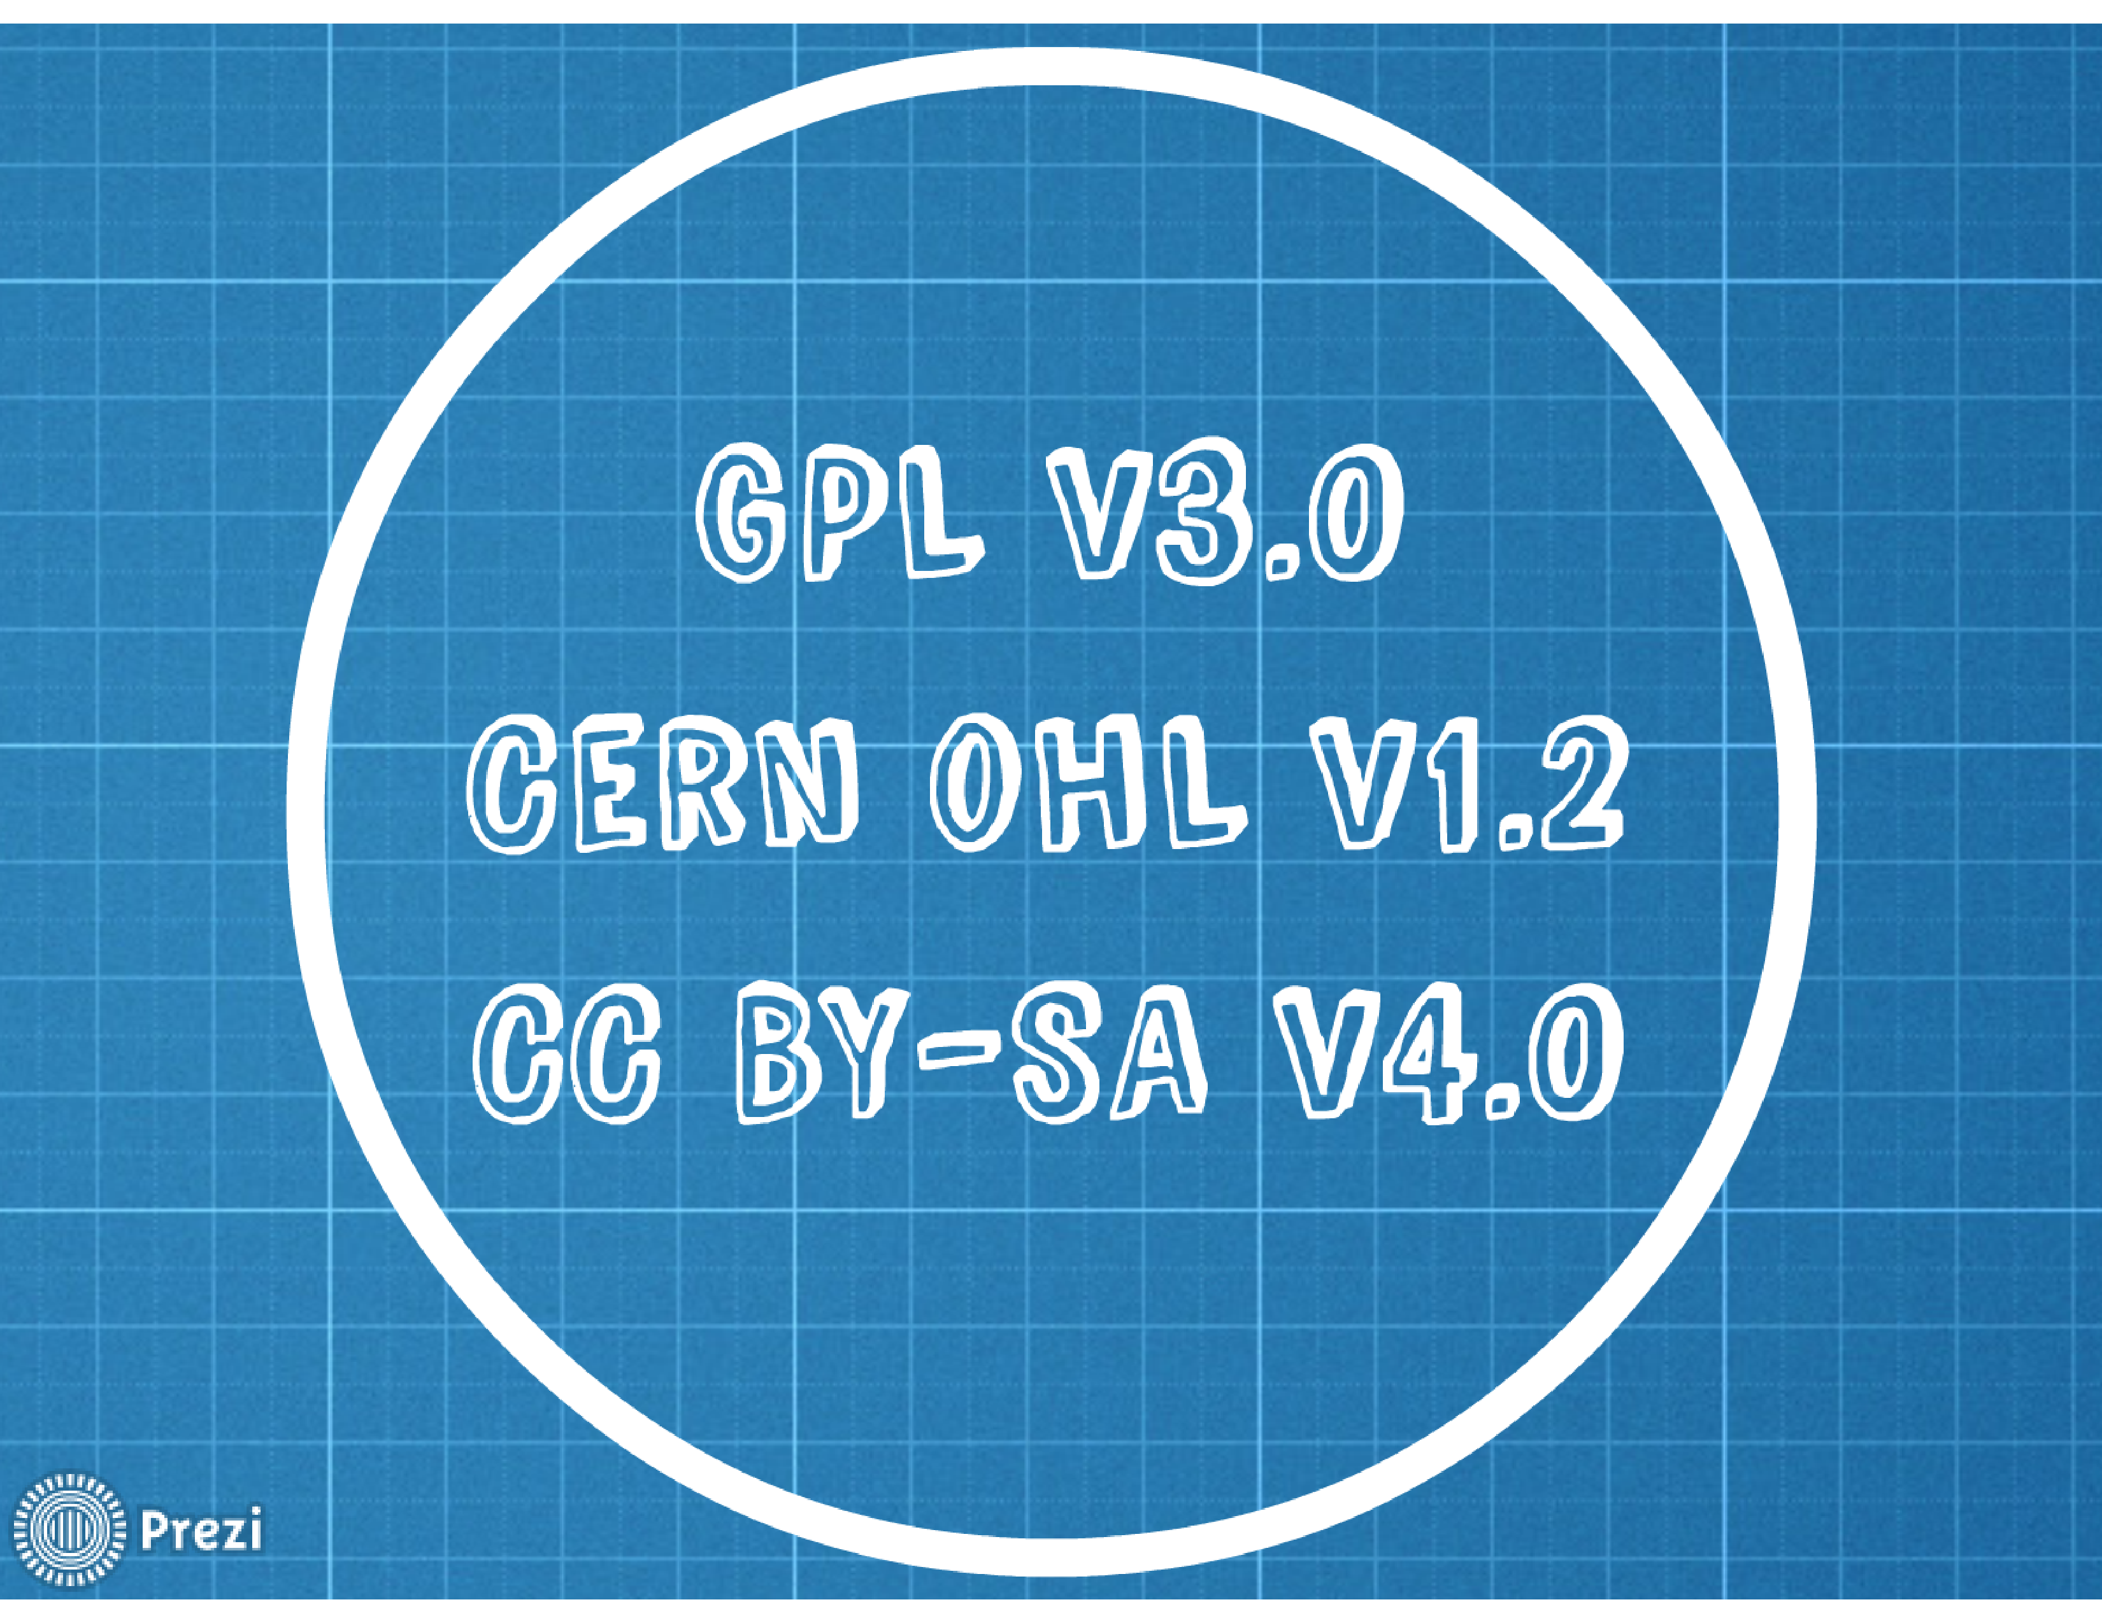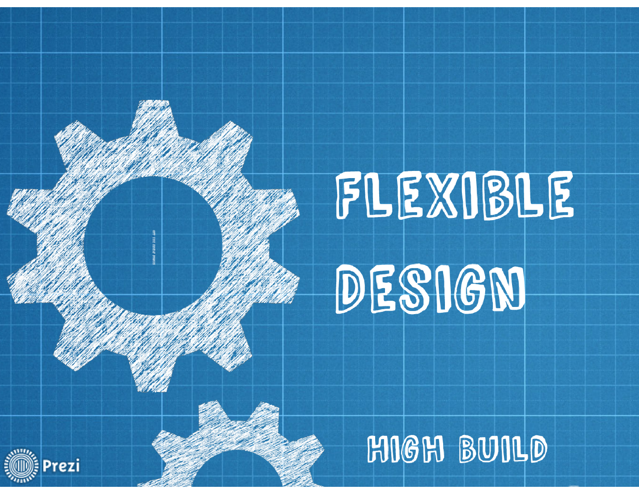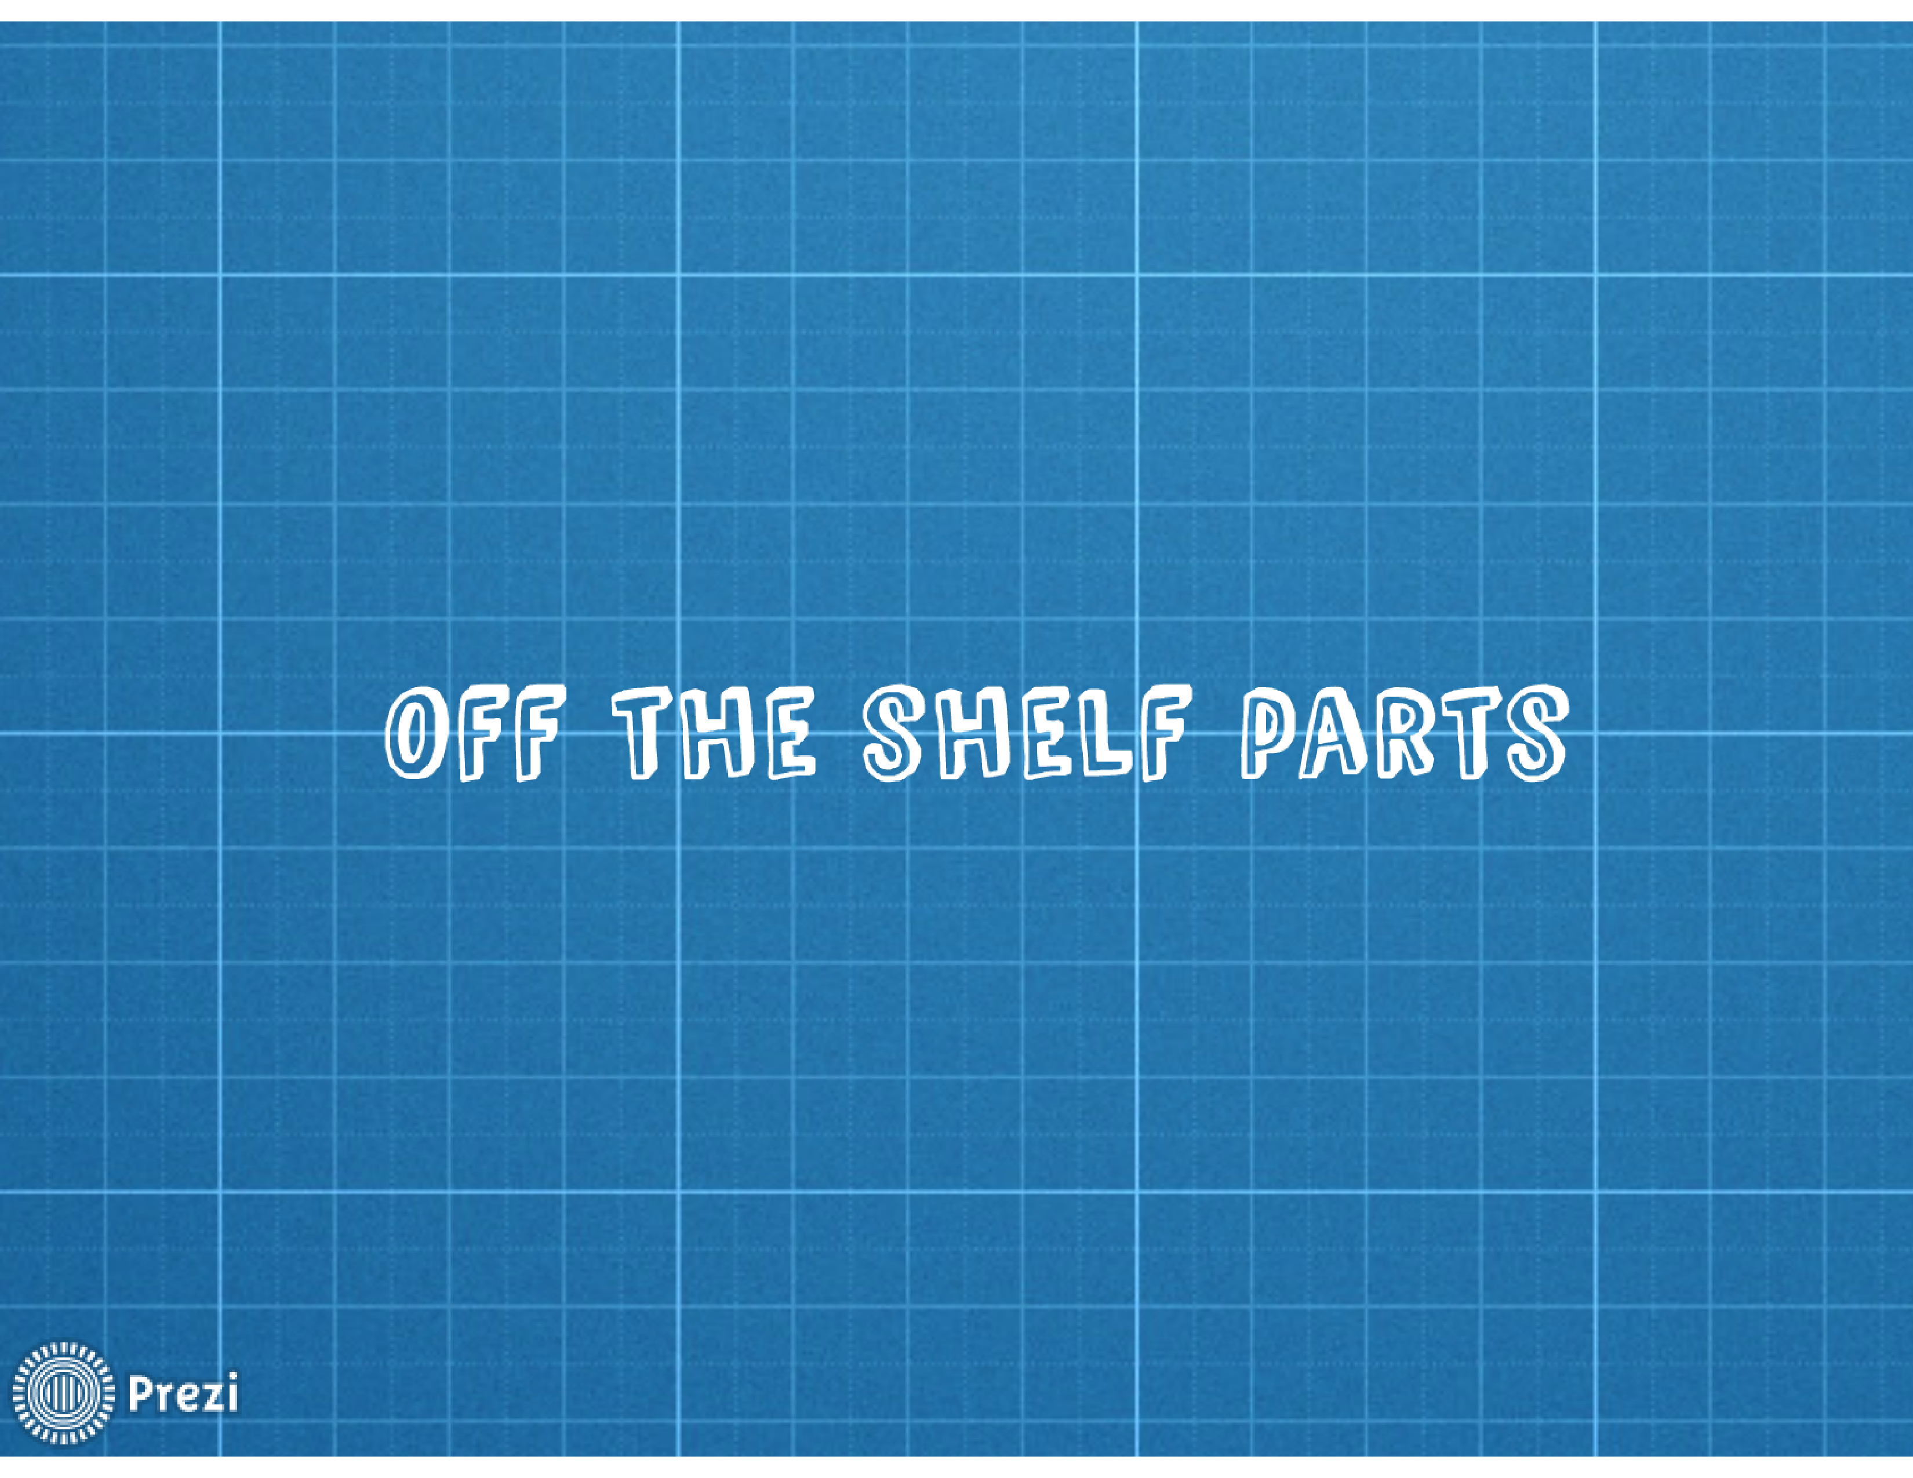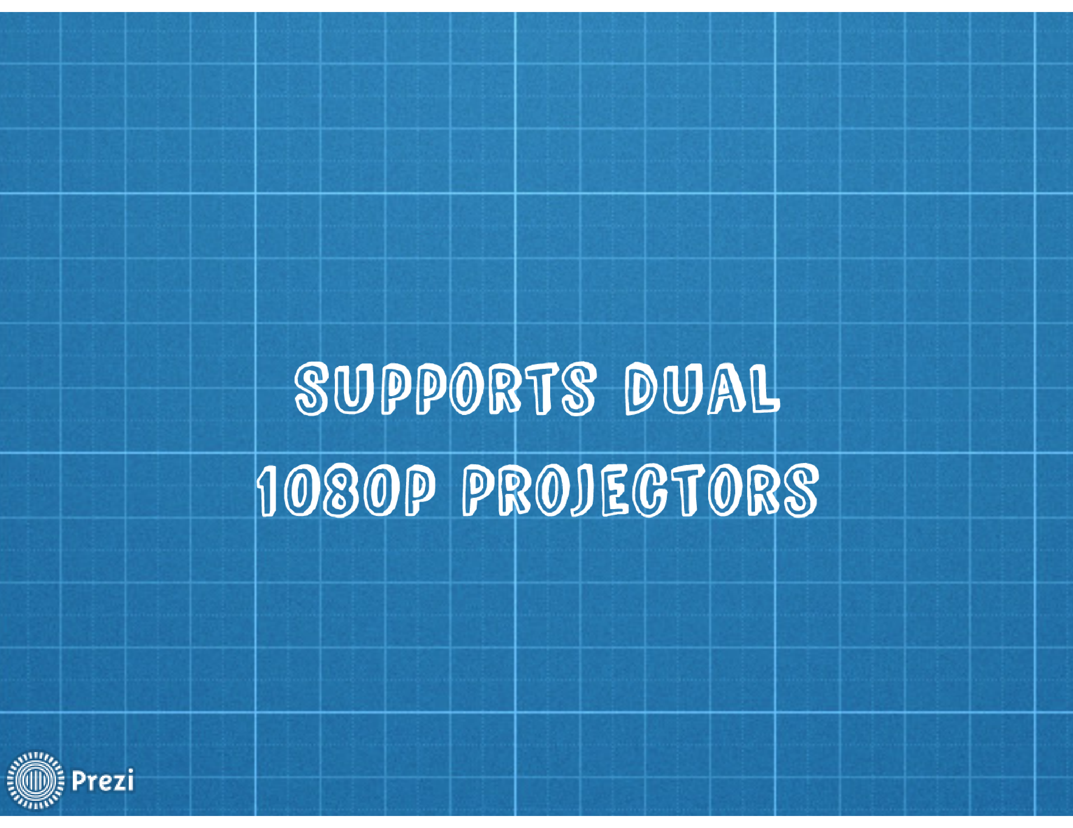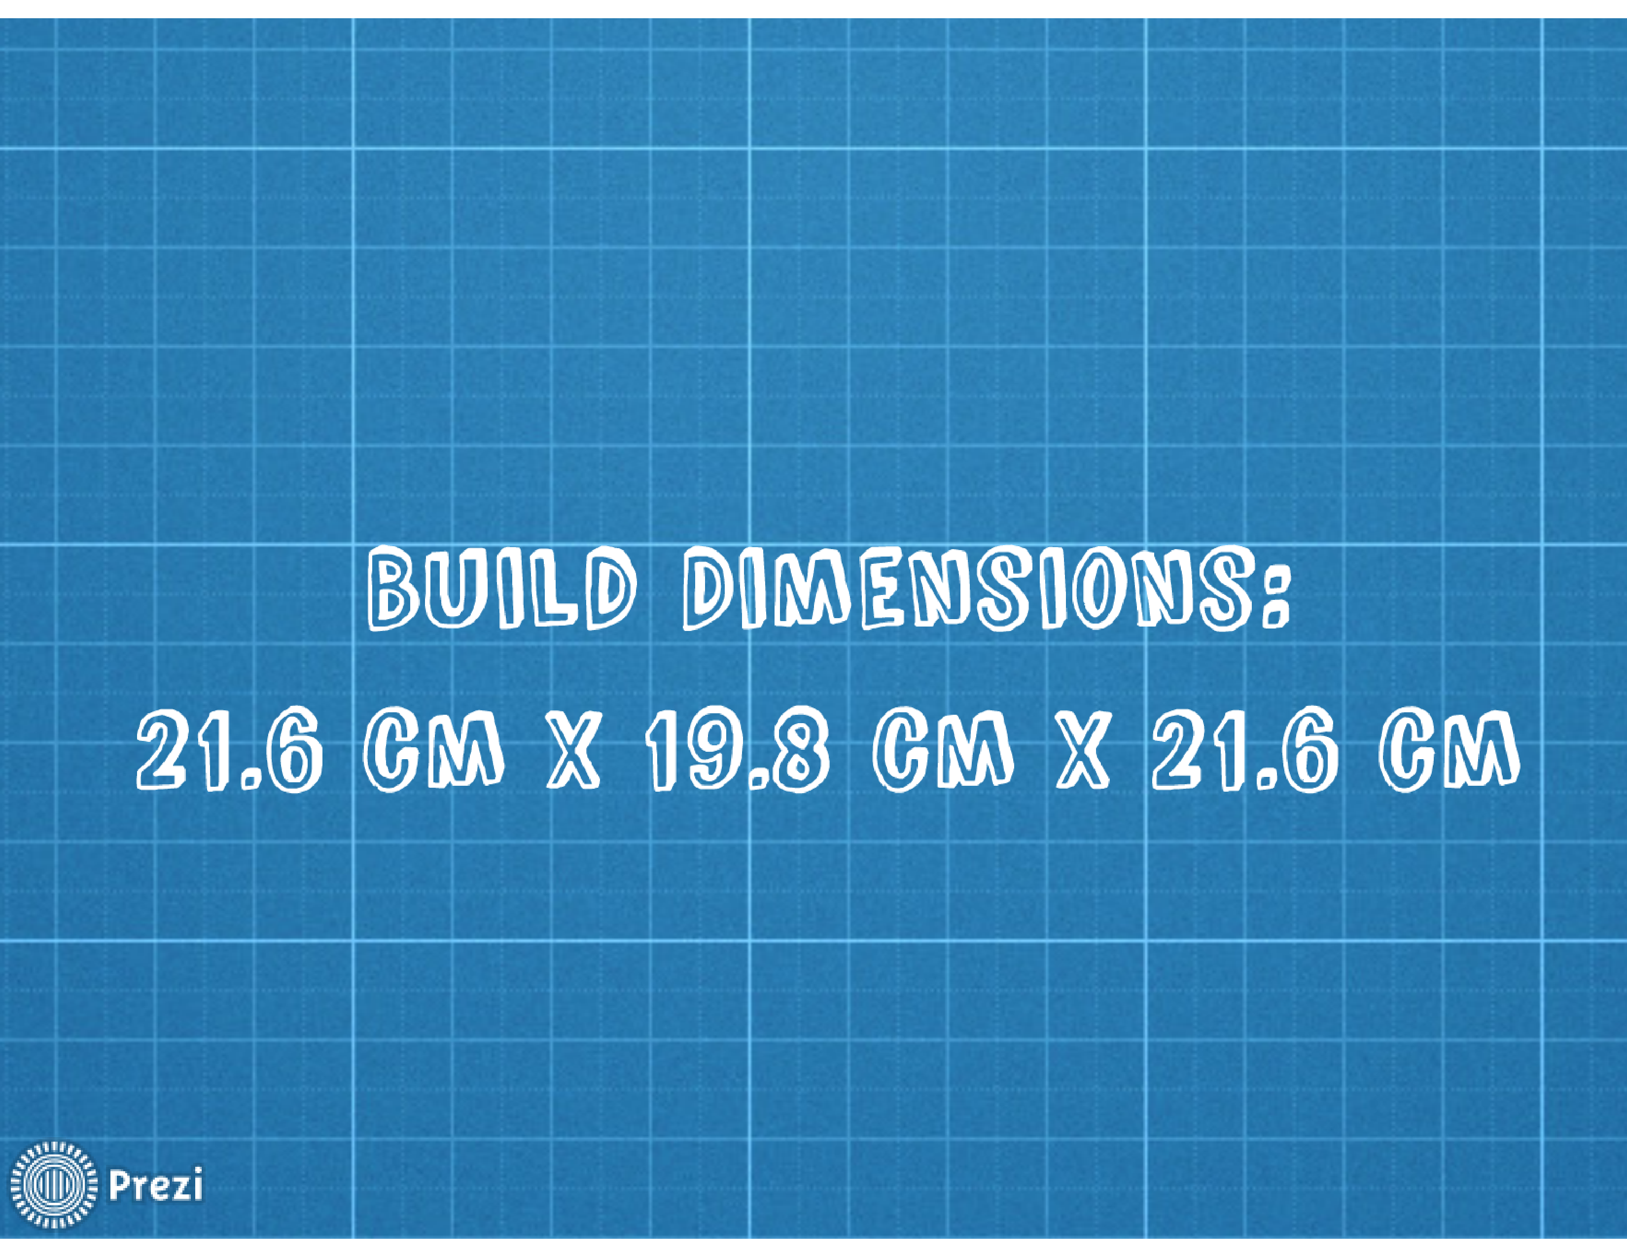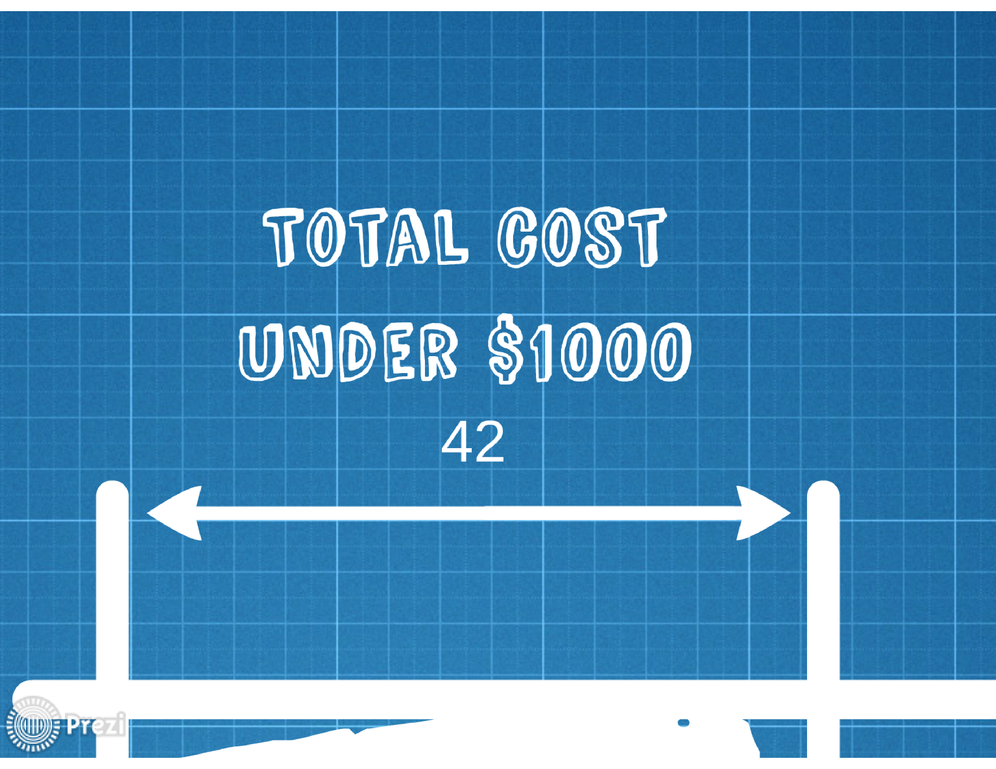

## Indiegogo

### Story

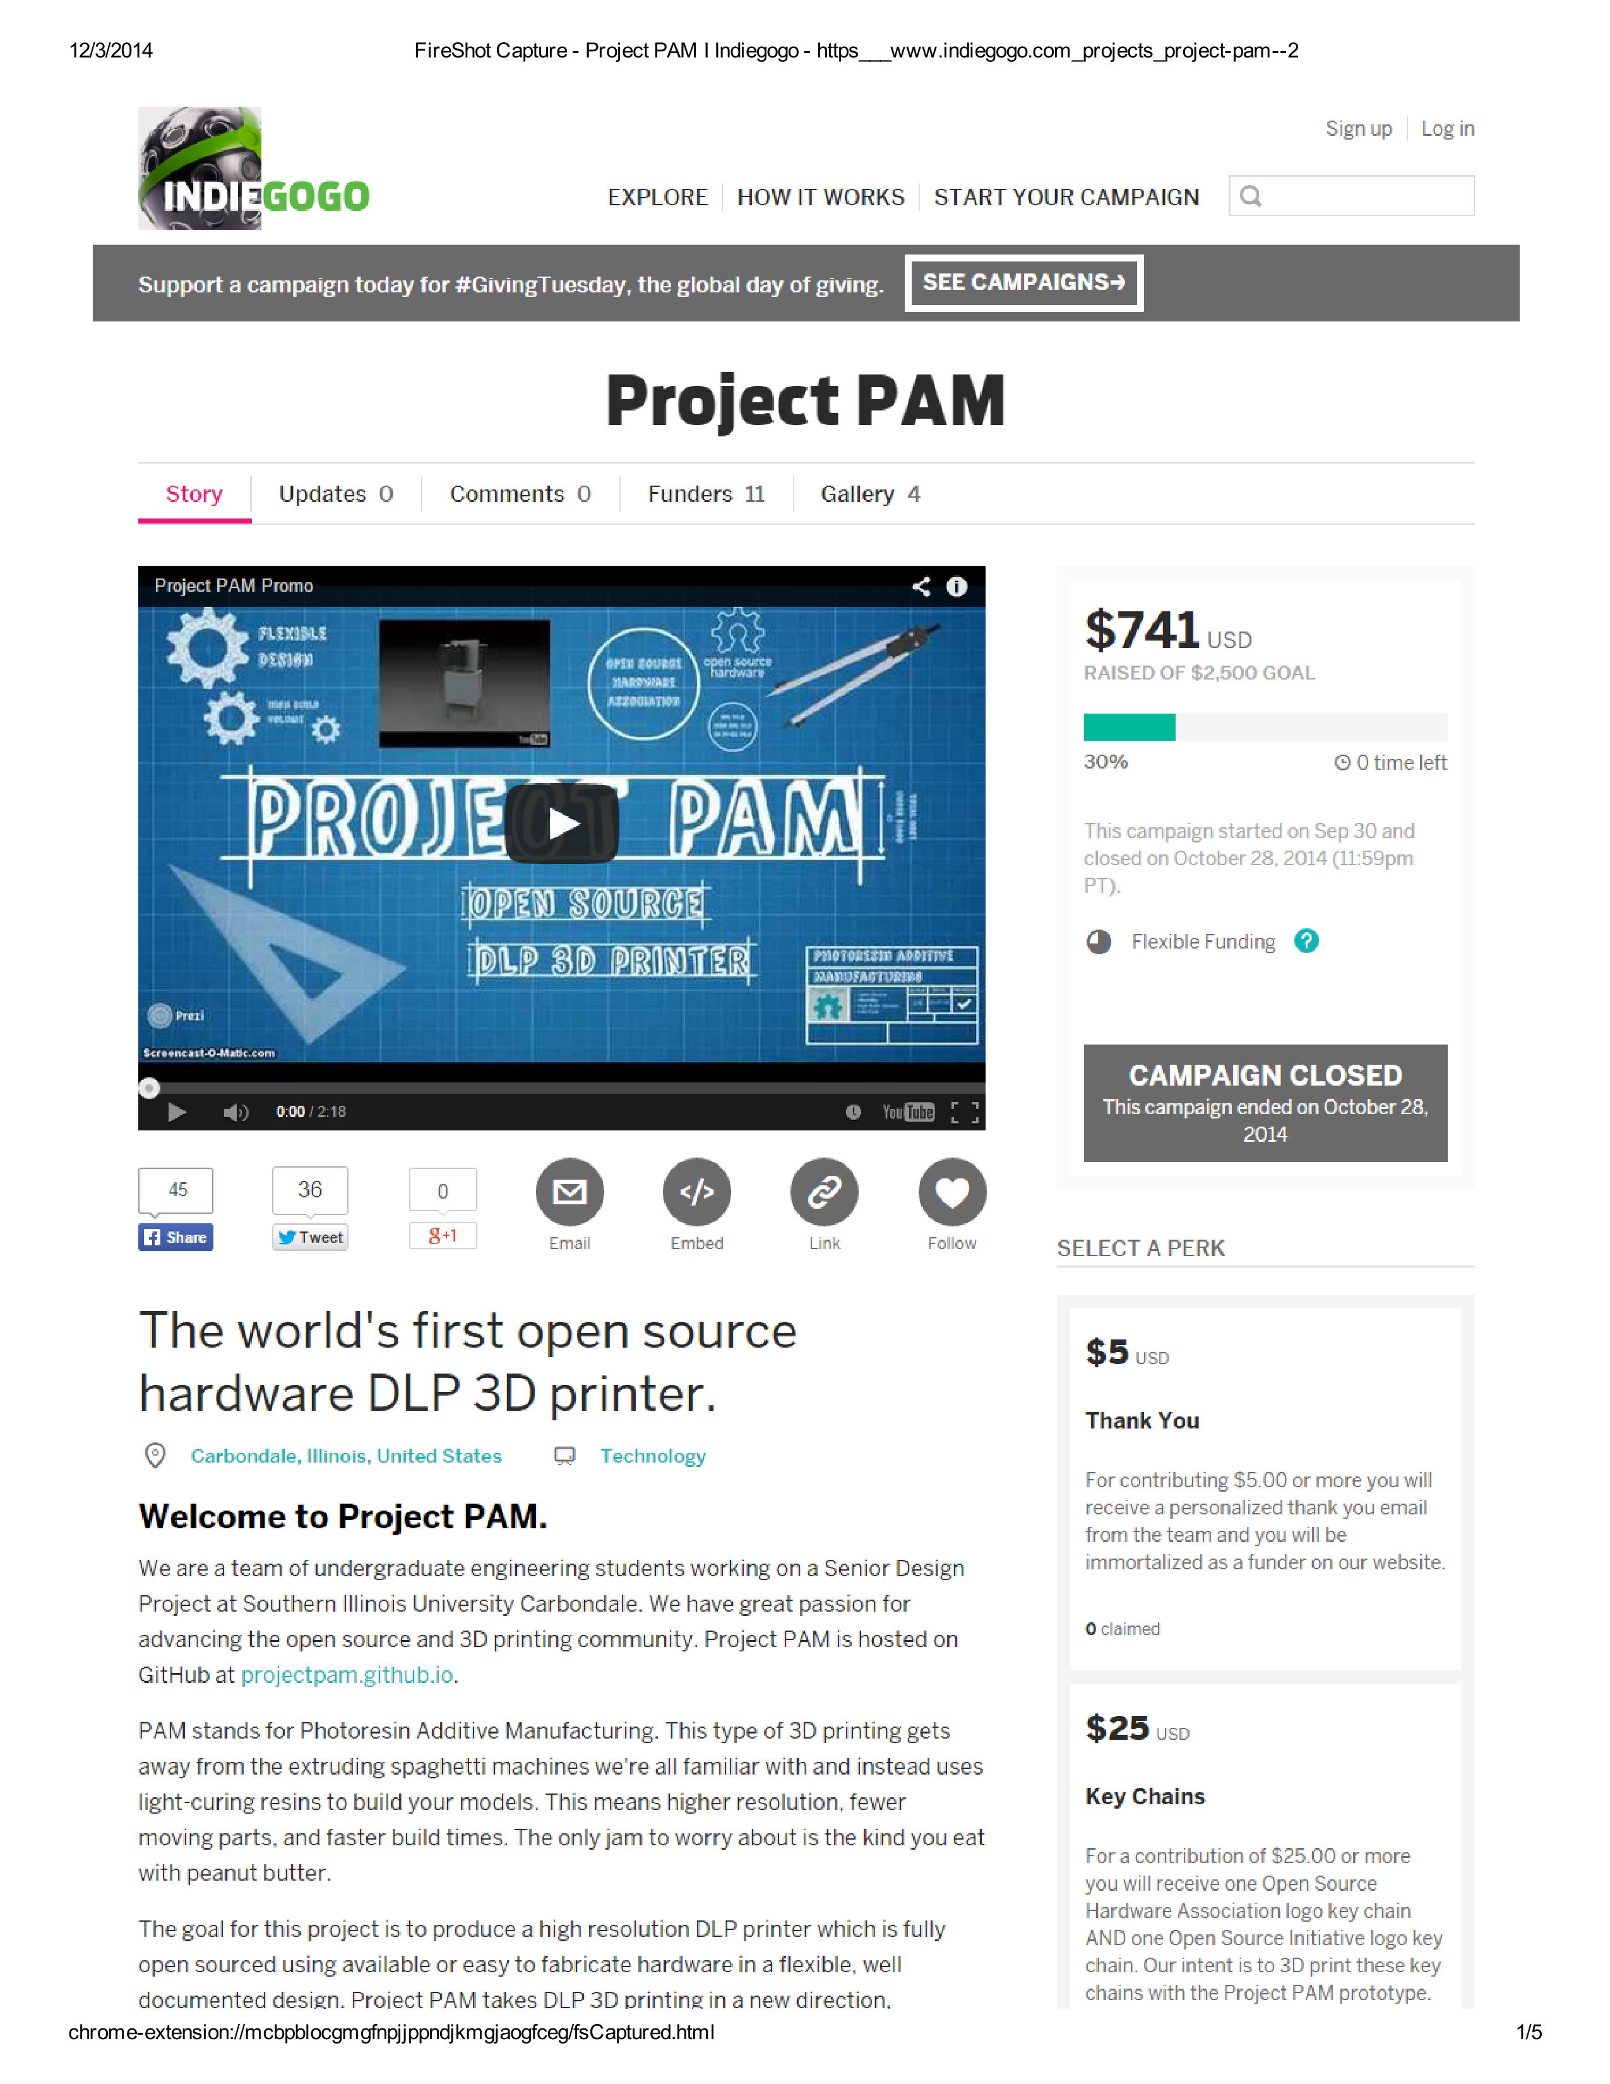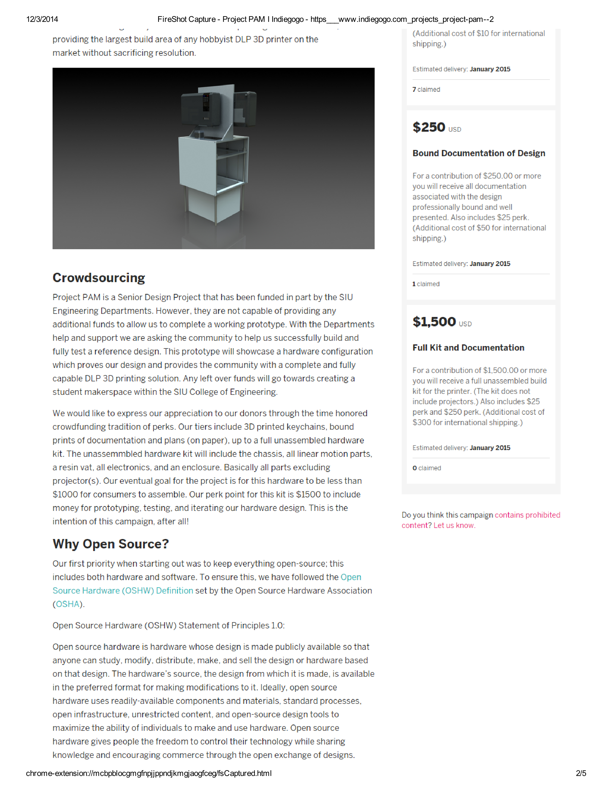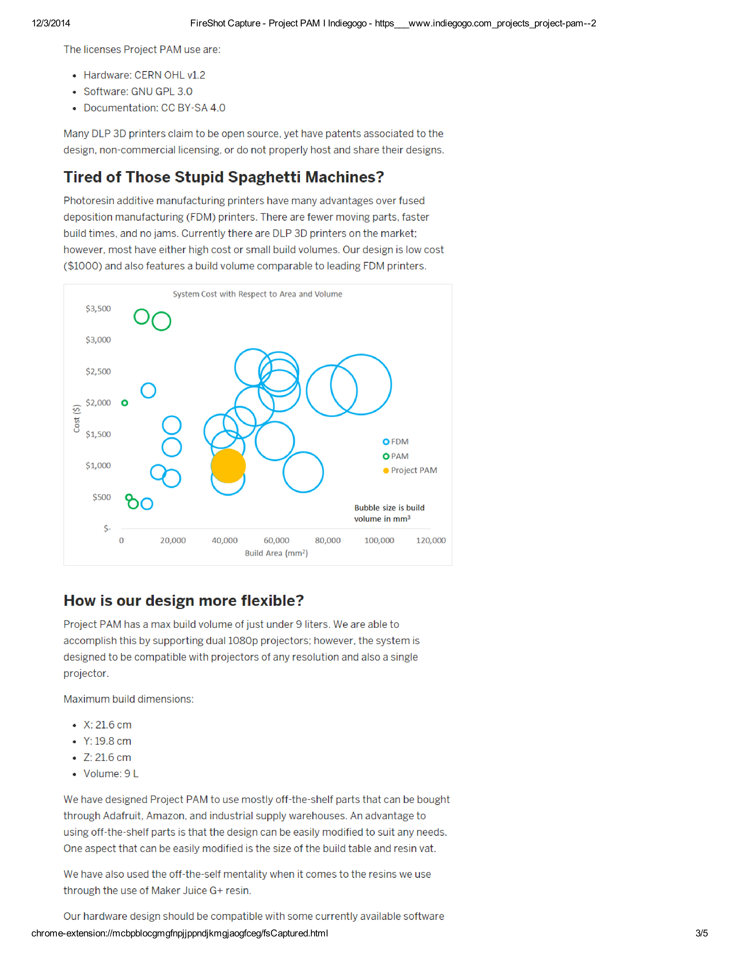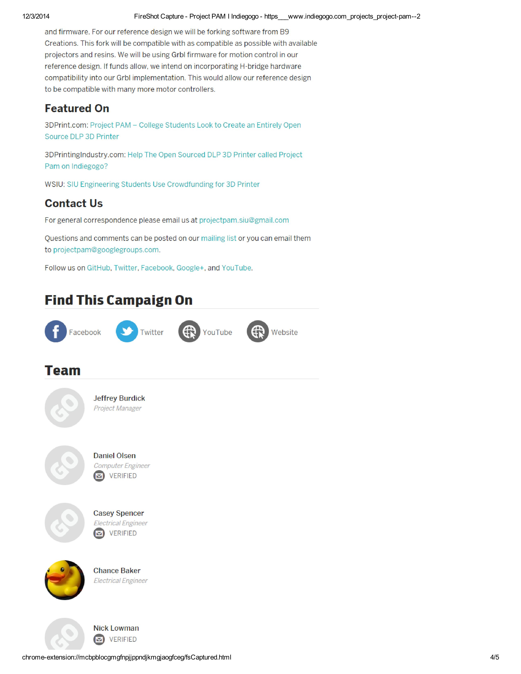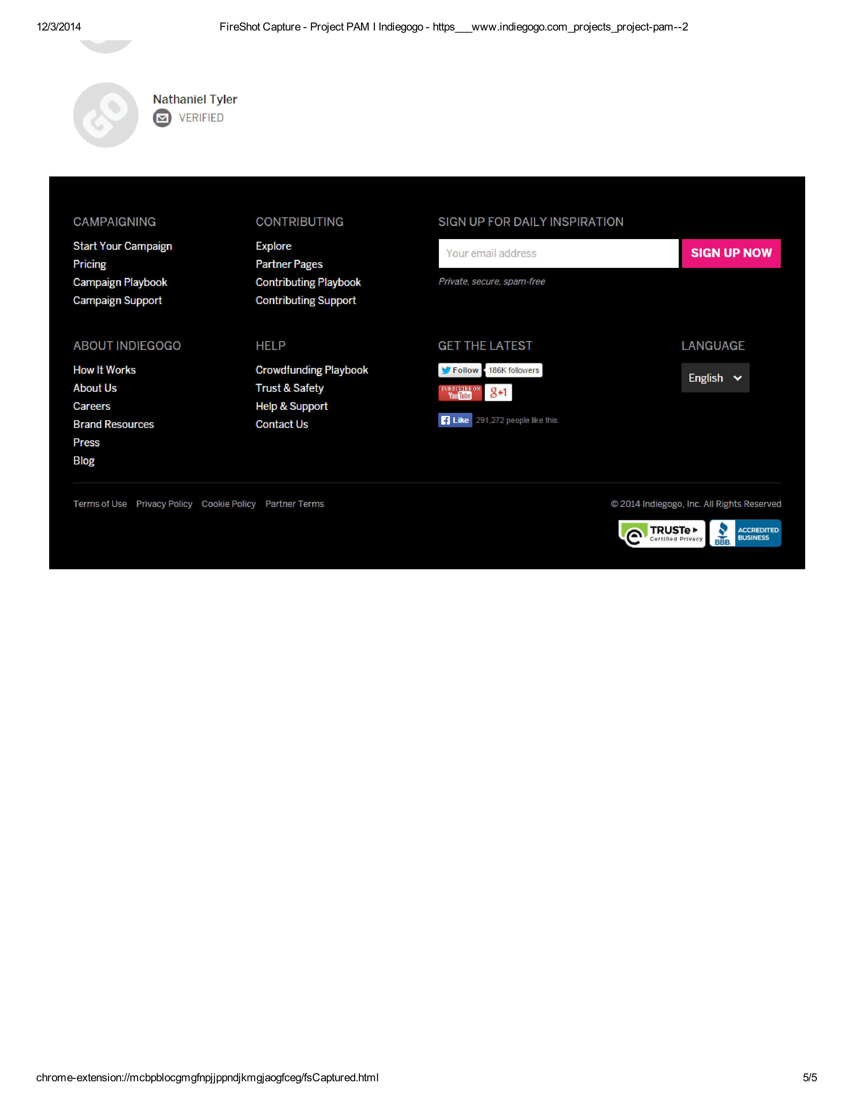

### Funders

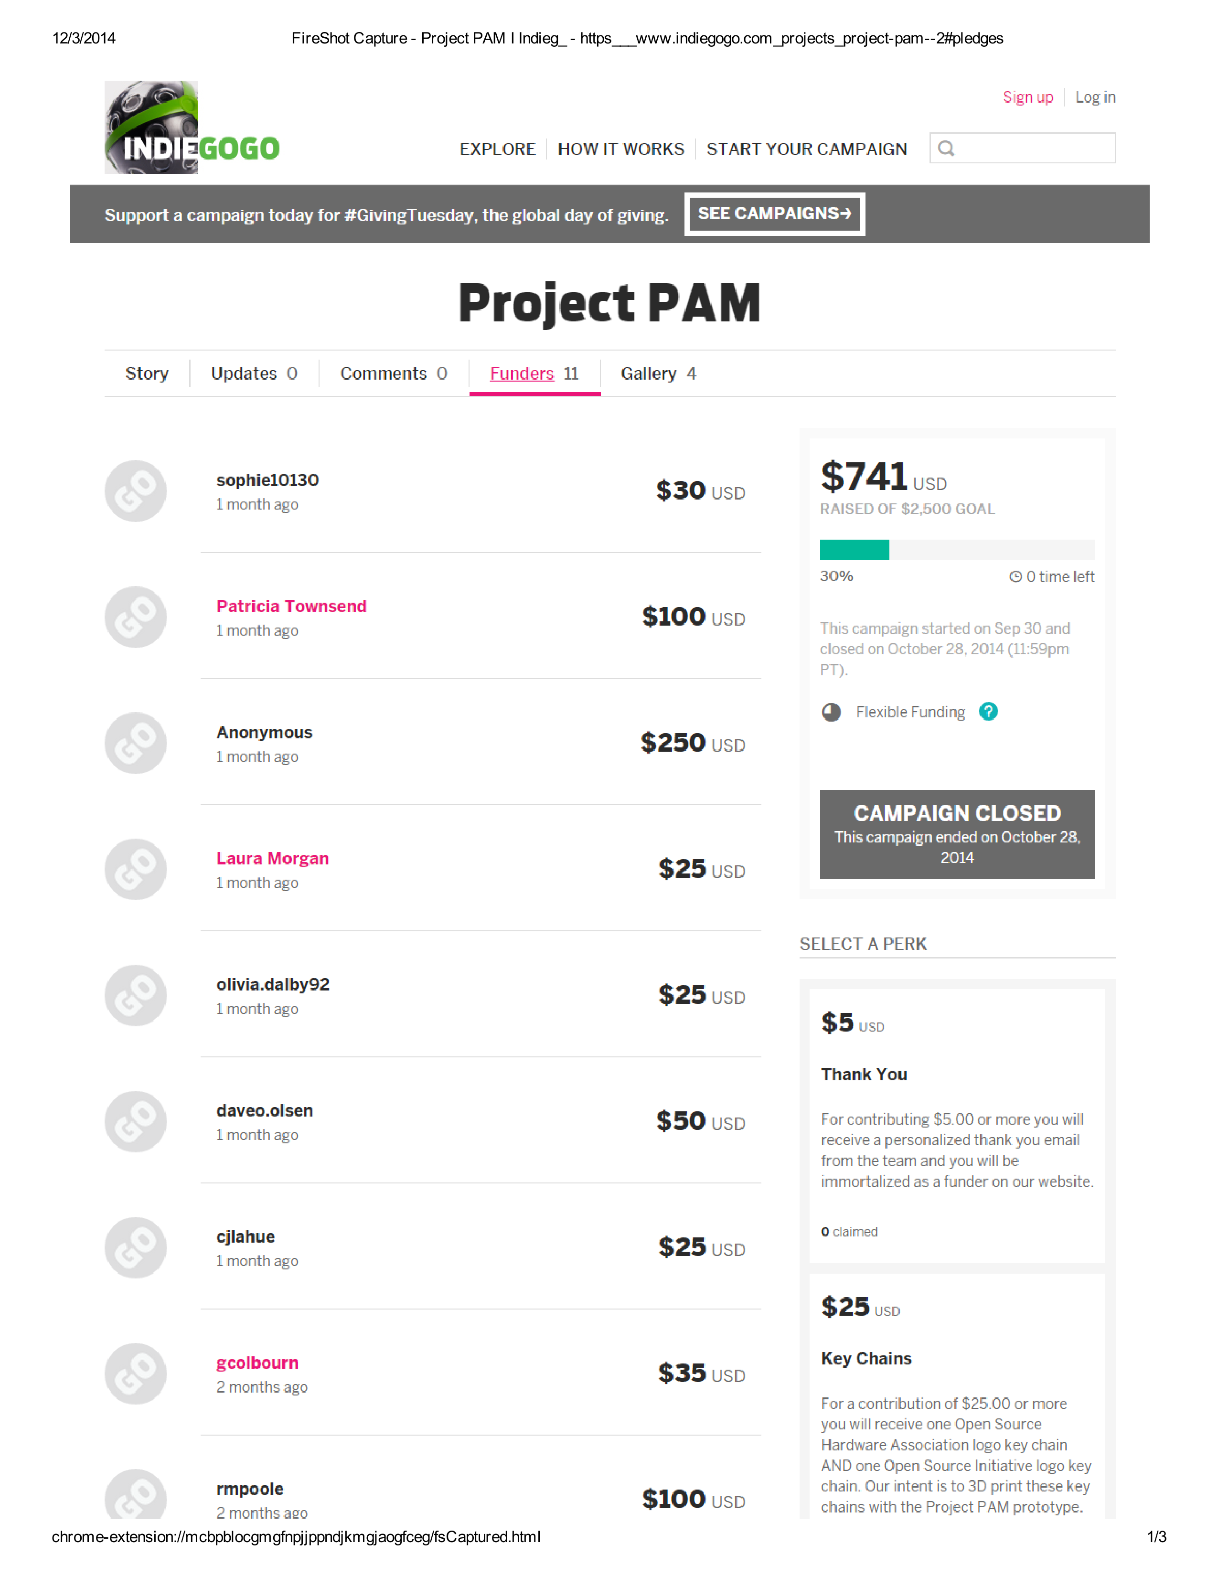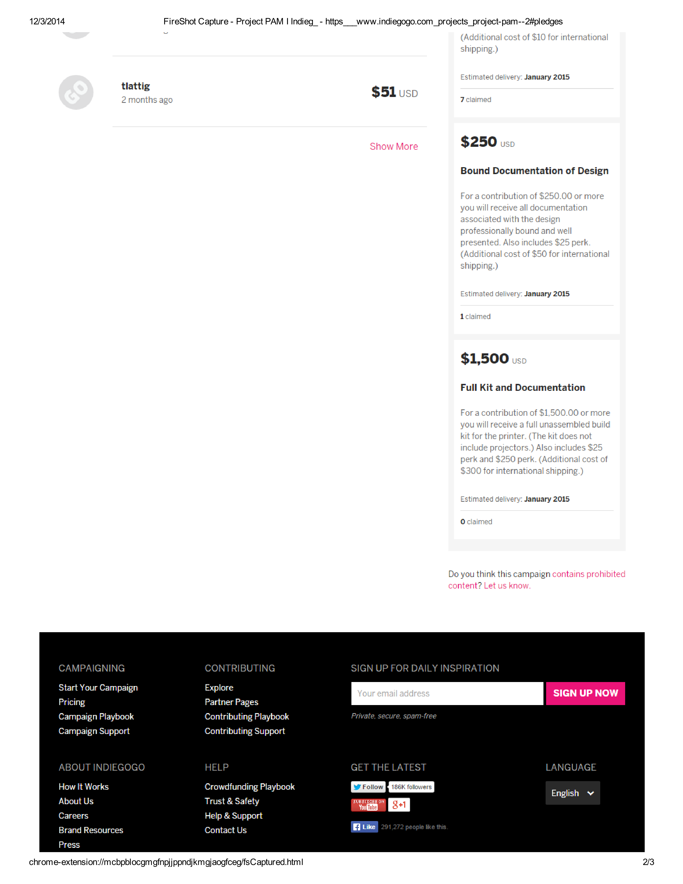

### Gallery

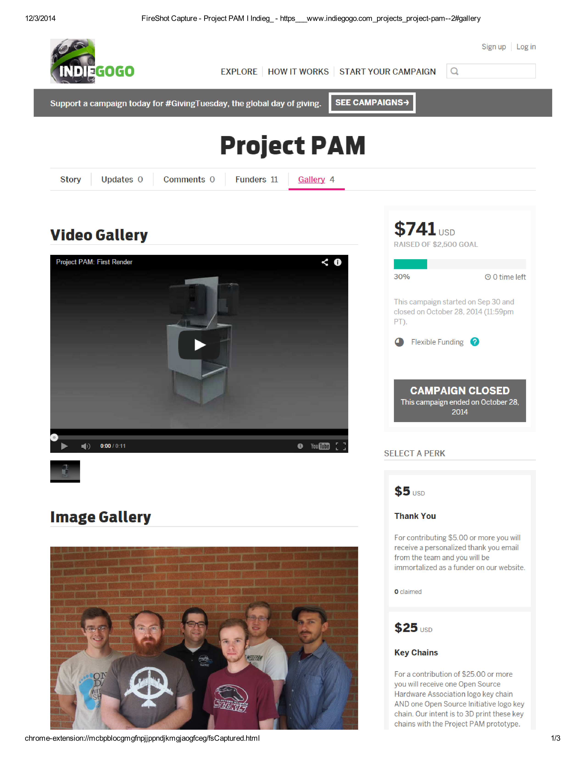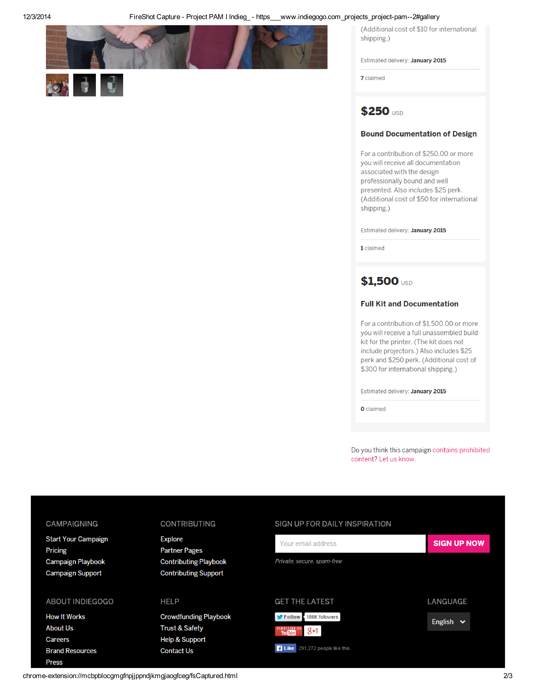

## Social Media Pages

### Twitter Page

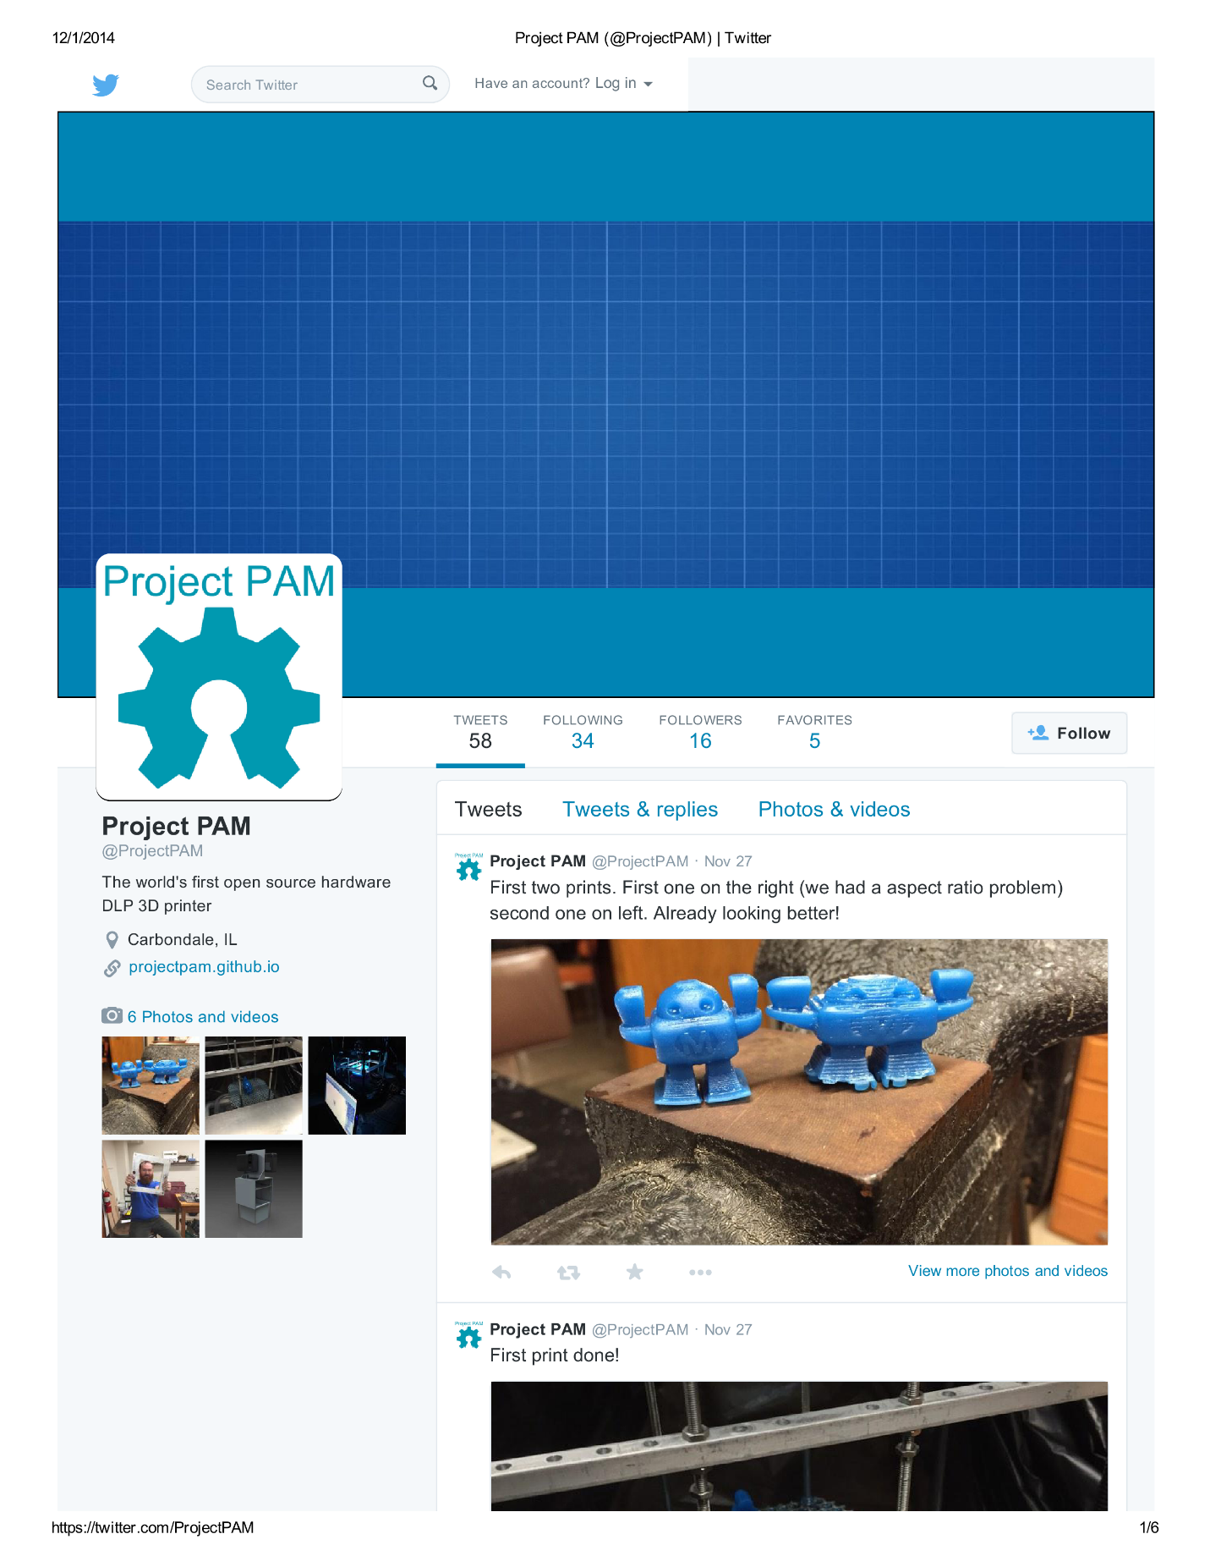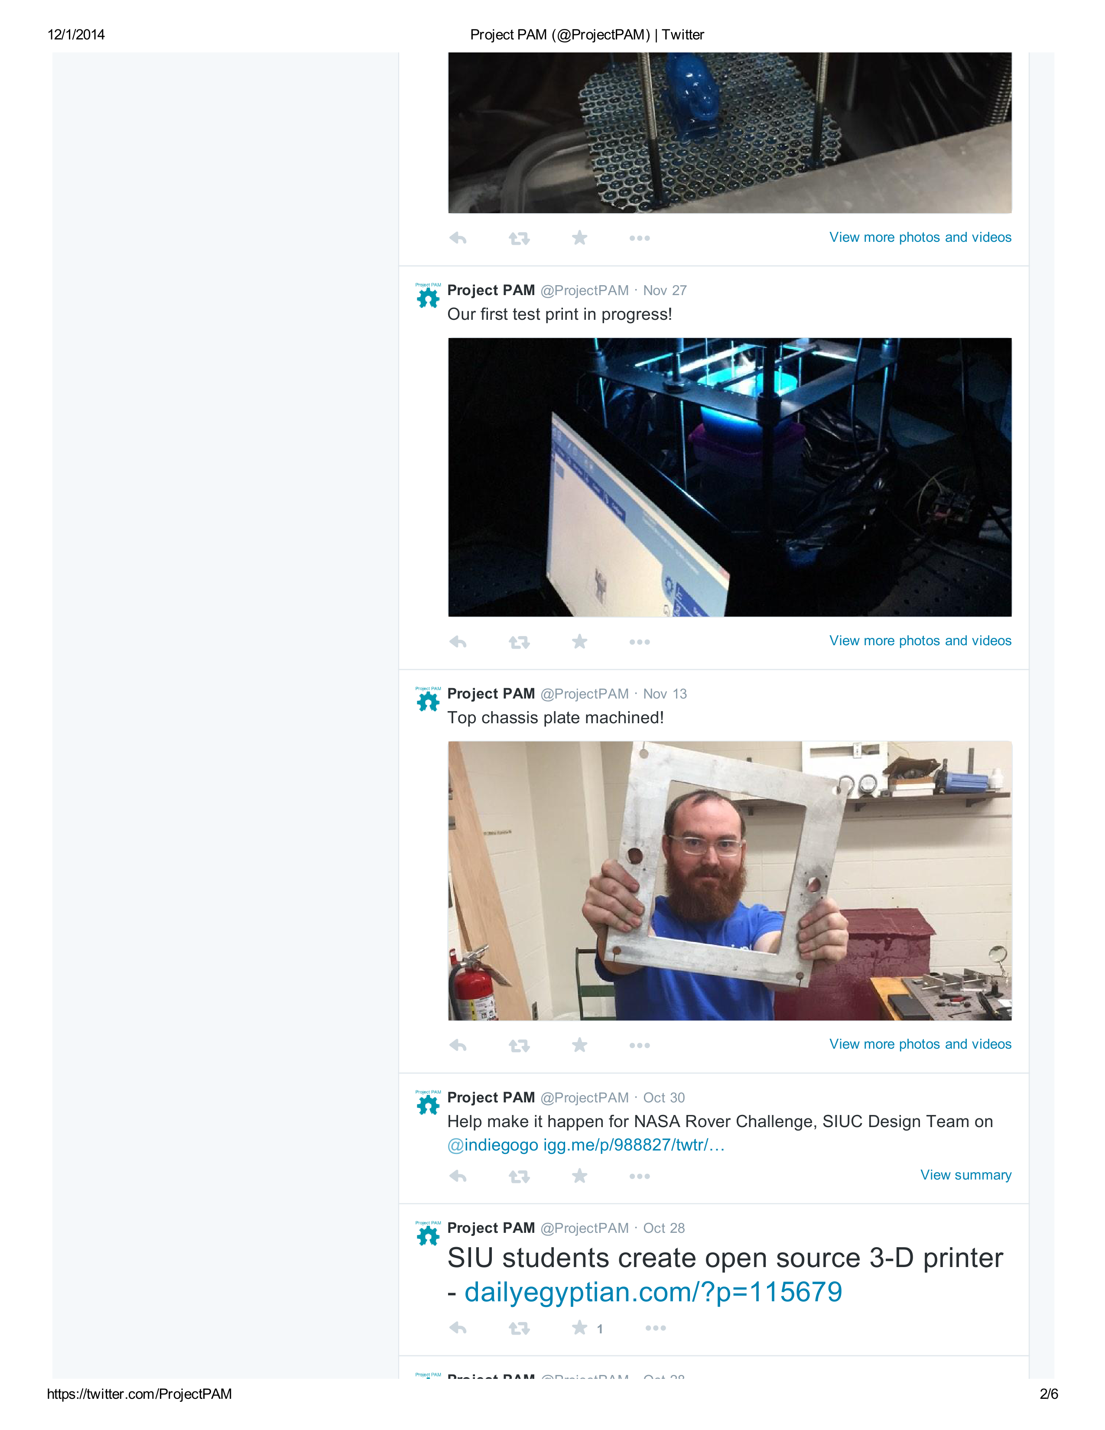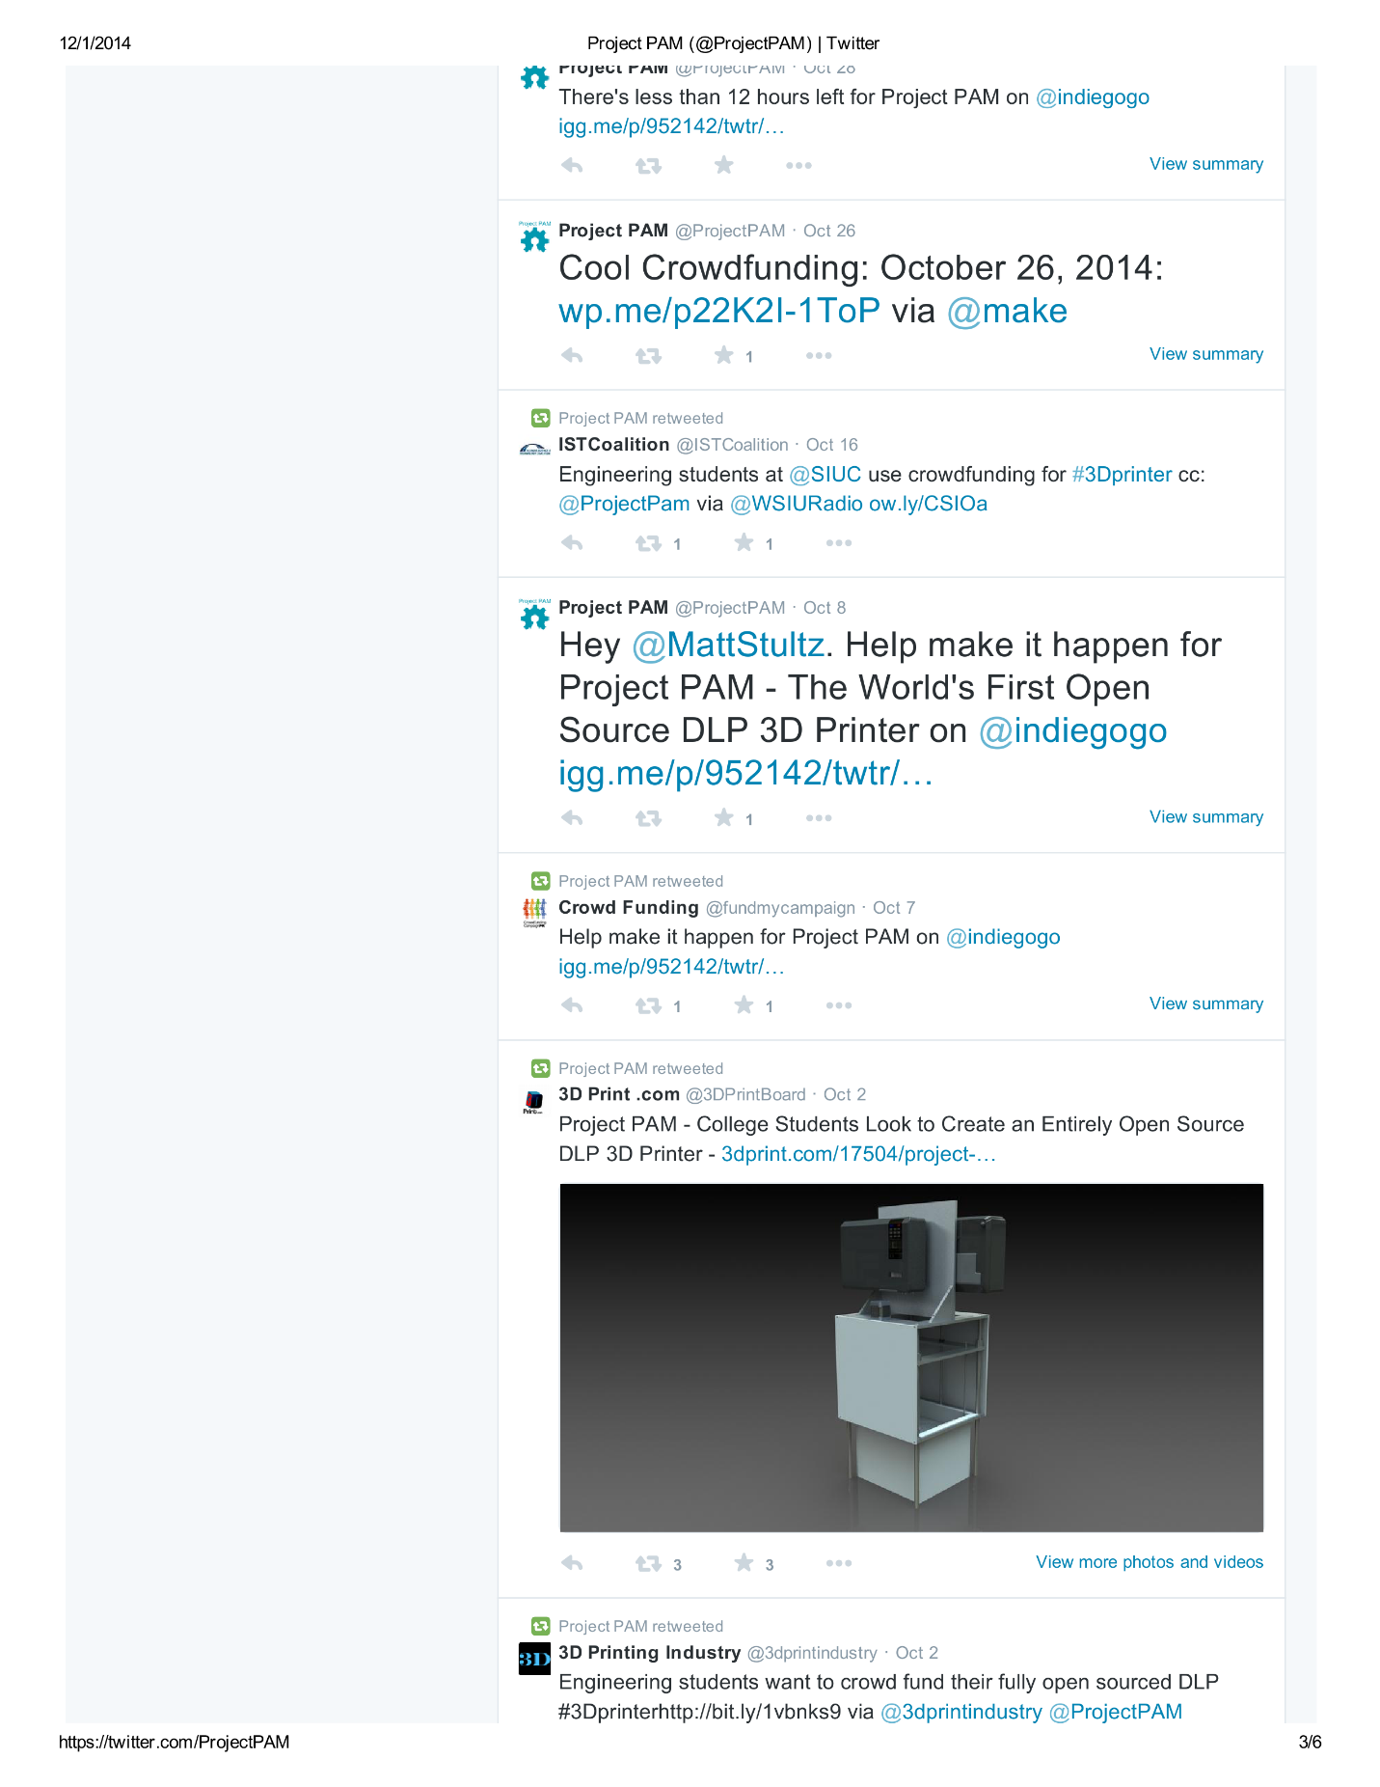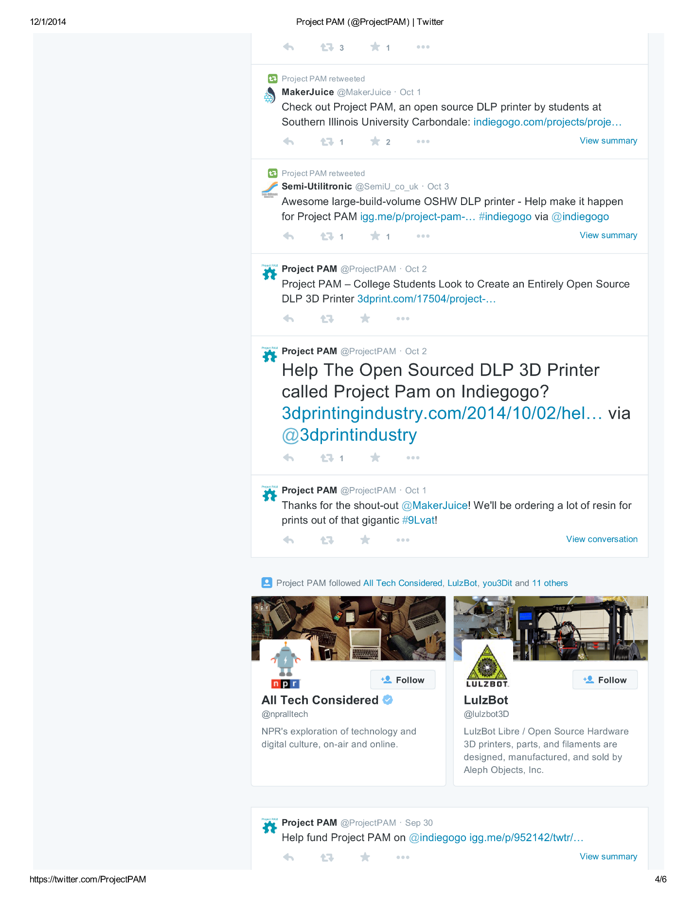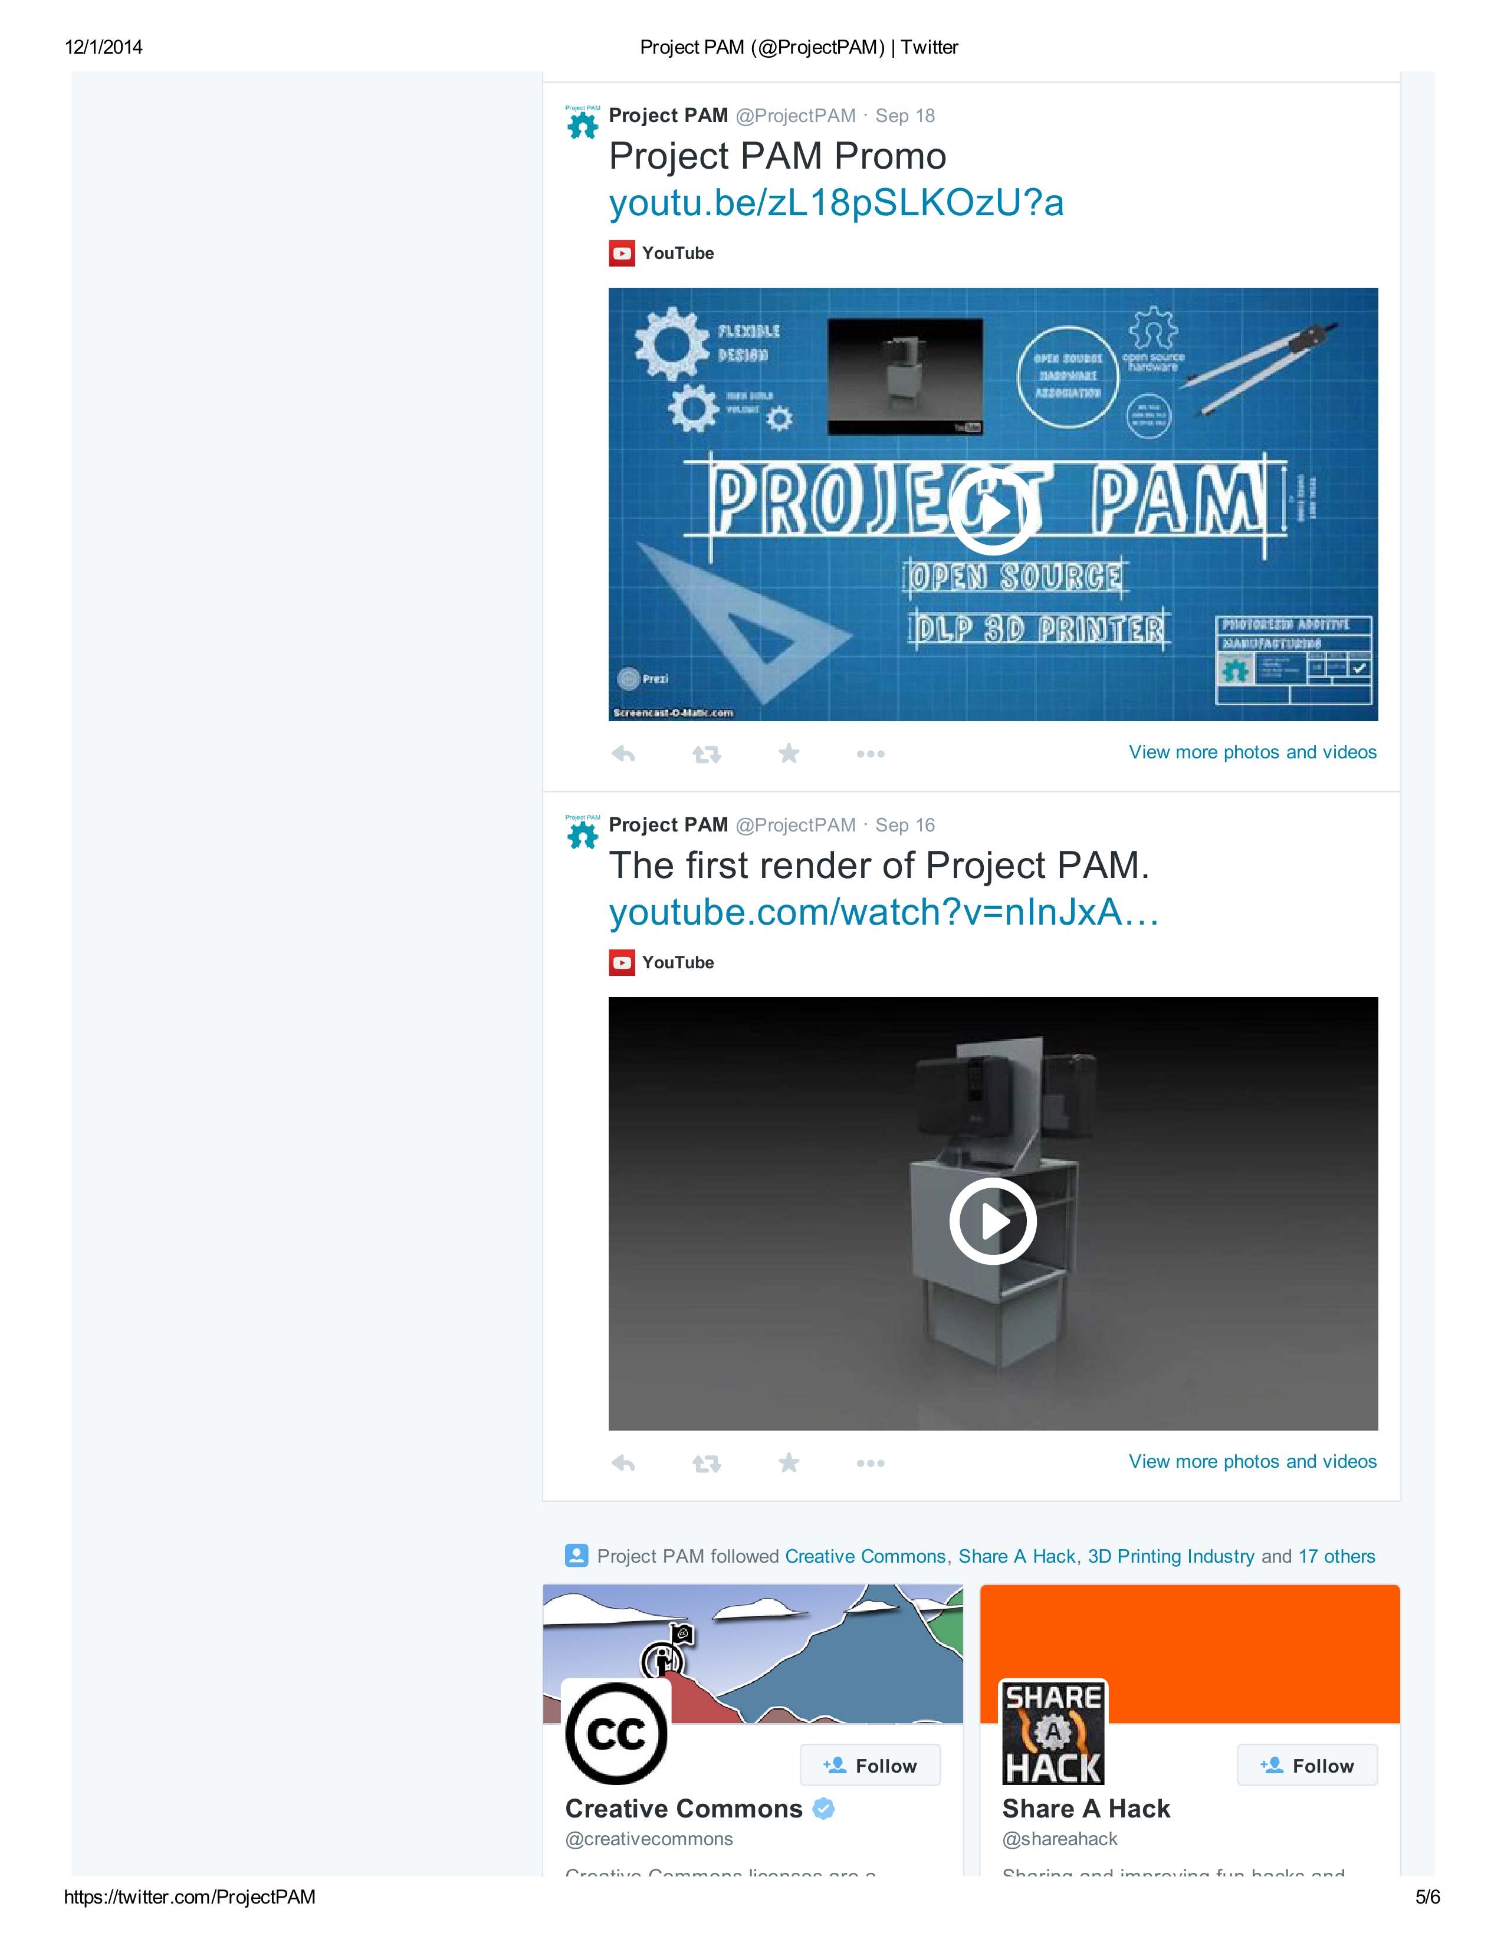

### Facebook Page

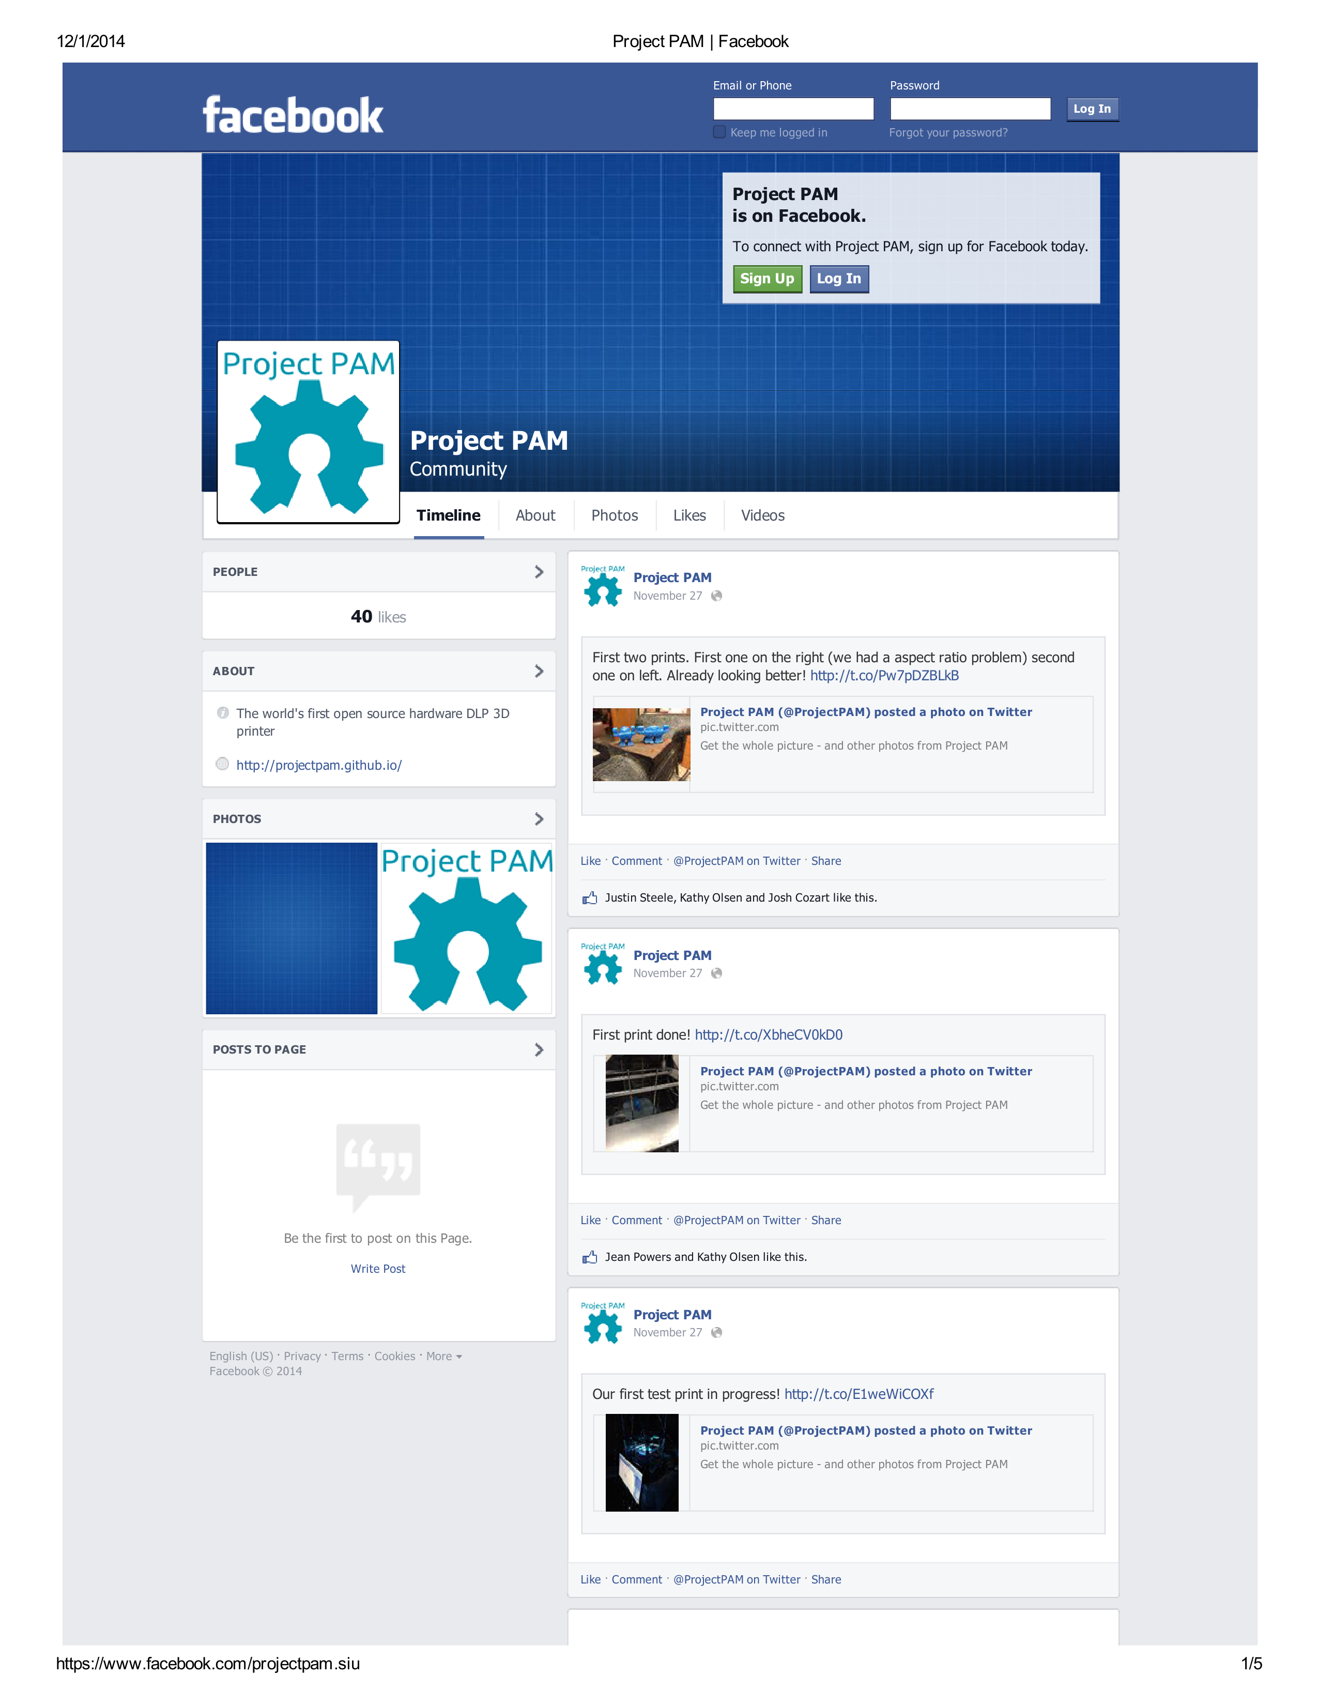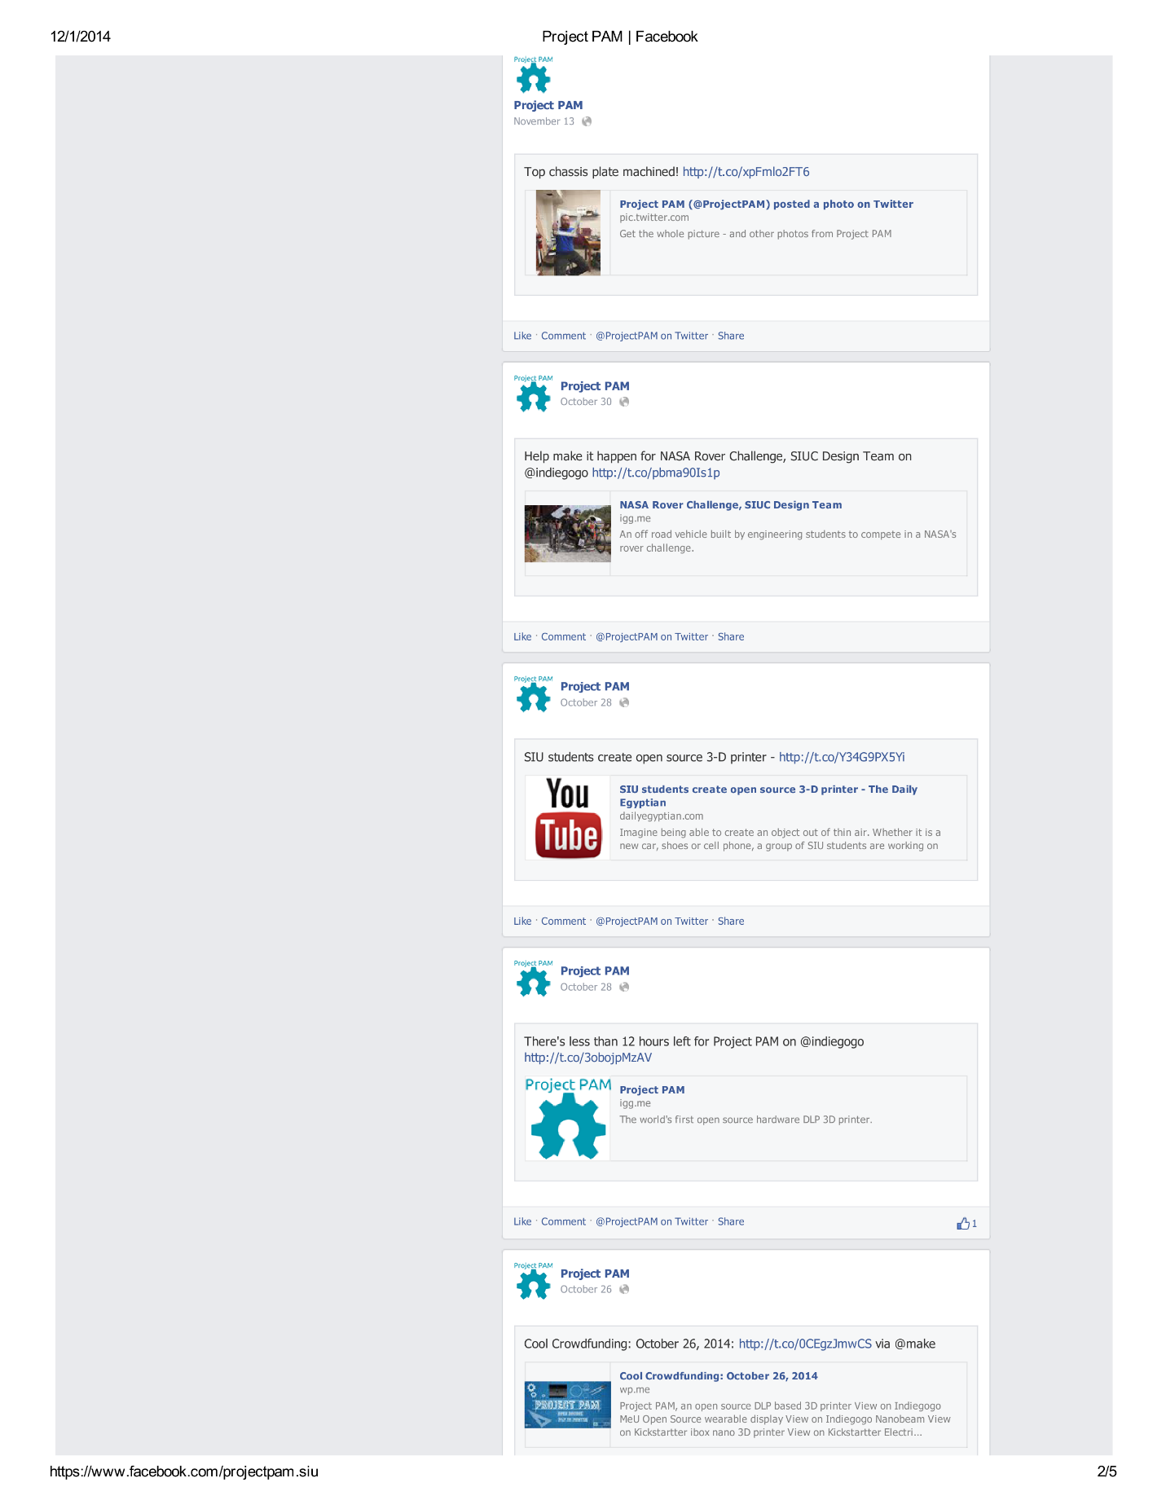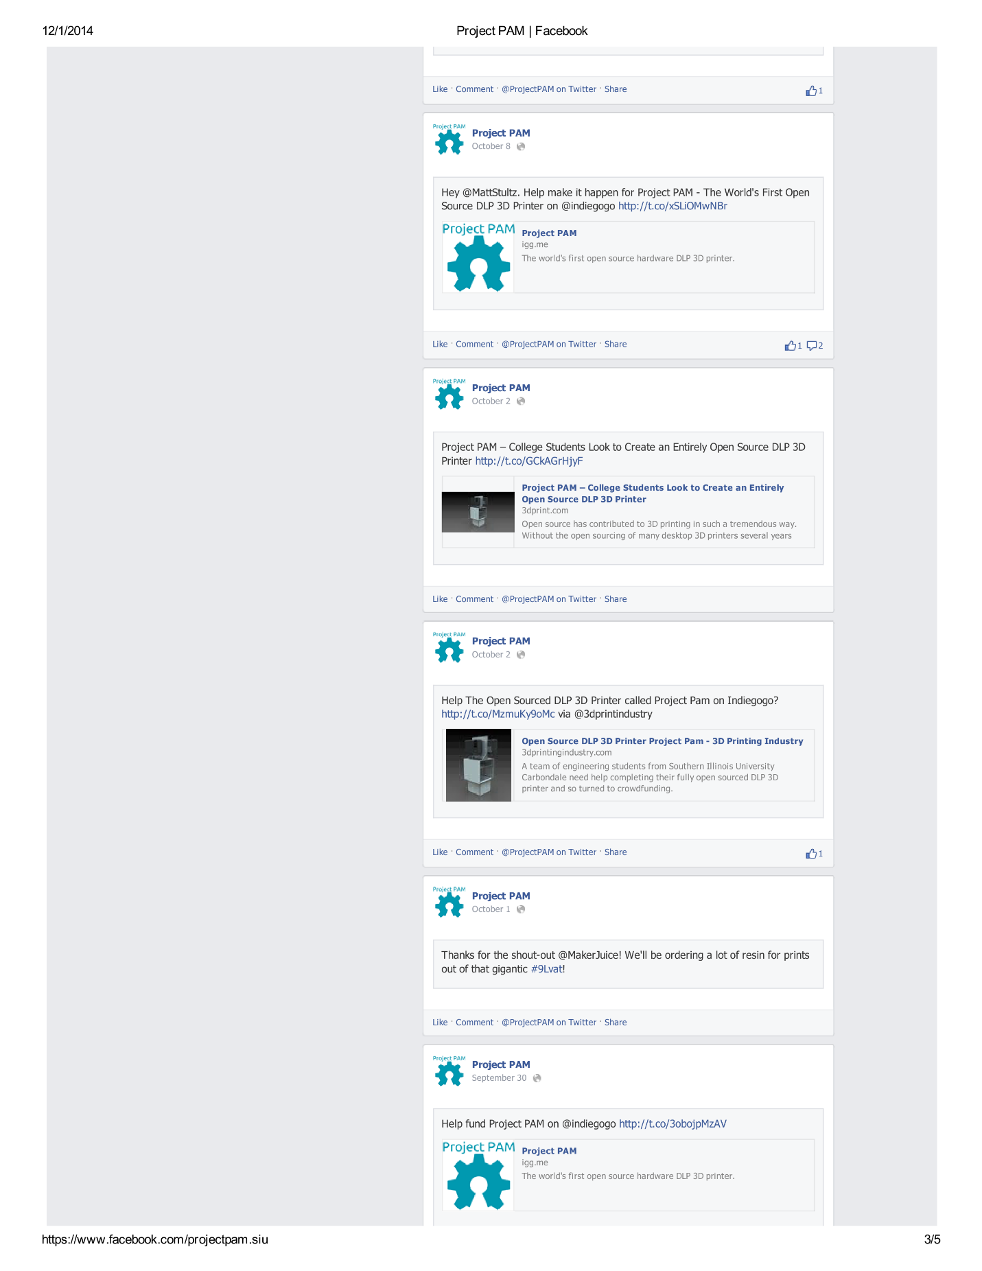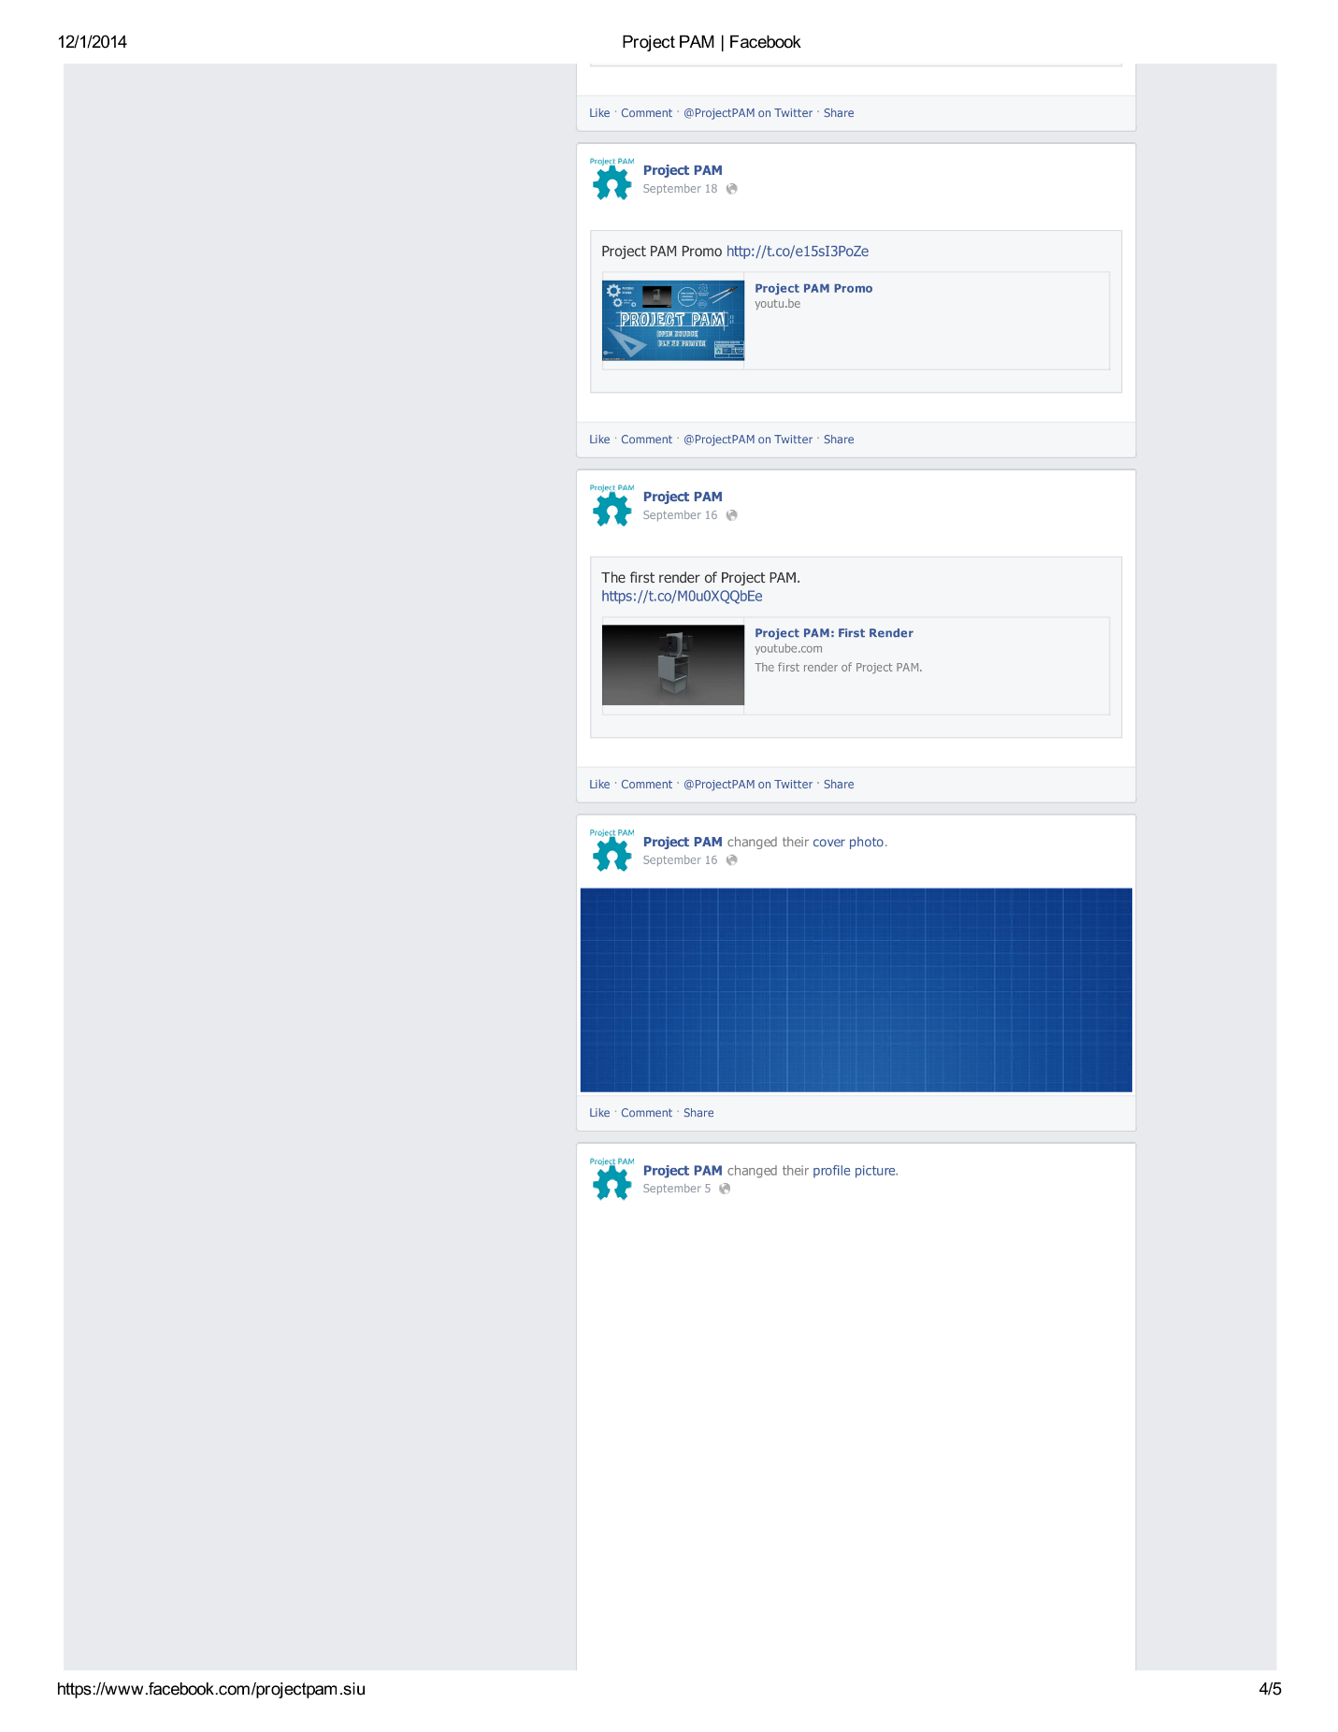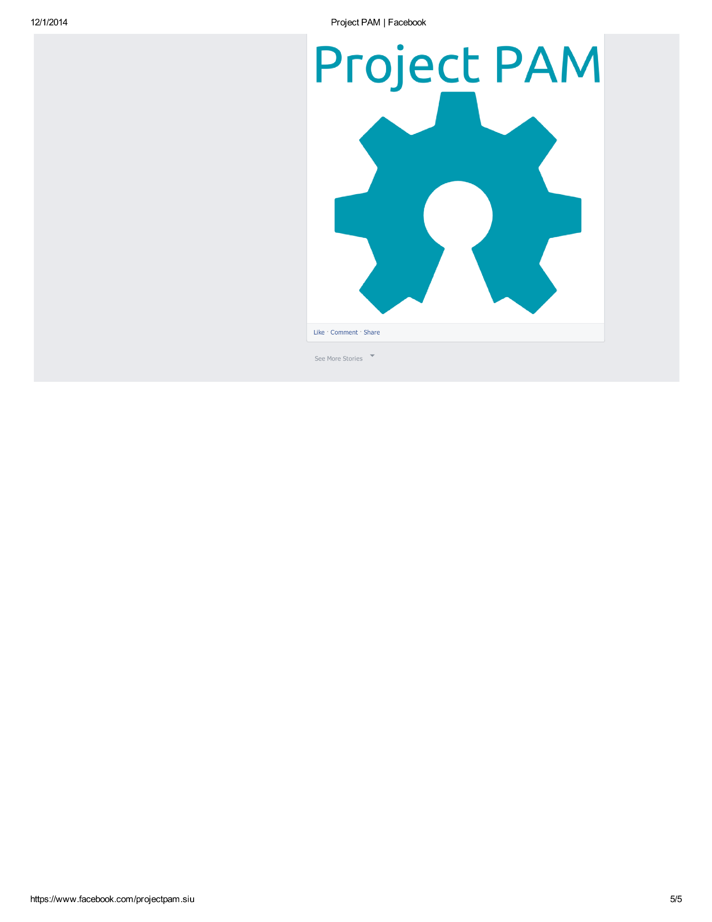

## Articles Project PAM Was Featured In

### 3DPrint.com

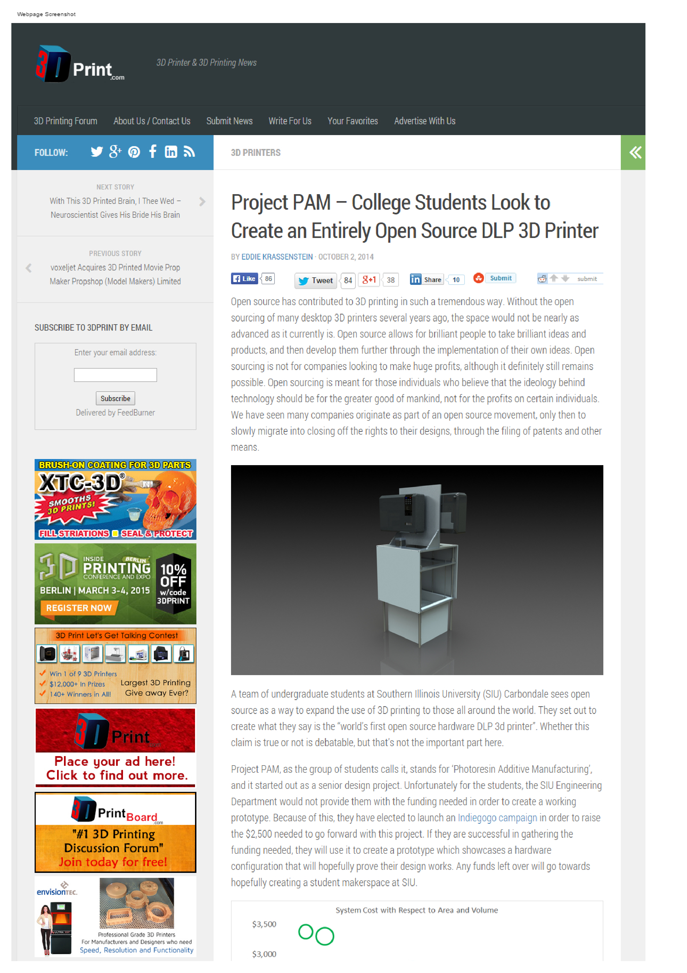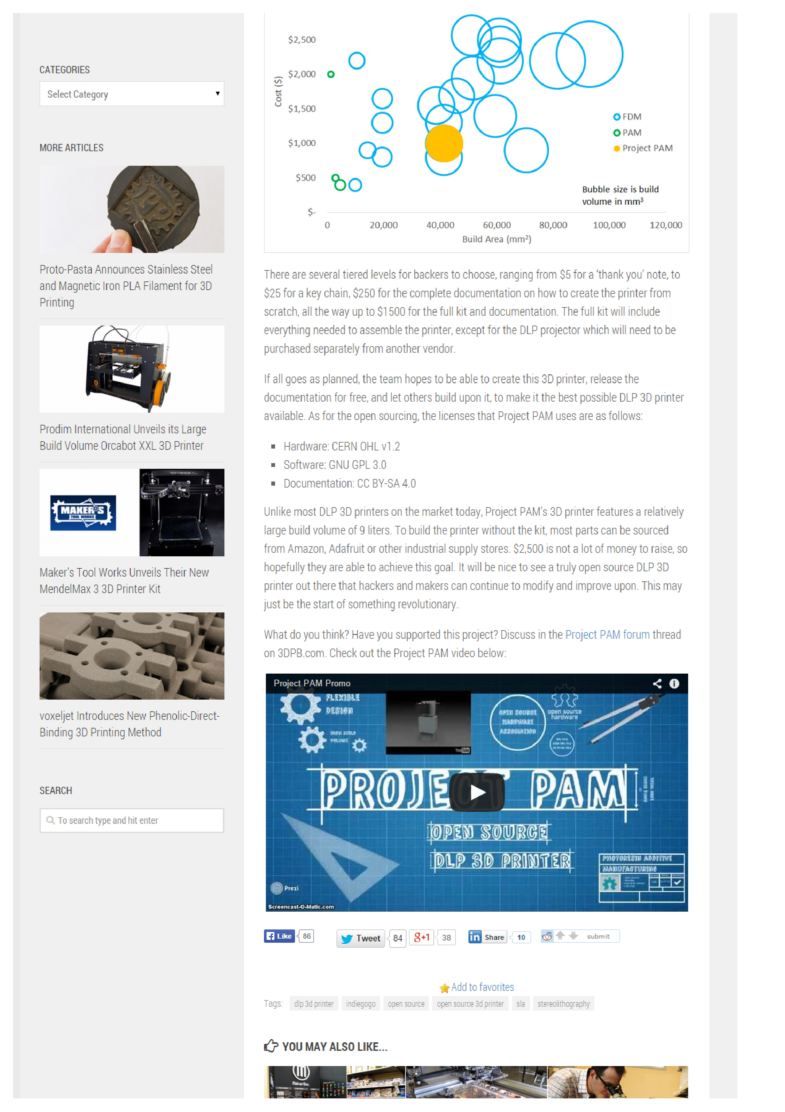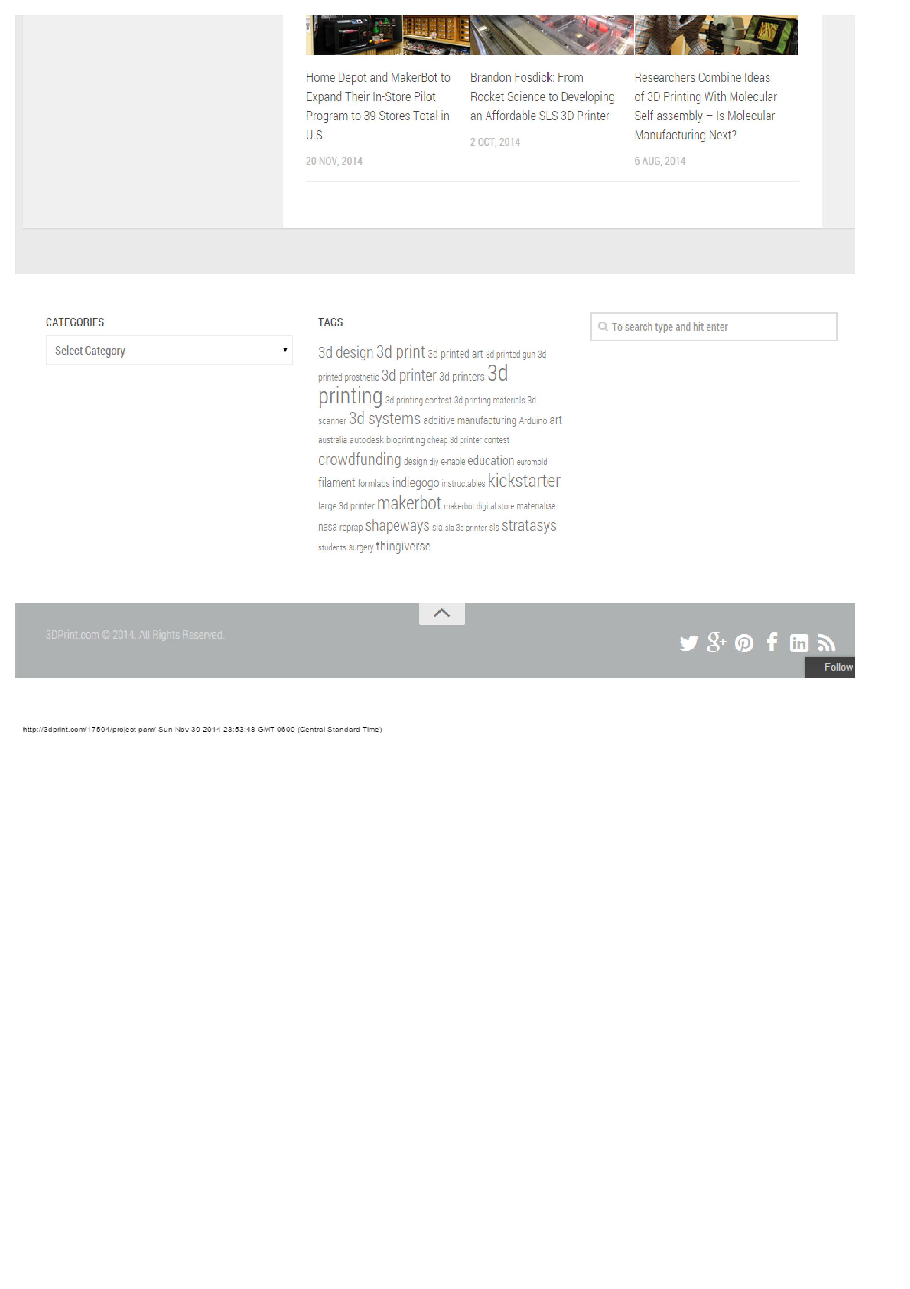

### 3D Printing Industry

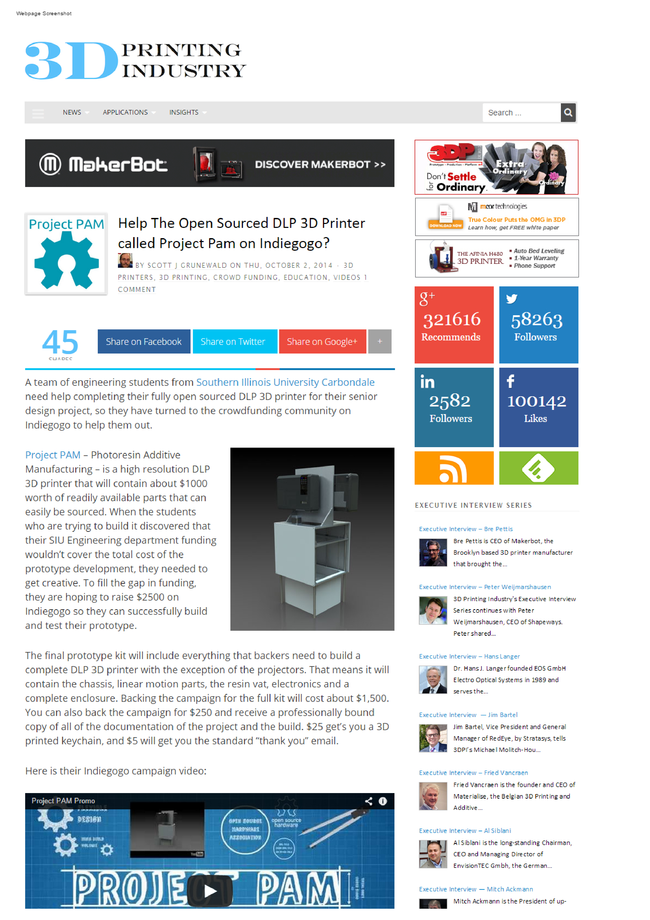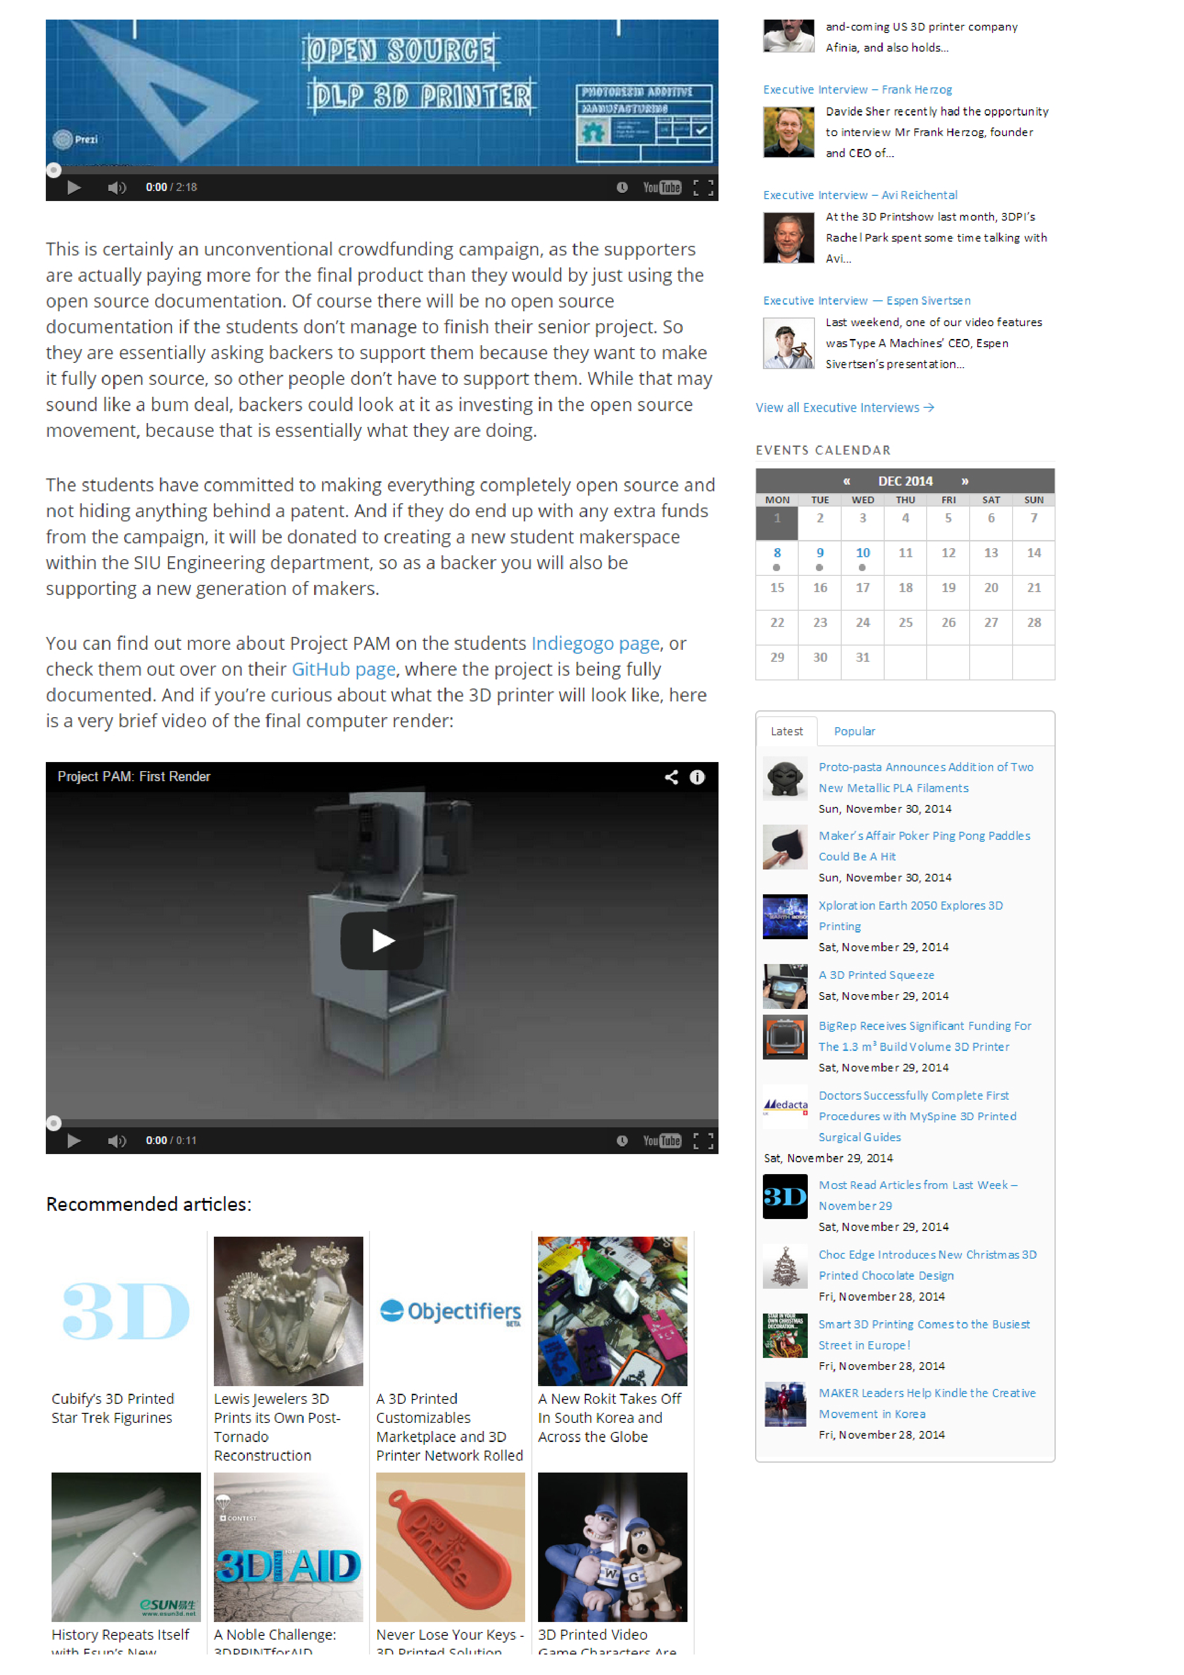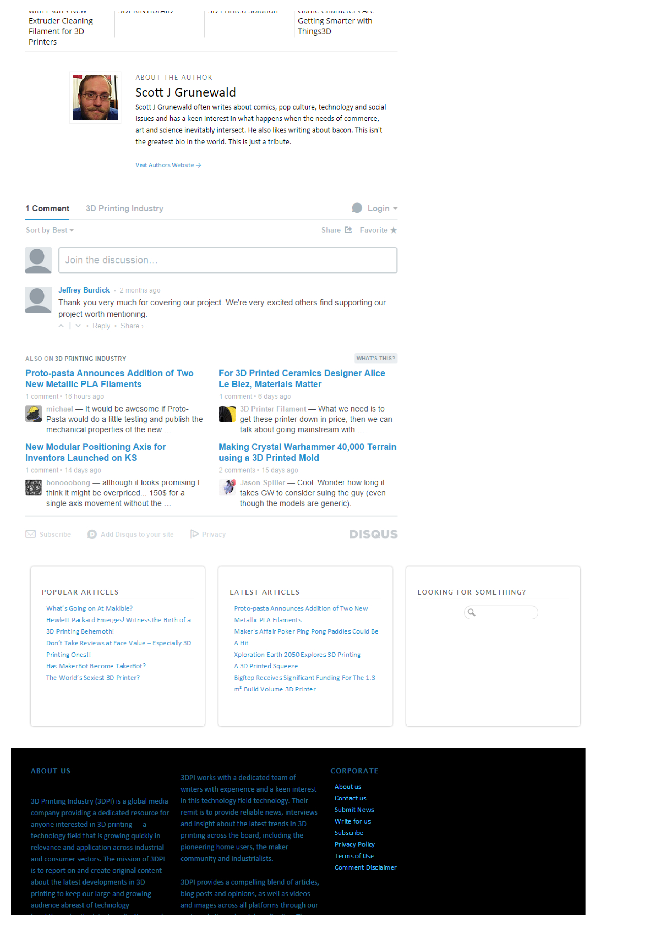

### WSIU

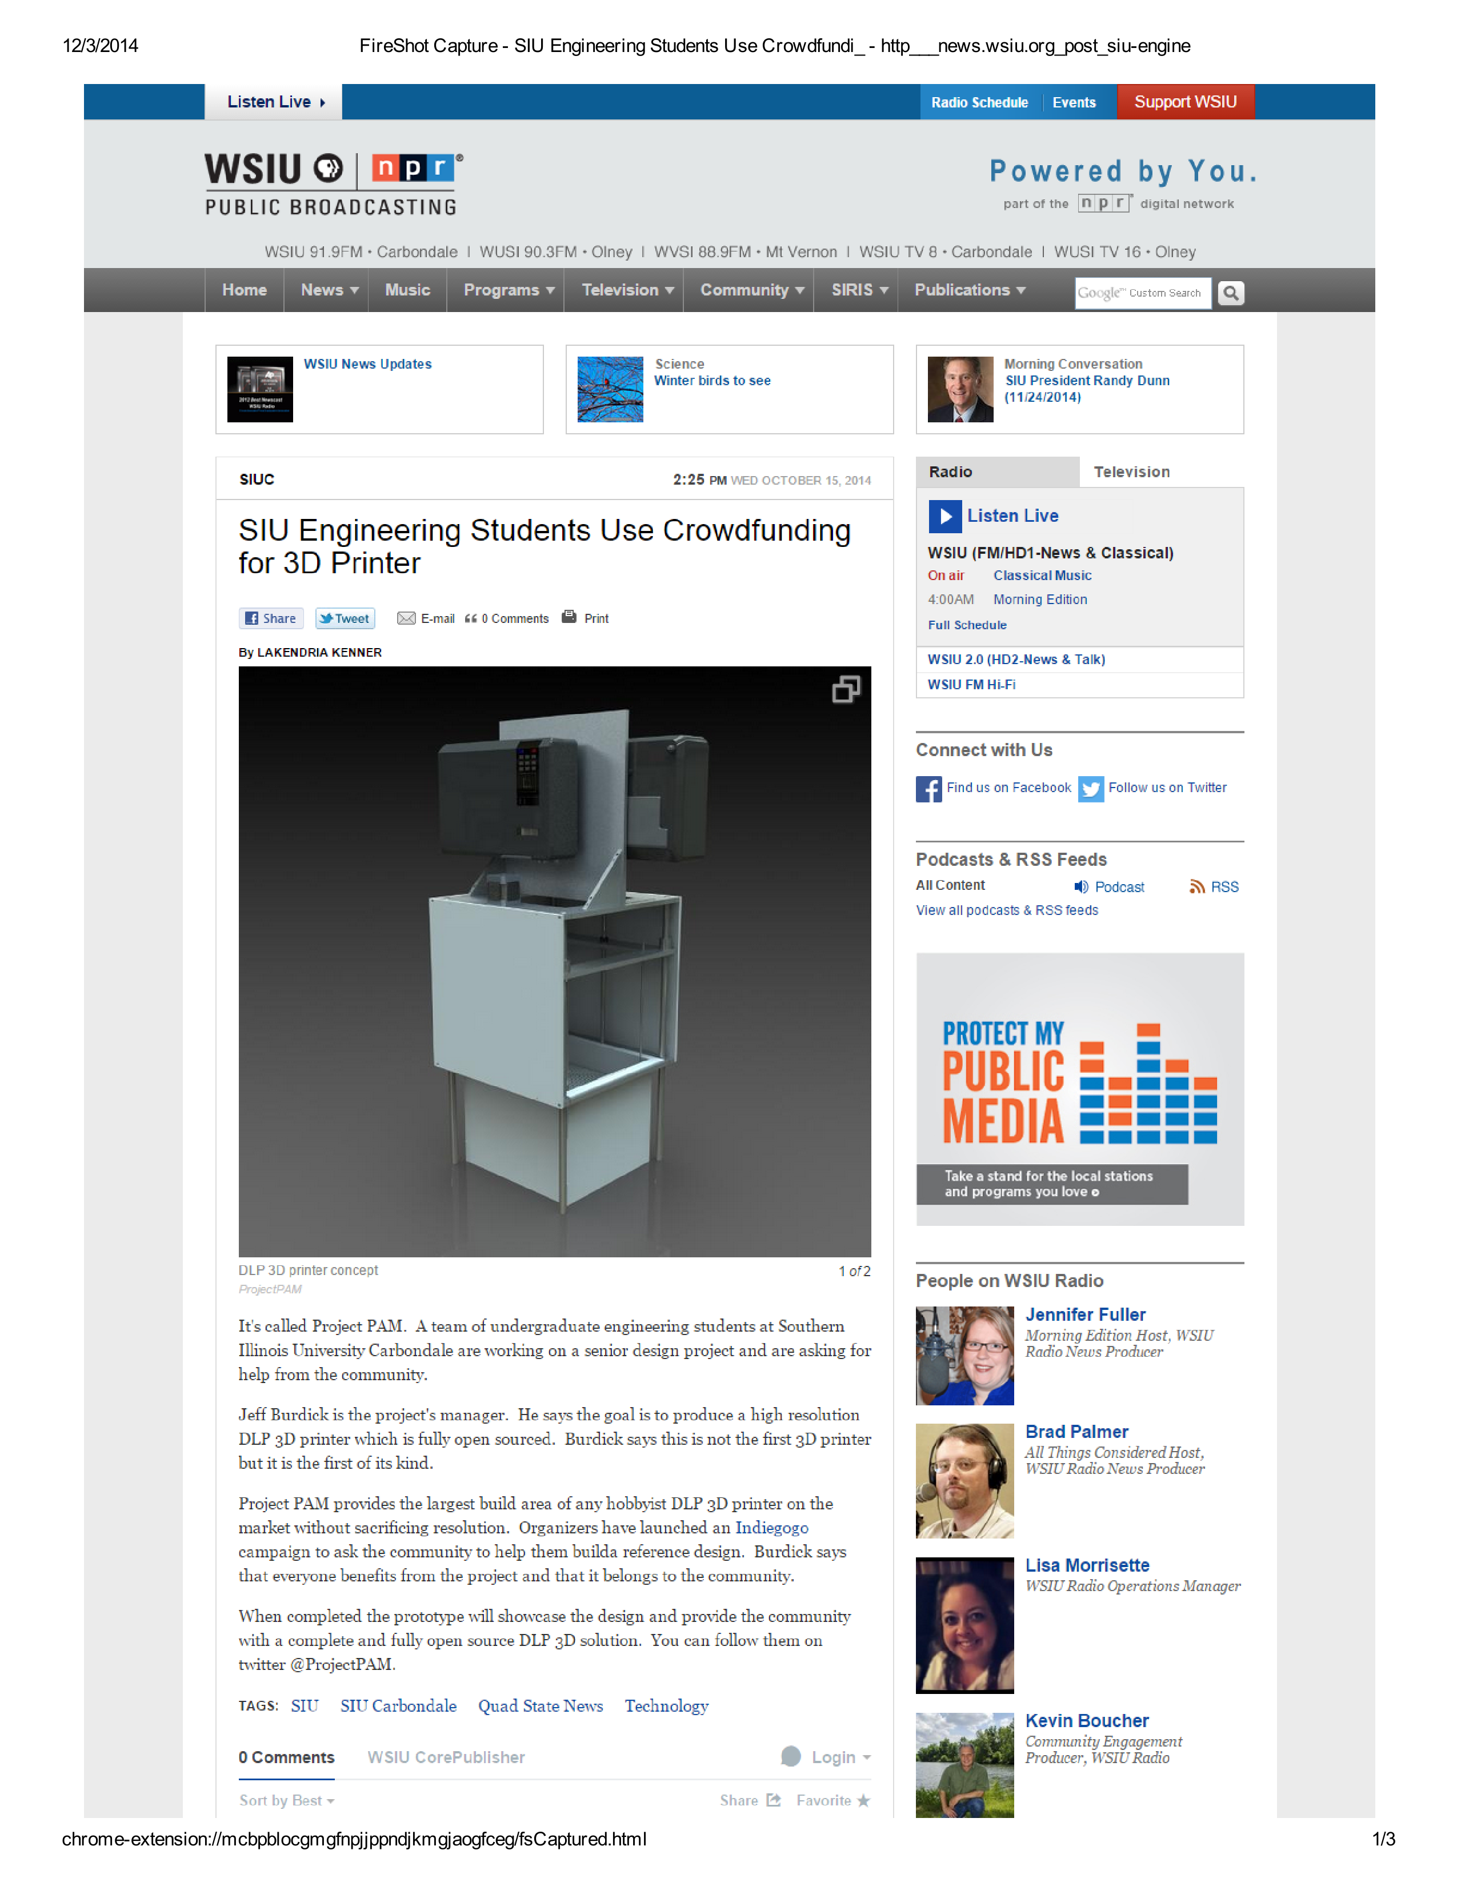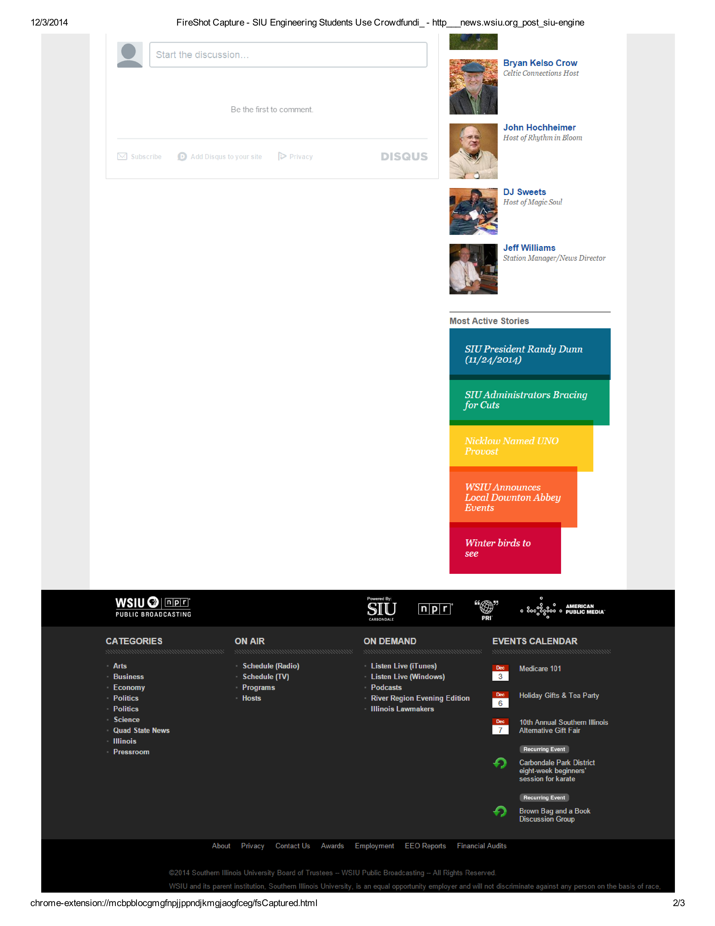

### Make Magazine

